**DAILY ONLINE ACTIVITIES SUMMARY**

|  |  |  |  |  |  |  |  |  |
| --- | --- | --- | --- | --- | --- | --- | --- | --- |
| **Date:** | **27-06-2020** | | | | | **Name:** | **Dhanya Bhat** | |
| **Sem & Sec** | **6th A** | | | | | **USN:** | **4AL17CS027** | |
| **Online Test Summary** | | | | | | | | |
| **Subject** | | JDBC and DBMS quiz | | | | | | |
| **Max. Marks** | |  | | **Score** | | |  | |
| **Pre-Placement Training Summary** | | | | | | | | |
| **Pre-Placement training** | 9.20-11.00: DBMS11.10-1.00: JDBC | | | | | | | |
| **Faculty name** | | | **Hemanth kumar and Sayeesh** | | **Duration** | | | **4hrs** |
| **Coding Challenges** | | | | | | | | |
| Problem Statement: 1. Python program to interchange first and last elements in a list | | | | | | | | |
| **Status: YES, Completed all Programs.** | | | | | | | | |
| **Uploaded the report in Github** | | | | | **YES** | | | |
| **If yes Repository name** | | | | | <https://github.com/alvas-education-foundation/Dhanya-bhat-4AL17CS027> | | | |
| **Uploaded the report in slack** | | | | | **YES** | | | |

Online test Details: (Attach the snapshot and briefly write the report for the same)

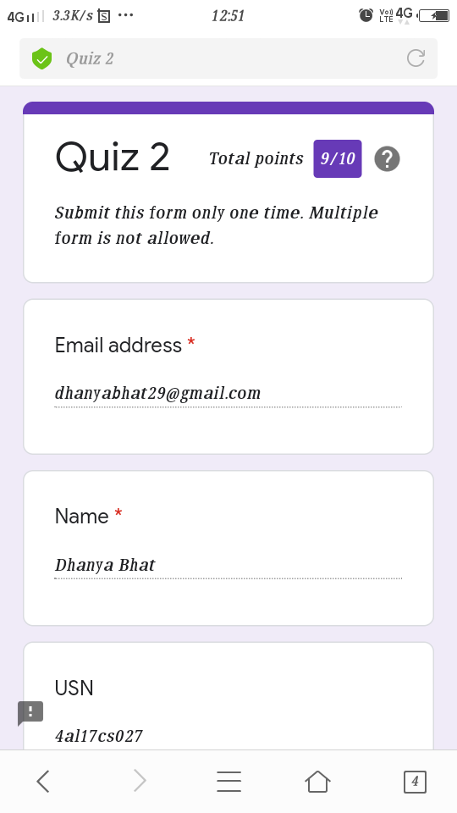

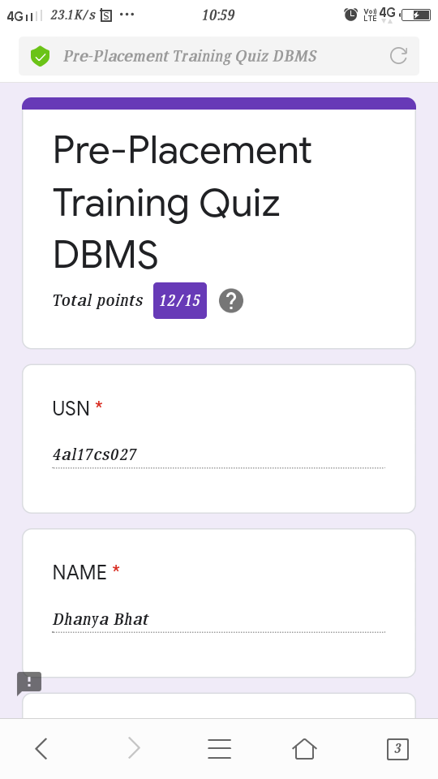

Quiz on JDBC and DBMS

Pre-Placement Course Details: (Attach the snapshot and briefly write the report for the same)

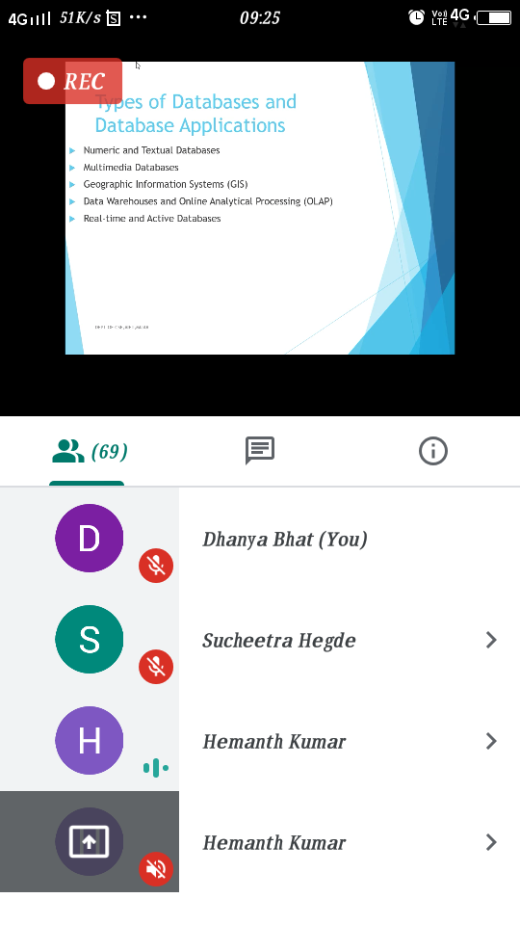

DBMS

Today in the session I studied about Database management system. I also attended 1 quiz in the middle of the session.

The exercise of the session is in the following link:

<https://github.com/alvas-education-foundation/Dhanya-bhat/tree/master/coding_solutions>

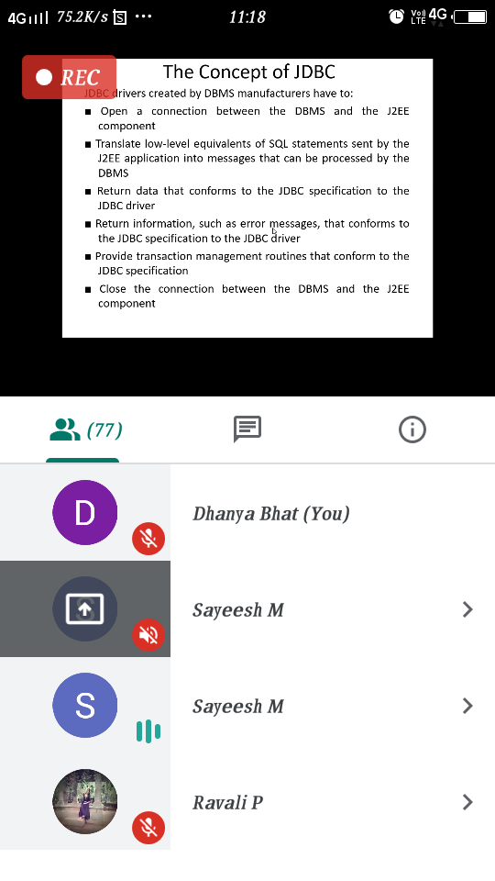

JDBC

Today in the session I studied about JBDC with Java programming examples. I also attended 1 quiz in the middle of the session.

Coding Challenges Details: (Attach the snapshot and briefly write the report for the same)

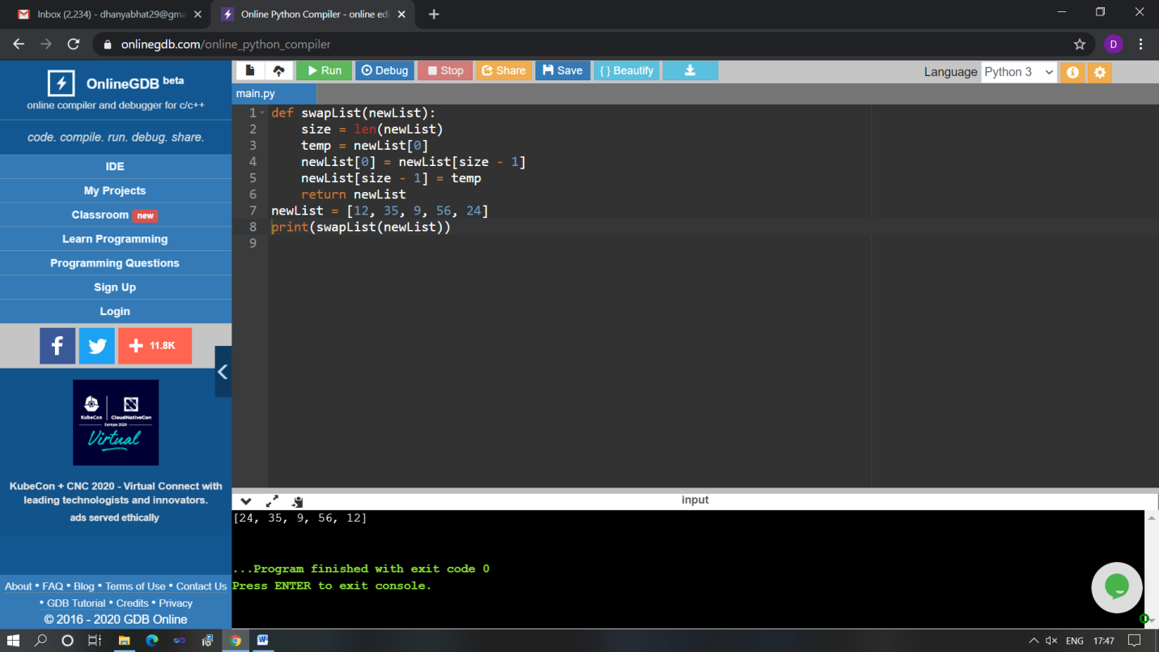

The above Programs were written and executed and the output of the same is displayed above. The code for those 1 programs have been uploaded to the github repository and the link to the same is provided on the form.