**DAILY ONLINE ACTIVITIES SUMMARY**

|  |  |  |  |  |  |  |  |  |
| --- | --- | --- | --- | --- | --- | --- | --- | --- |
| **Date:** | **27-07-2020** | | | | | **Name:** | **Dhanya Bhat** | |
| **Sem & Sec** | **6th A** | | | | | **USN:** | **4AL17CS027** | |
| **Online Test Summary** | | | | | | | | |
| **Subject** | | Operating system | | | | | | |
| **Max. Marks** | | **30** | | **Score** | | | **-** | |
| **Online Course Summary** | | | | | | | | |
| **Online Course**  **name** | Salesforce (developer) | | | | | | | |
| **Certificate provider** | | | **Salesforce** | | **Duration** | | | **90hrs** |
| **Coding Challenges** | | | | | | | | |
| Problem Statement: 1. C program to display Floyd’s triangle. | | | | | | | | |
| **Status: YES, Completed all Programs.** | | | | | | | | |
| **Uploaded the report in Github** | | | | | **YES** | | | |
| **If yes Repository name** | | | | | <https://github.com/alvas-education-foundation/Dhanya-bhat-4AL17CS027> | | | |
| **Uploaded the report in slack** | | | | | **YES** | | | |

Online course Details: (Attach the snapshot and briefly write the report for the same)

. 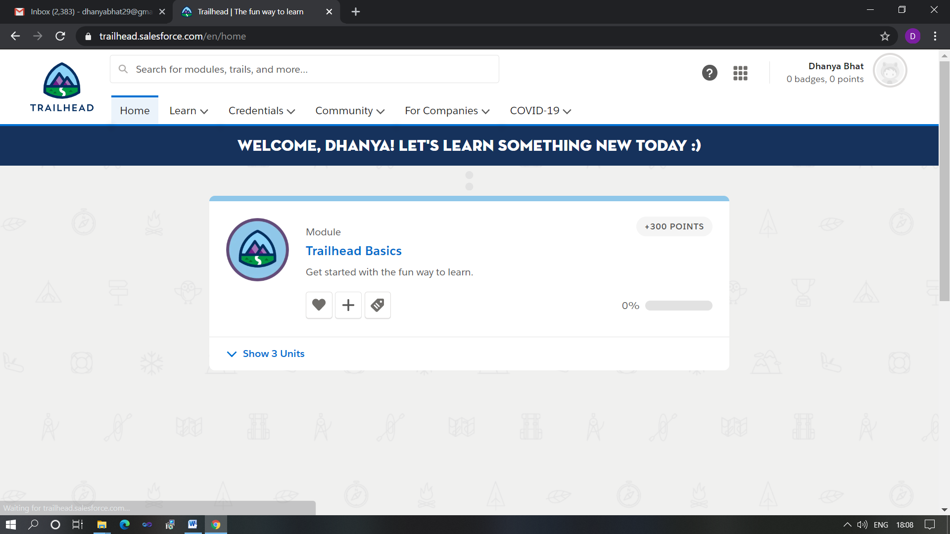

Registered for salesforce online certification course.

Coding Challenges Details: (Attach the snapshot and briefly write the report for the same)

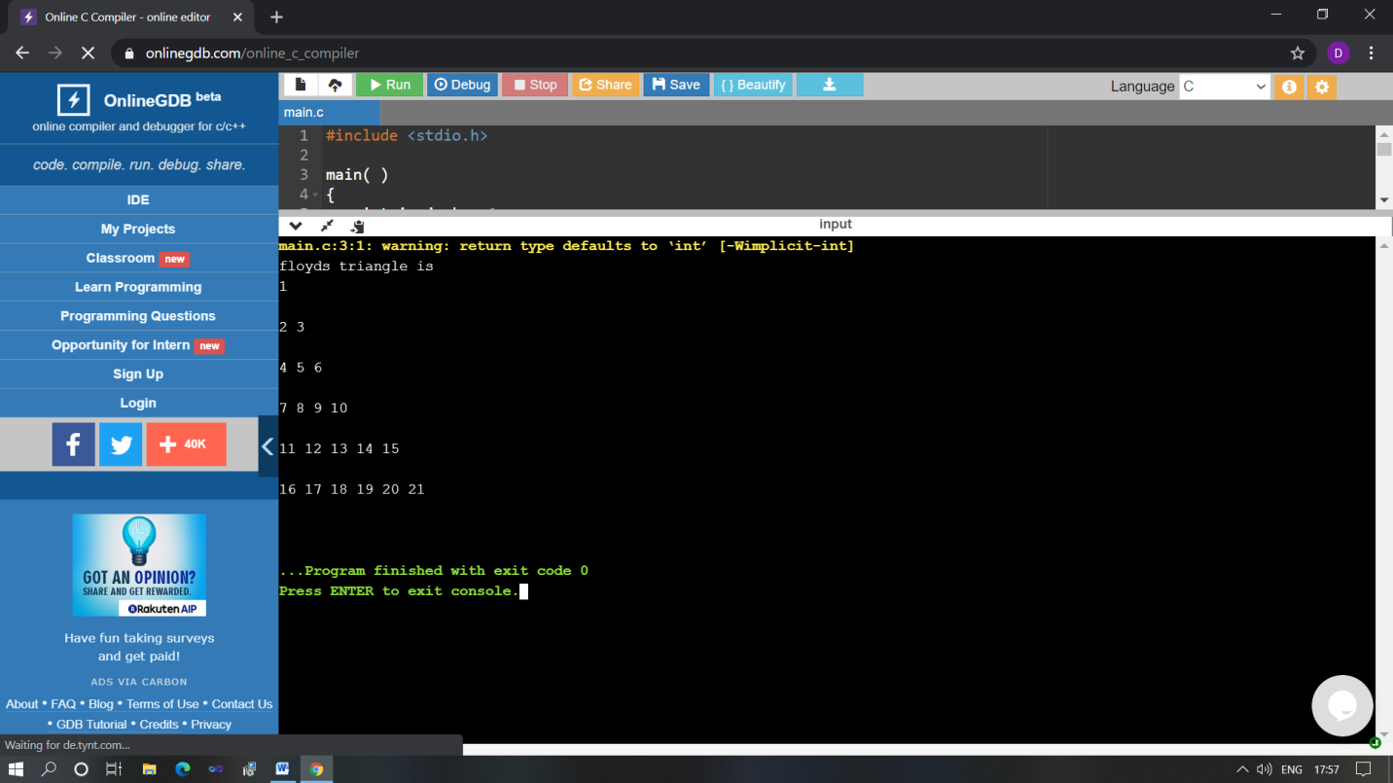

The above Programs were written and executed and the output of the same is displayed above. The code for those 1 programs have been uploaded to the github repository and the link to the same is provided on the form.