**DAILY ONLINE ACTIVITIES SUMMARY**

|  |  |  |  |  |  |  |  |  |
| --- | --- | --- | --- | --- | --- | --- | --- | --- |
| **Date:** | **29-06-2020** | | | | | **Name:** | **Dhanya Bhat** | |
| **Sem & Sec** | **6th A** | | | | | **USN:** | **4AL17CS027** | |
| **Online Test Summary** | | | | | | | | |
| **Subject** | | Cyber security and DBMS quiz | | | | | | |
| **Max. Marks** | |  | | **Score** | | |  | |
| **Pre-Placement Training Summary** | | | | | | | | |
| **Pre-Placement training** | 9.20-11.00: DBMS11.10-1.00: Cyber security | | | | | | | |
| **Faculty name** | | | **Reena lobo and Manajunath kotari** | | **Duration** | | | **4hrs** |
| **Coding Challenges** | | | | | | | | |
| Problem Statement: 1. Python program to print the identity matrix. 2. Python program to find LCM of 2 numbers. | | | | | | | | |
| **Status: YES, Completed all Programs.** | | | | | | | | |
| **Uploaded the report in Github** | | | | | **YES** | | | |
| **If yes Repository name** | | | | | <https://github.com/alvas-education-foundation/Dhanya-bhat-4AL17CS027> | | | |
| **Uploaded the report in slack** | | | | | **YES** | | | |

Online test Details: (Attach the snapshot and briefly write the report for the same)

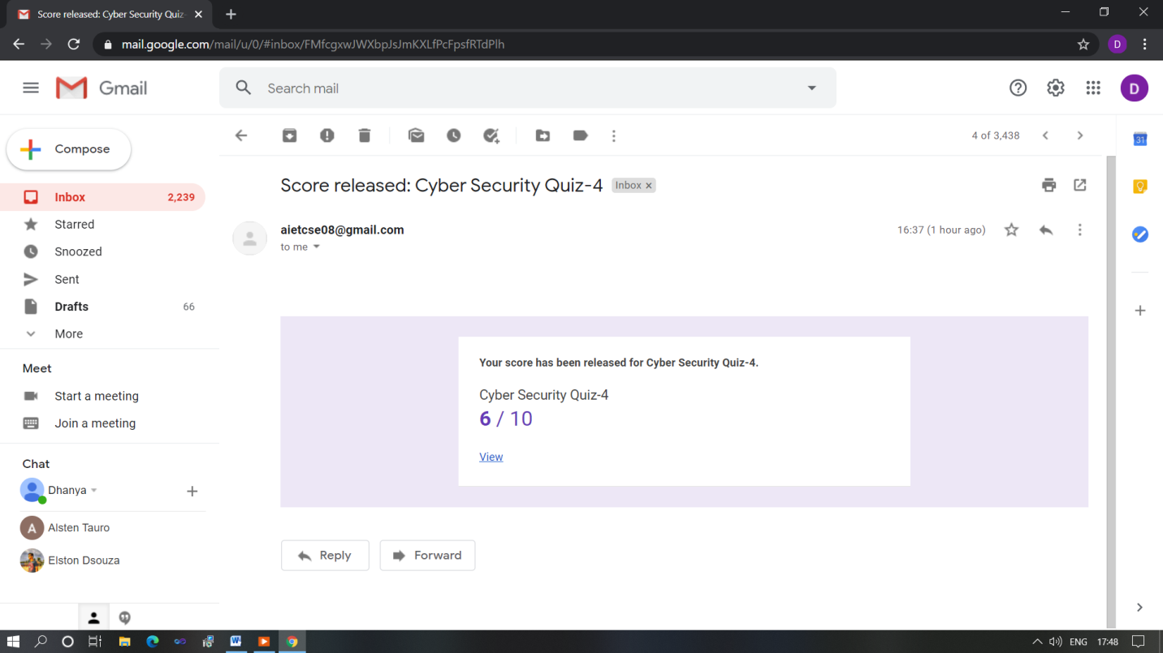

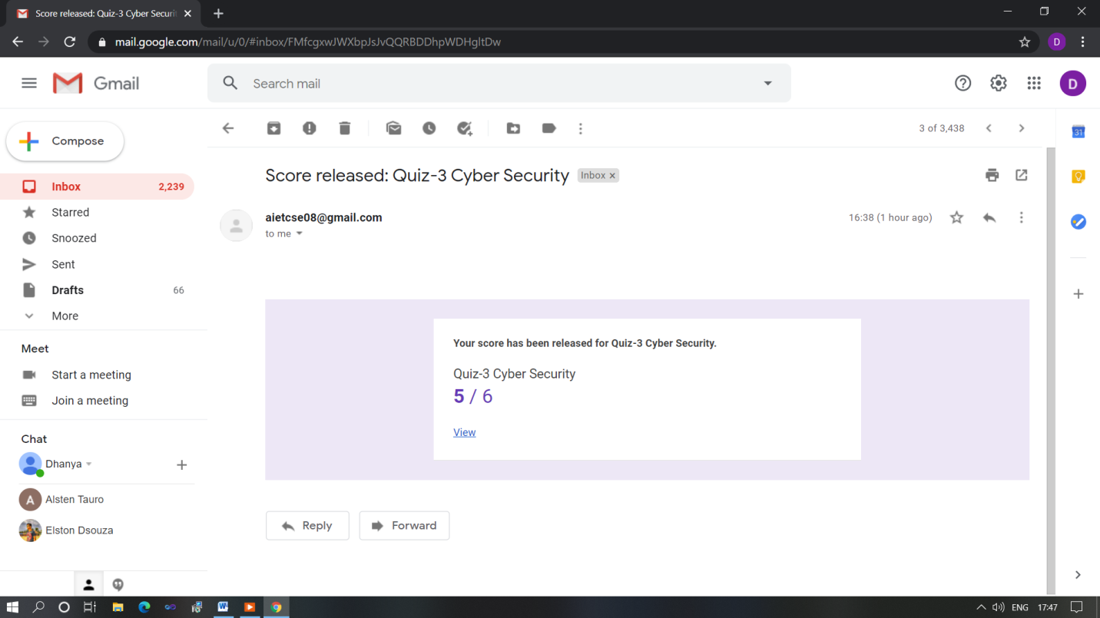

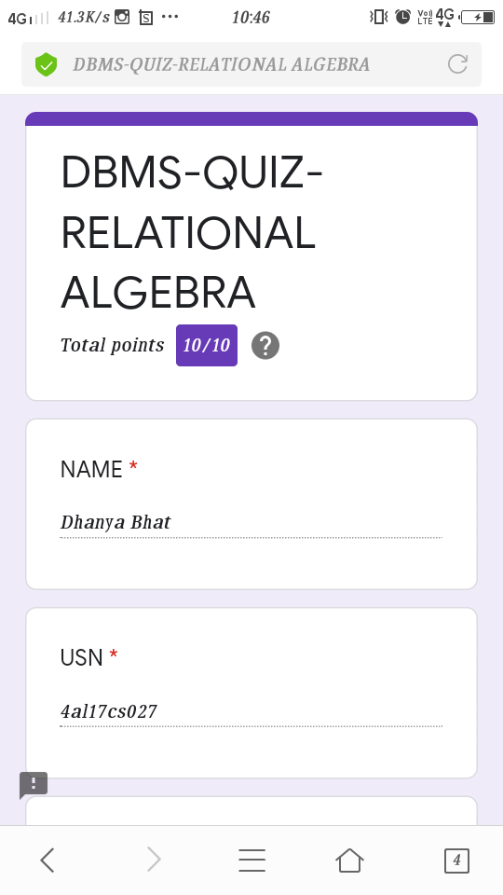

Quiz on Cyber security and DBMS

Pre-Placement Course Details: (Attach the snapshot and briefly write the report for the same)

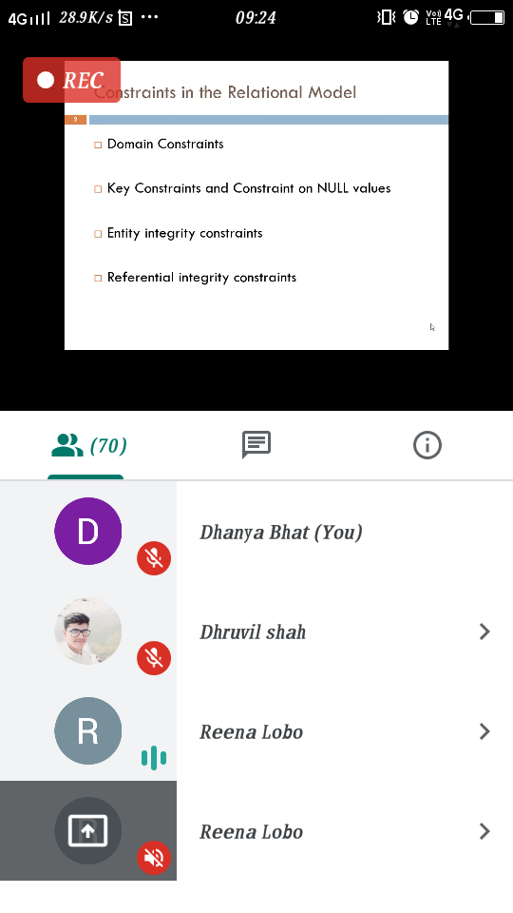

DBMS

Today in the session I studied about Relational algebra in Database management system. I also attended 1 quiz in the middle of the session.

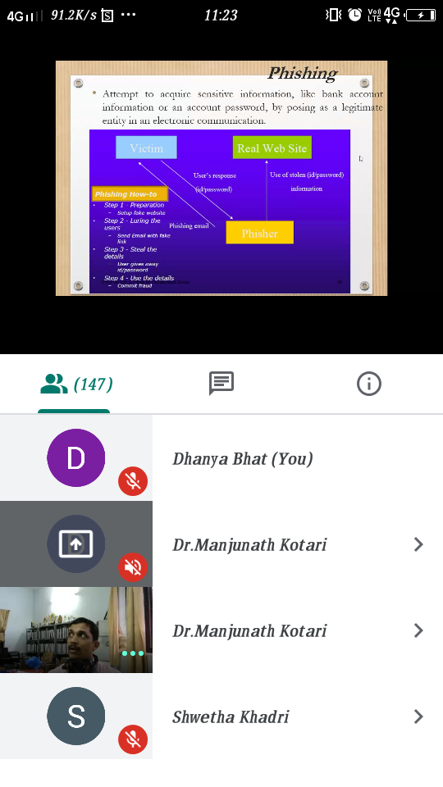

Cyber security

Today in the session I studied about Malware, phishing in Cyber security. I also attended 2 quiz in the middle of the session.

Coding Challenges Details: (Attach the snapshot and briefly write the report for the same)

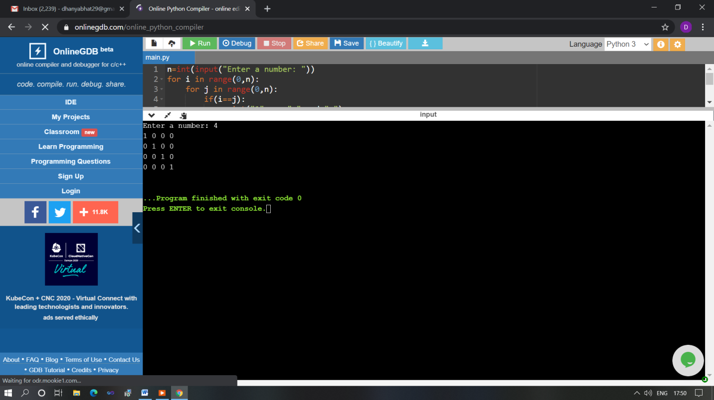

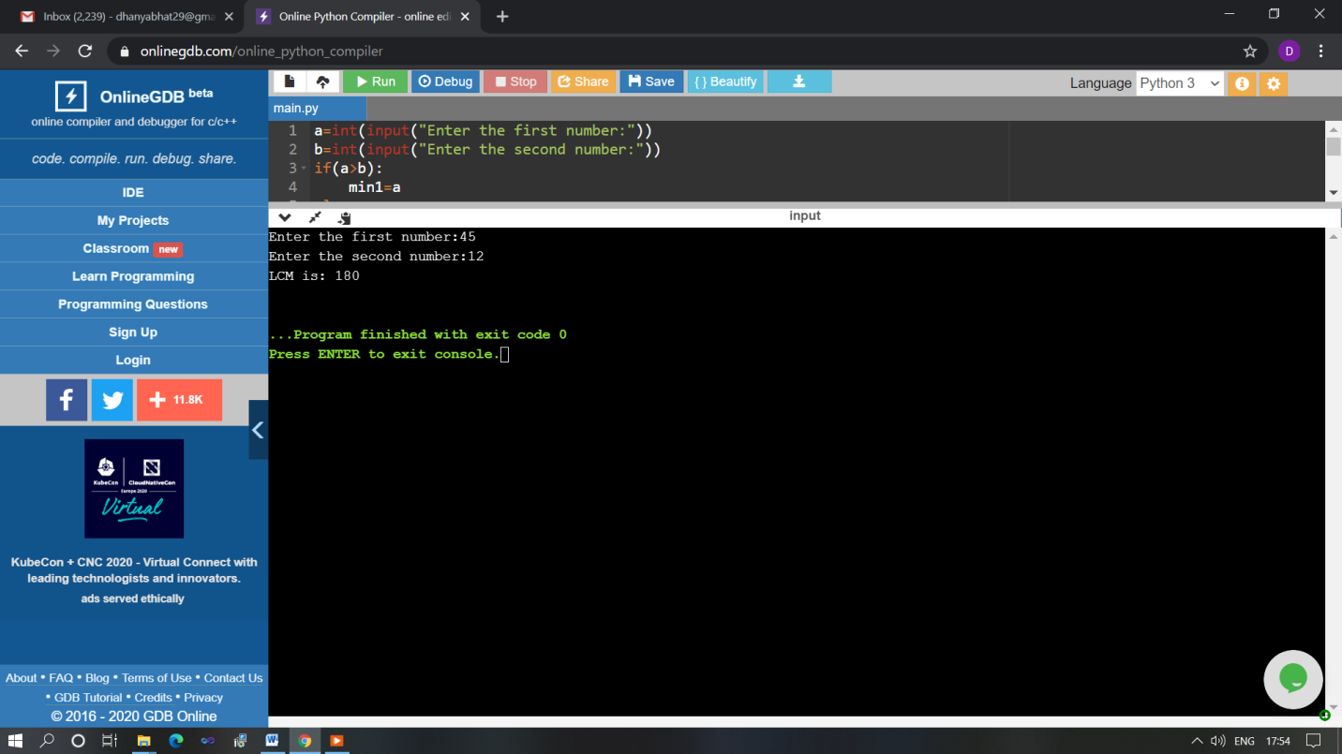

The above Programs were written and executed and the output of the same is displayed above. The code for those 2 programs have been uploaded to the github repository and the link to the same is provided on the form.