**DAILY ONLINE ACTIVITIES SUMMARY**

|  |  |  |  |  |  |  |  |  |
| --- | --- | --- | --- | --- | --- | --- | --- | --- |
| **Date:** | **30-05-2020** | | | | | **Name:** | **Dhanya Bhat** | |
| **Sem & Sec** | **6th A** | | | | | **USN:** | **4AL17CS027** | |
| **Online Test Summary** | | | | | | | | |
| **Subject** | | **PAP** | | | | | | |
| **Max. Marks** | | **30** | | **Score** | | | **10** | |
| **Certification Course Summary** | | | | | | | | |
| **Course** | **A Full Stack Web Developer – Beginner to Advanced** | | | | | | | |
| **Certificate Provider** | | | **Udemy** | | **Duration** | | | **19.5hrs** |
| **Coding Challenges** | | | | | | | | |
| **Problem Statement:**   1. Write a java program to Count number of trailing zeros in product of array. 2. Python program to read a number and print the pattern. | | | | | | | | |
| **Status: YES, Completed all Programs** | | | | | | | | |
| **Uploaded the report in Github** | | | | | **YES** | | | |
| **If yes Repository name** | | | | | <https://github.com/alvas-education-foundation/Dhanya-bhat> | | | |
| **Uploaded the report in slack** | | | | | **YES** | | | |

Online Test Details: (Attach the snapshot and briefly write the report for the same)

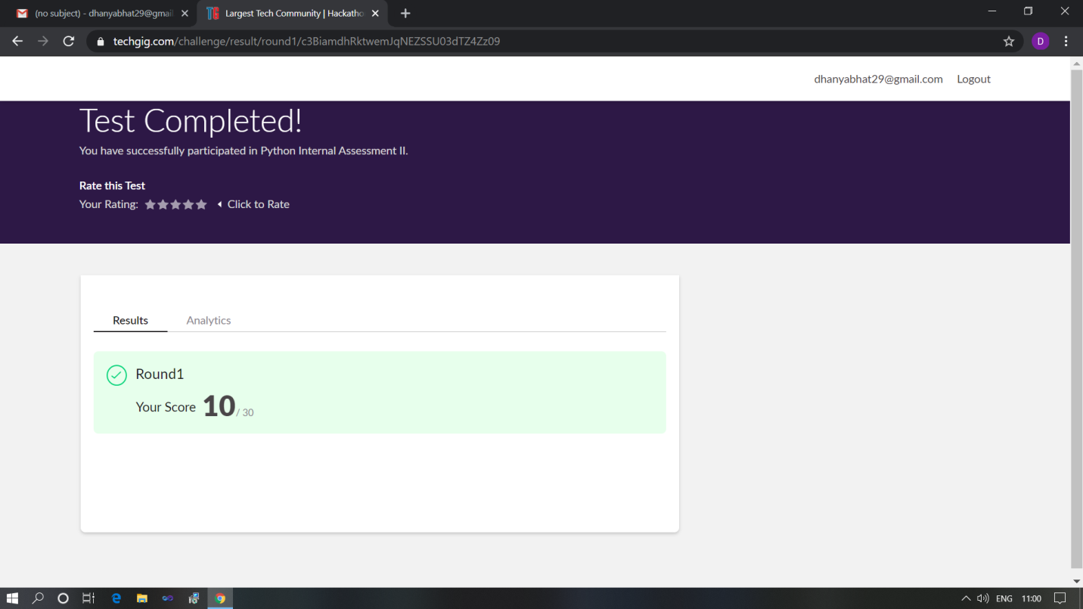

Scored 10 out of 30 in PAP 2nd I.A test

Certification Course Details: (Attach the snapshot and briefly write the report for the same)

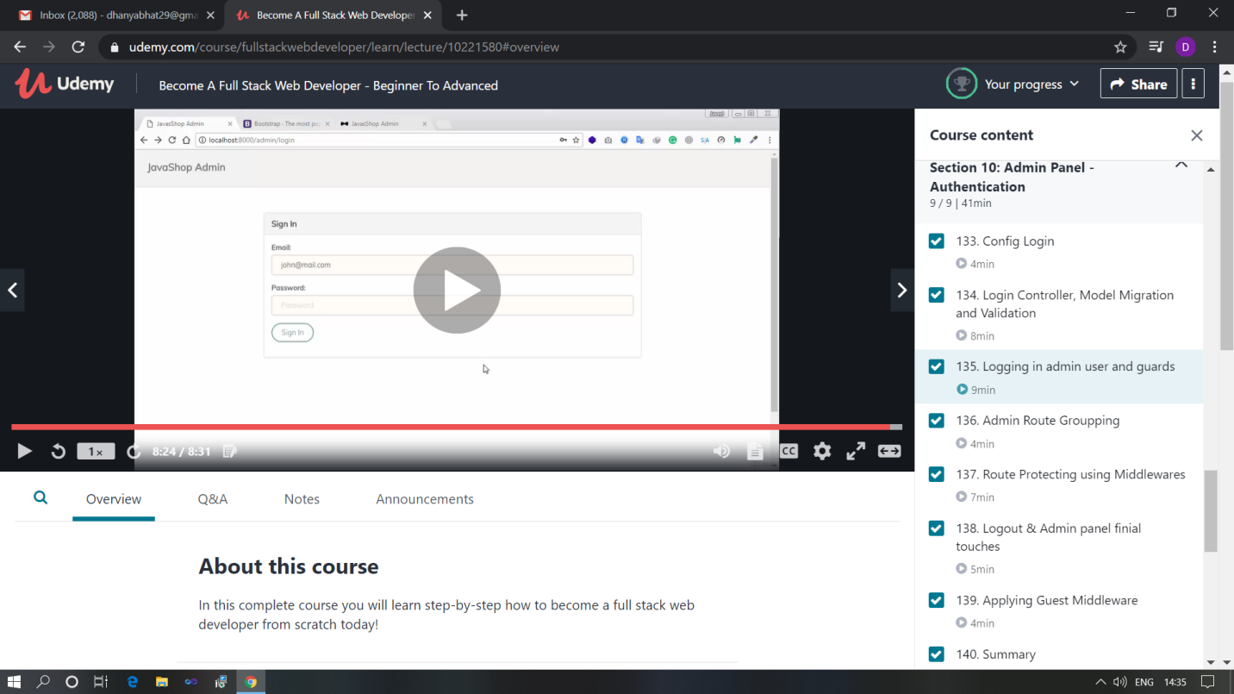

The above course is being taken up by me which is based on the full stack web development. It started with the basics of HTML, Today in Online course I studied about Config login, Login controlling, Model migration, Logging in admin user and guards, Admin route grouping, Route protecting using middlewares, Logout & admin panel finial, Applying guest middleware, Summary. The details of the course and certificate provider is mentioned in the above form.

Coding Challenges Details: (Attach the snapshot and briefly write the report for the same)

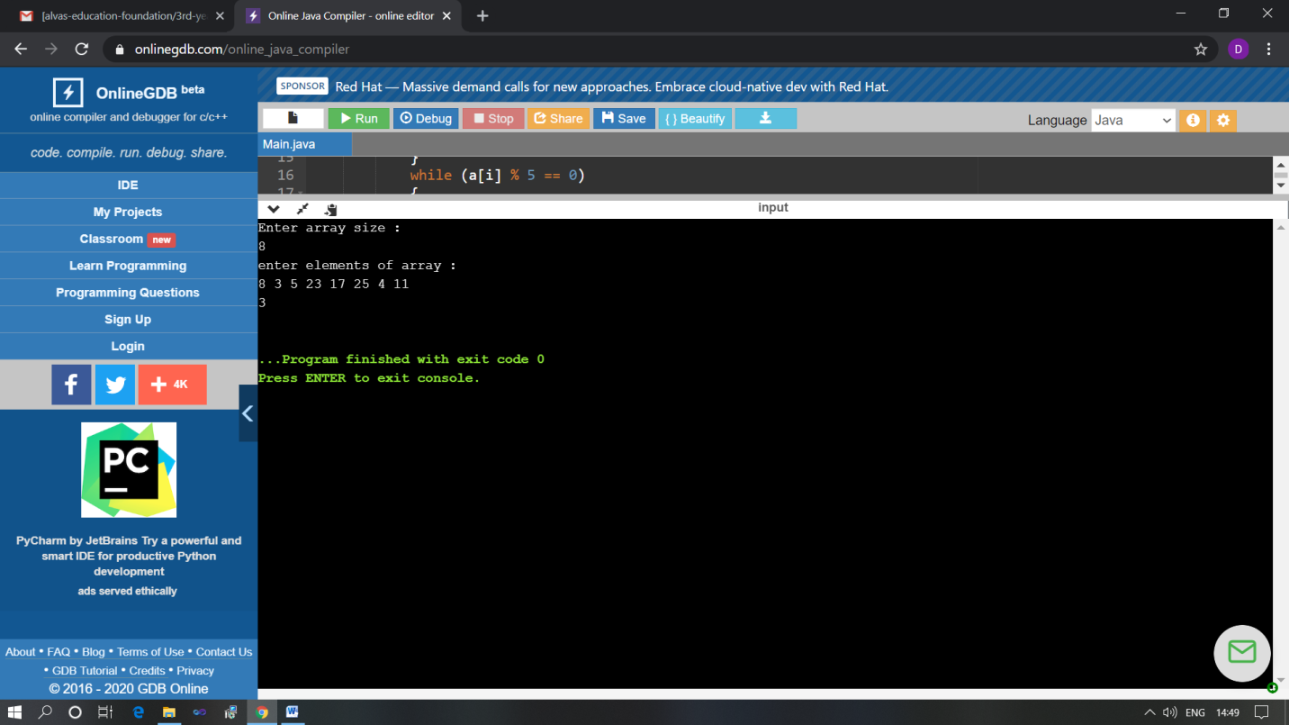

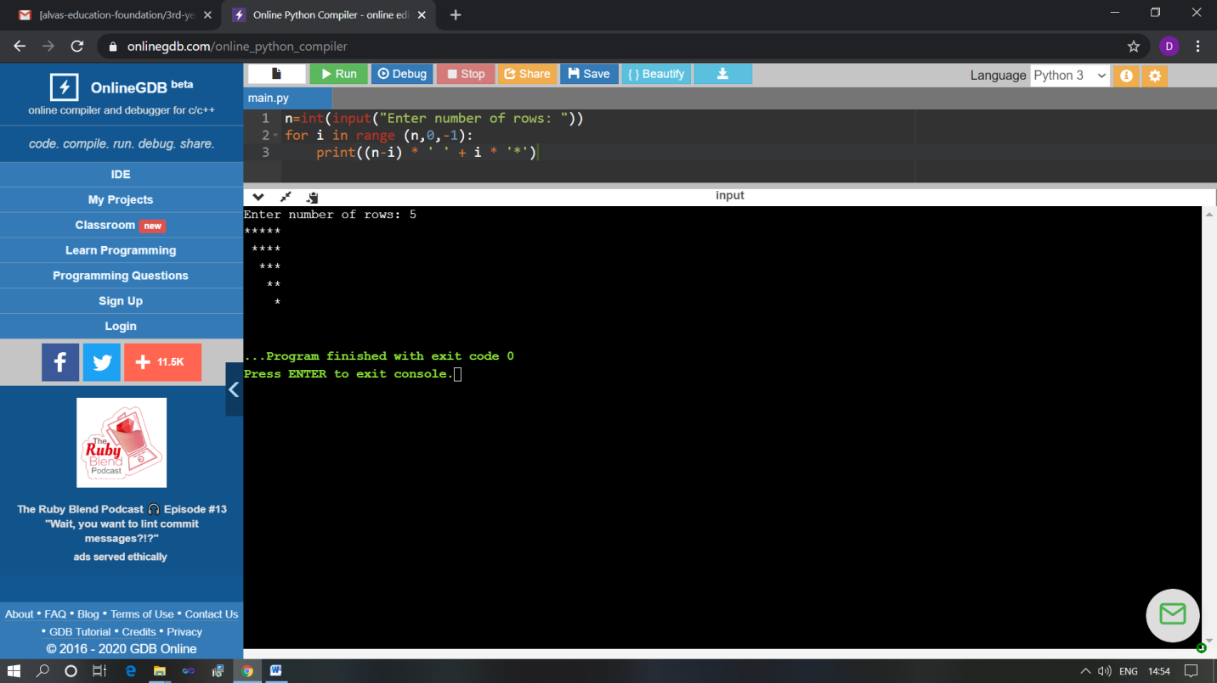

The above Programs were written and executed and the output of the same is displayed above. The code for those 2 programs have been uploaded to the github repository and the link to the same is provided on the form.