**DAILY ONLINE ACTIVITIES SUMMARY**

|  |  |  |  |  |  |  |  |  |
| --- | --- | --- | --- | --- | --- | --- | --- | --- |
| **Date:** | **30-06-2020** | | | | | **Name:** | **Dhanya Bhat** | |
| **Sem & Sec** | **6th A** | | | | | **USN:** | **4AL17CS027** | |
| **Online Test Summary** | | | | | | | | |
| **Subject** | | Java quiz | | | | | | |
| **Max. Marks** | |  | | **Score** | | |  | |
| **Pre-Placement Training Summary** | | | | | | | | |
| **Pre-Placement training** | 9.20-11.00: Java | | | | | | | |
| **Faculty name** | | | **Sharan pais** | | **Duration** | | | **2hrs** |
| **Coding Challenges** | | | | | | | | |
| Problem Statement: 1. Write a C Program to generate first n Ugly Numbers. 2. Write a Java Program to determine whether one string is a rotation of another. | | | | | | | | |
| **Status: YES, Completed all Programs.** | | | | | | | | |
| **Uploaded the report in Github** | | | | | **YES** | | | |
| **If yes Repository name** | | | | | <https://github.com/alvas-education-foundation/Dhanya-bhat-4AL17CS027> | | | |
| **Uploaded the report in slack** | | | | | **YES** | | | |

Online test Details: (Attach the snapshot and briefly write the report for the same)

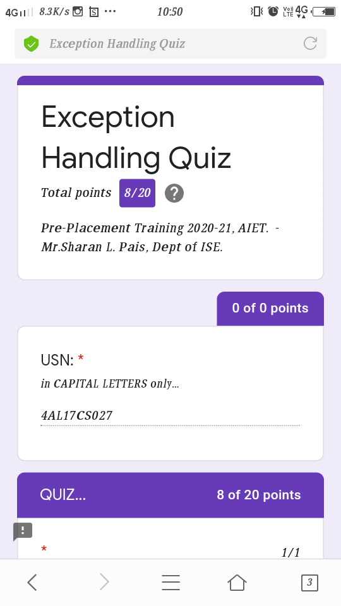

Java quiz

Pre-Placement Course Details: (Attach the snapshot and briefly write the report for the same)

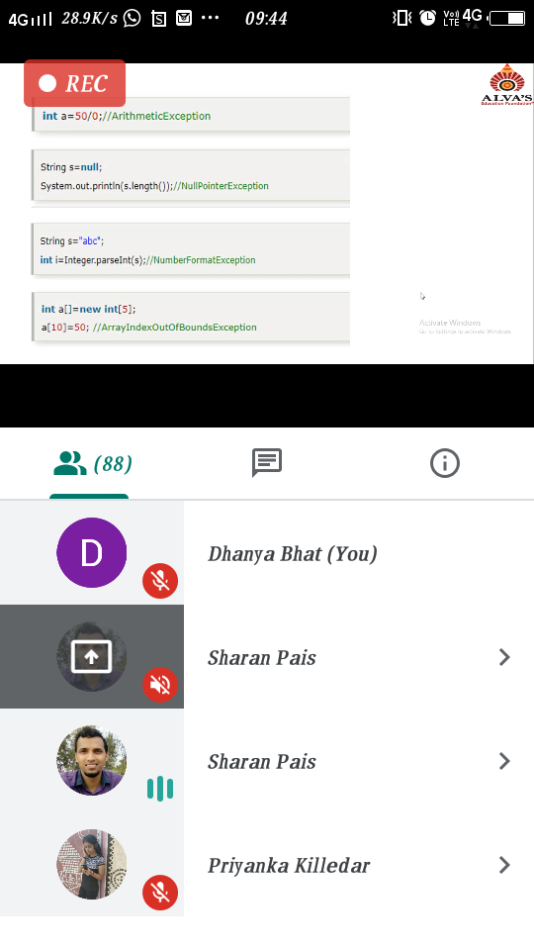

Java

Today in the session I studied about Exception handling in Java with programming exmpales. I also attended 1 quiz in the middle of the session.

Coding Challenges Details: (Attach the snapshot and briefly write the report for the same)

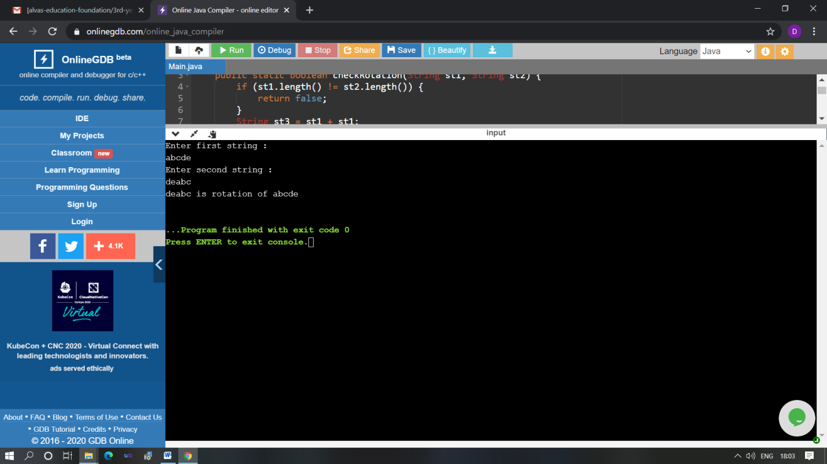

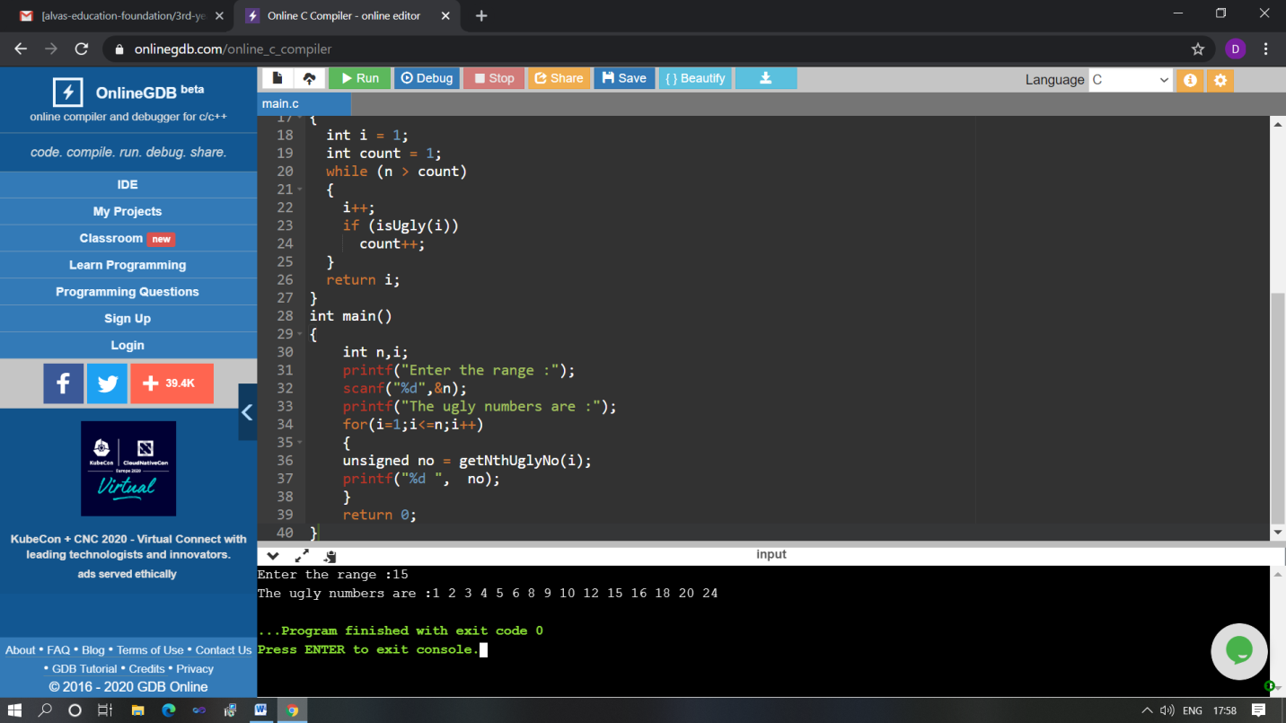

The above Programs were written and executed and the output of the same is displayed above. The code for those 2 programs have been uploaded to the github repository and the link to the same is provided on the form.