**DAILY ONLINE ACTIVITIES SUMMARY**

|  |  |  |  |  |  |  |  |  |
| --- | --- | --- | --- | --- | --- | --- | --- | --- |
| **Date:** | **31-05-2020** | | | | | **Name:** | **Dhanya Bhat** | |
| **Sem & Sec** | **6th A** | | | | | **USN:** | **4AL17CS027** | |
| **Online Test Summary** | | | | | | | | |
| **Subject** | |  | | | | | | |
| **Max. Marks** | |  | | **Score** | | |  | |
| **Certification Course Summary** | | | | | | | | |
| **Course** | **Step into Robotic Process Automation(RPA)** | | | | | | | |
| **Certificate Provider** | | | **GUVI** | | **Duration** | | | **3 hrs** |
| **Coding Challenges** | | | | | | | | |
| **Problem Statement:**   1. Write a C++ program to print Pascal Triangle. 2. Write a C++ program for Quick sort using arrays.   **2.** | | | | | | | | |
| **Status: Yes, Completed all programs** | | | | | | | | |
| **Uploaded the report in Github** | | | | | **YES** | | | |
| **If yes Repository name** | | | | | <https://github.com/alvas-education-foundation/Dhanya-bhat> | | | |
| **Uploaded the report in slack** | | | | | **YES** | | | |

Certification Course Details: (Attach the snapshot and briefly write the report for the same)

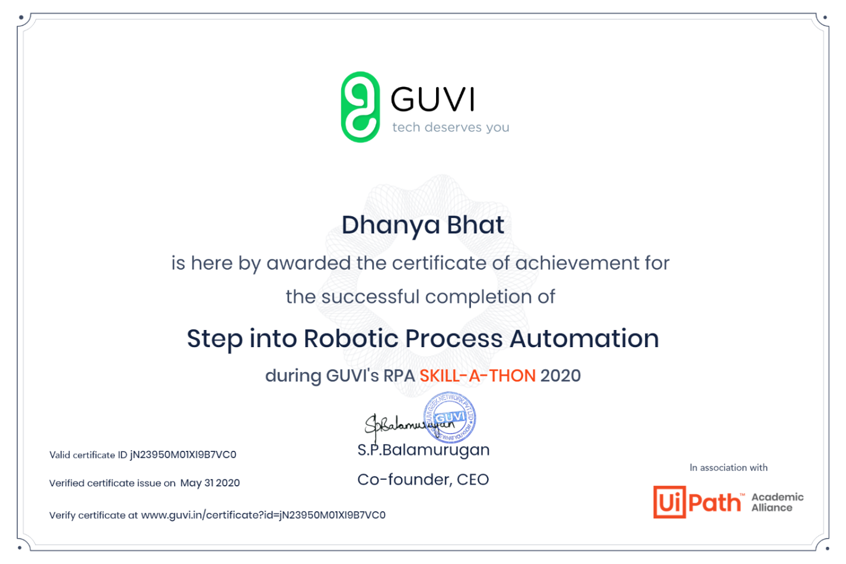

Completed Step into Robotic Process during GUVI’s RPA SKILL-A-THON 2020

Coding Challenges Details: (Attach the snapshot and briefly write the report for the same)

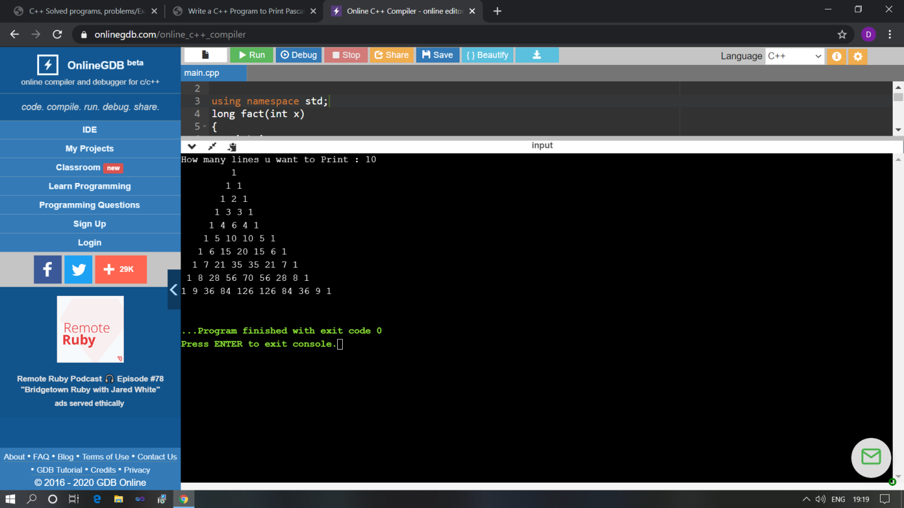

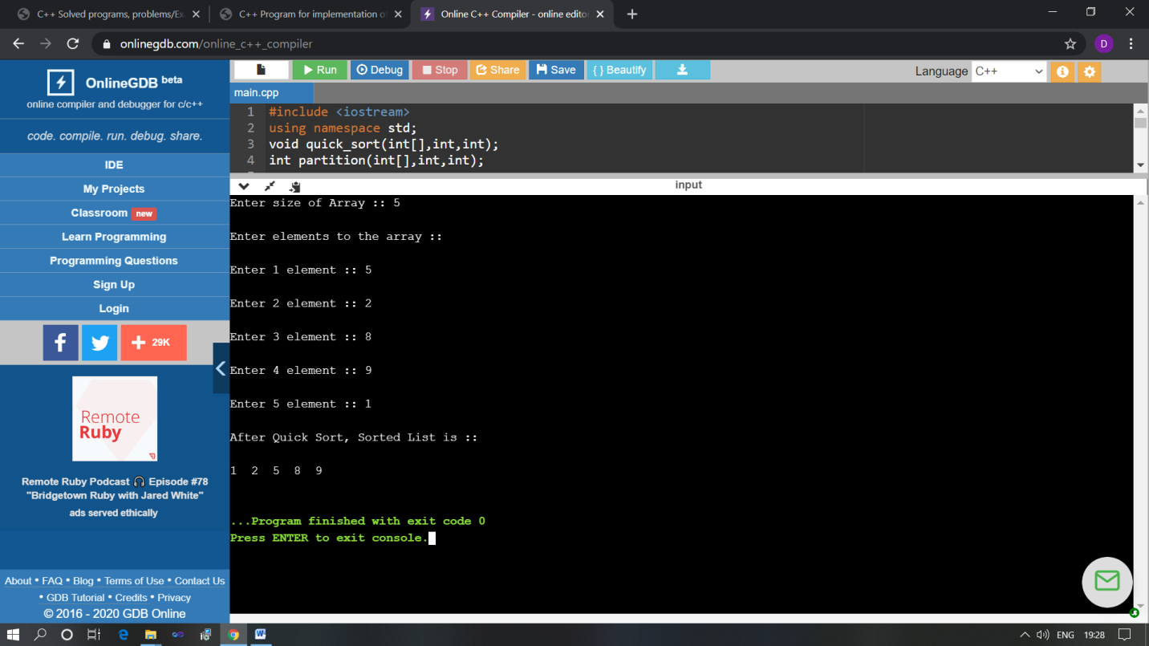

The above Programs were written and executed and the output of the same is displayed above. The code for those 2 programs have been uploaded to the github repository and the link to the same is provided on the form.