**DAILY ONLINE ACTIVITIES SUMMARY**

|  |  |  |  |  |  |  |  |  |
| --- | --- | --- | --- | --- | --- | --- | --- | --- |
| **Date:** | **7-06-2020** | | | | | **Name:** | **Dhanya Bhat** | |
| **Sem & Sec** | **6th A** | | | | | **USN:** | **4AL17CS027** | |
| **Online Test Summary** | | | | | | | | |
| **Subject** | | **System Software and Compiler Design(SSCD)** | | | | | | |
| **Max. Marks** | | **30** | | **Score** | | | **23** | |
| **Certification Course Summary** | | | | | | | | |
| **Course** | **Python for Machine Learning** | | | | | | | |
| **Certificate Provider** | | | **Great Learning** | | **Duration** | | | 5**hrs** |
| **Coding Challenges** | | | | | | | | |
| **Problem Statement**: 1. Write a java Program to print smallest and biggest possible palindrome word in a given string.  **2.** Python program the first and last 5 elements. | | | | | | | | |
| **Status: YES, Completed all Programs.** | | | | | | | | |
| **Uploaded the report in Github** | | | | | **YES** | | | |
| **If yes Repository name** | | | | | <https://github.com/alvas-education-foundation/Dhanya-bhat-4AL17CS027> | | | |
| **Uploaded the report in slack** | | | | | **YES** | | | |

Online Test Details: (Attach the snapshot and briefly write the report for the same) 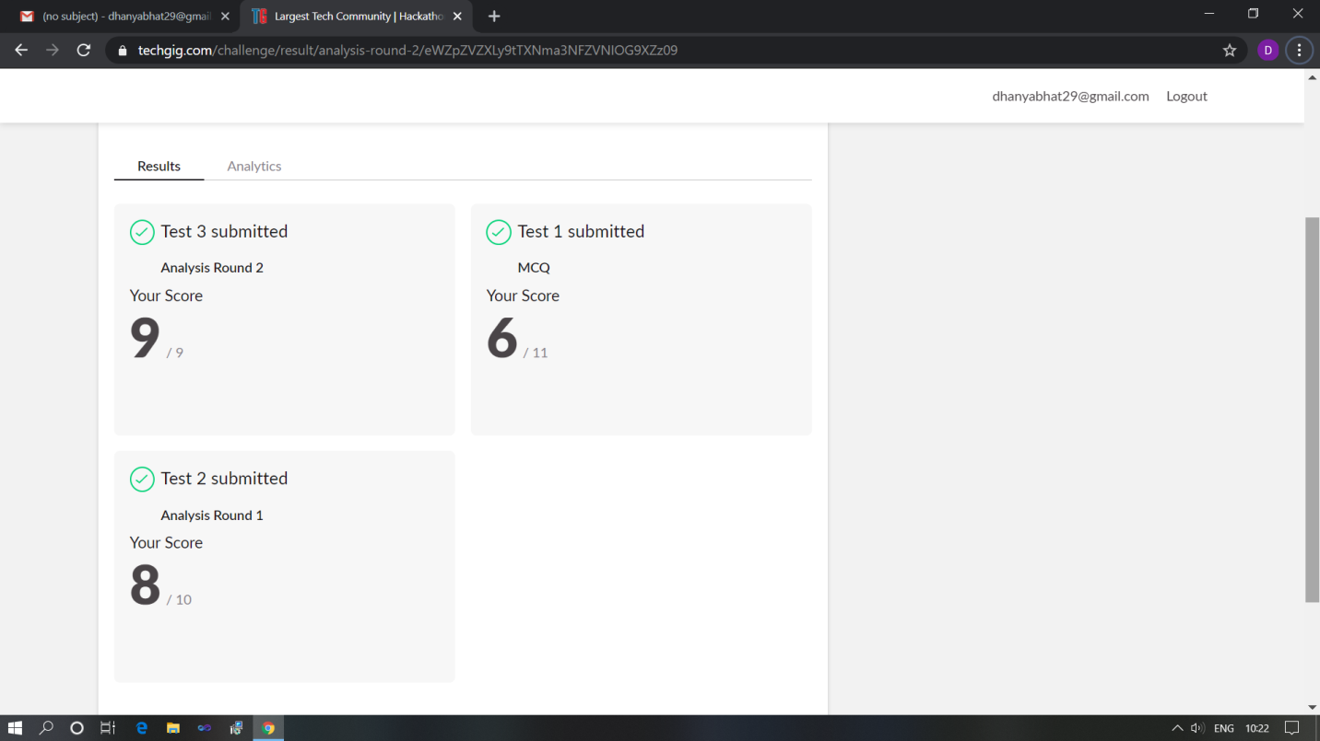

Scored 23 out of 30 in SSCD test

Certification Course Details: (Attach the snapshot and briefly write the report for the same)

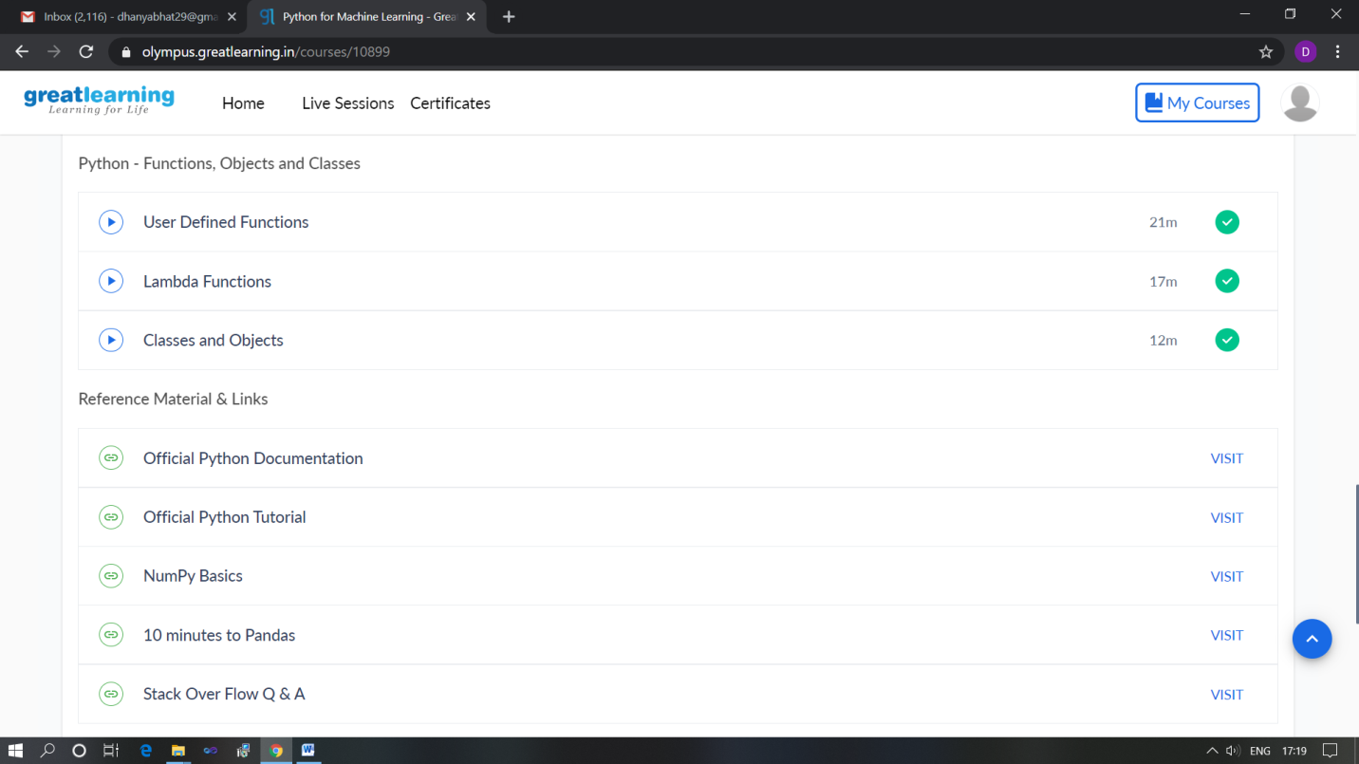

The above course is being taken up by me which is based on the Python for Machine Learning. Today in online course I studied about Python functions, objects and classes it includes User defined functions, Lambda function, Classes and objects. The details of the course and certificate provider is mentioned in the above form.

Coding Challenges Details: (Attach the snapshot and briefly write the report for the same)

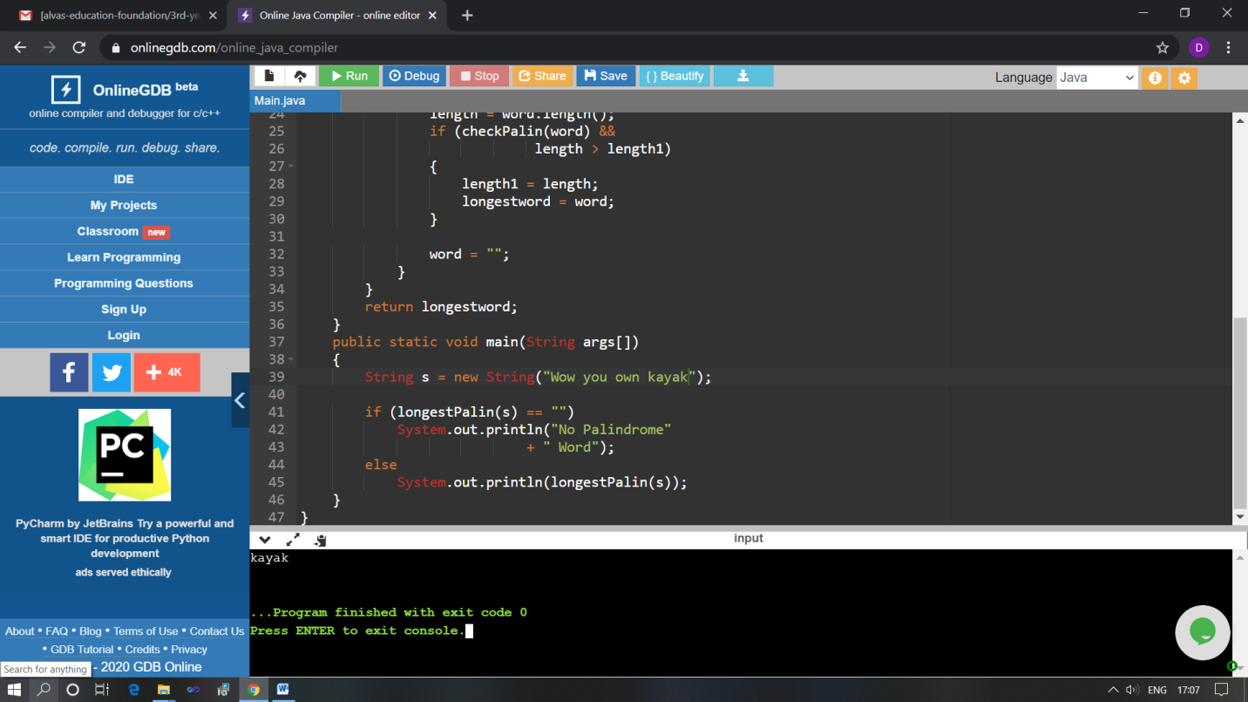

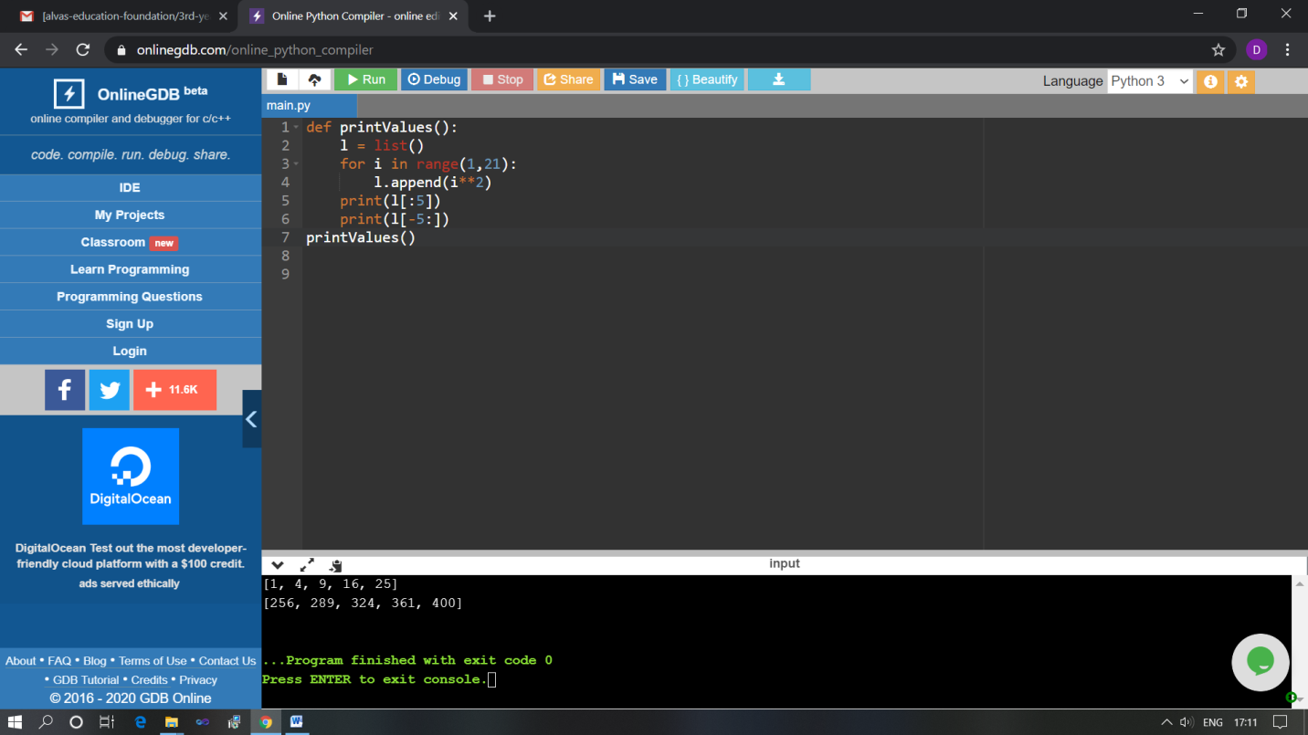The above Programs were written and executed and the output of the same is displayed above. The code for those 2 programs have been uploaded to the github repository and the link to the same is provided on the form.