**DAILY ONLINE ACTIVITIES SUMMARY**

|  |  |  |  |  |  |  |  |  |
| --- | --- | --- | --- | --- | --- | --- | --- | --- |
| **Date:** | **7-08-2020** | | | | | **Name:** | **Dhanya Bhat** | |
| **Sem & Sec** | **6th A** | | | | | **USN:** | **4AL17CS027** | |
| **Online Test Summary** | | | | | | | | |
| **Subject** | |  | | | | | | |
| **Max. Marks** | |  | | **Score** | | |  | |
| **Online Course Summary** | | | | | | | | |
| **Online Course**  **name** | Python for Everybody | | | | | | | |
| **Certificate provider** | | | **Coursera** | | **Duration** | | | **7 weeks** |
| **Coding Challenges** | | | | | | | | |
| Problem Statement: 1.Python program to swap first and last element of a list. | | | | | | | | |
| **Status: YES, Completed all Programs.** | | | | | | | | |
| **Uploaded the report in Github** | | | | | **YES** | | | |
| **If yes Repository name** | | | | | <https://github.com/alvas-education-foundation/Dhanya-bhat-4AL17CS027> | | | |
| **Uploaded the report in slack** | | | | | **YES** | | | |

.

Online course Details: (Attach the snapshot and briefly write the report for the same)

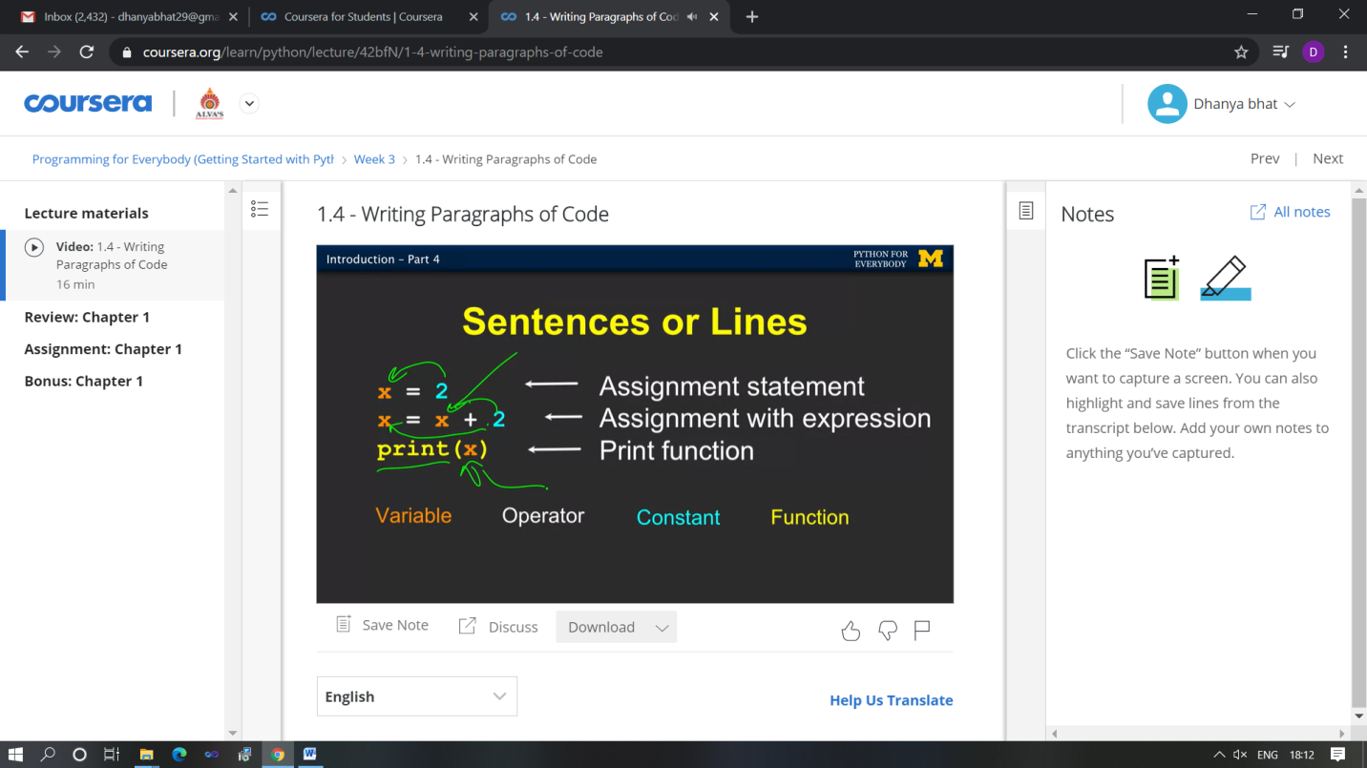

Started Python for everybody online course in coursera.

Coding Challenges Details: (Attach the snapshot and briefly write the report for the same)

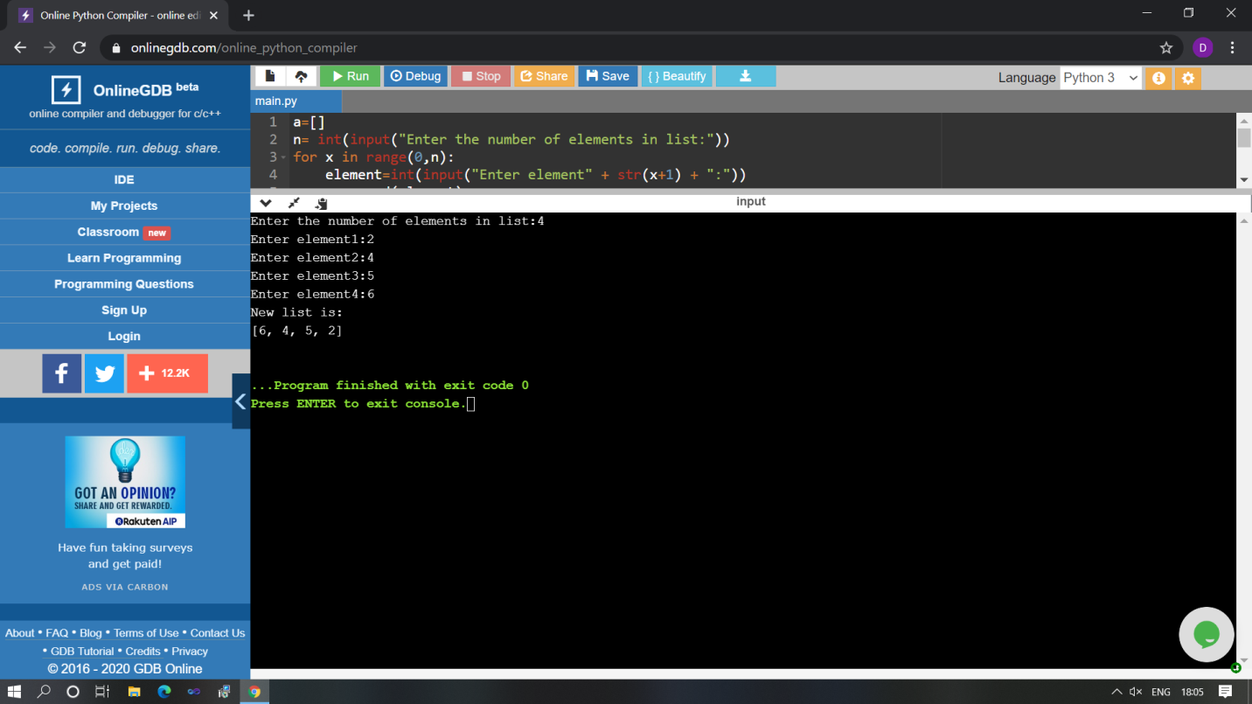

The above Programs were written and executed and the output of the same is displayed above. The code for those 1 programs have been uploaded to the github repository and the link to the same is provided on the form.