**DAILY ONLINE ACTIVITIES SUMMARY**

|  |  |  |  |  |  |  |  |  |
| --- | --- | --- | --- | --- | --- | --- | --- | --- |
| **Date:** | **9-07-2020** | | | | | **Name:** | **Dhanya Bhat** | |
| **Sem & Sec** | **6th A** | | | | | **USN:** | **4AL17CS027** | |
| **Online Test Summary** | | | | | | | | |
| **Subject** | |  | | | | | | |
| **Max. Marks** | |  | | **Score** | | |  | |
| **Pre-Placement Training Summary** | | | | | | | | |
| **Pre-Placement training** | System software and compiler design (SSCD) | | | | | | | |
| **Faculty name** | | | **Merlyn mathias** | | **Duration** | | | **2hr** |
| **Coding Challenges** | | | | | | | | |
| Problem Statement: 1. Python Program to sort words in alphabetical order. | | | | | | | | |
| **Status: YES, Completed all Programs.** | | | | | | | | |
| **Uploaded the report in Github** | | | | | **YES** | | | |
| **If yes Repository name** | | | | | <https://github.com/alvas-education-foundation/Dhanya-bhat-4AL17CS027> | | | |
| **Uploaded the report in slack** | | | | | **YES** | | | |

Pre-Placement training Details: (Attach the snapshot and briefly write the report for the same)

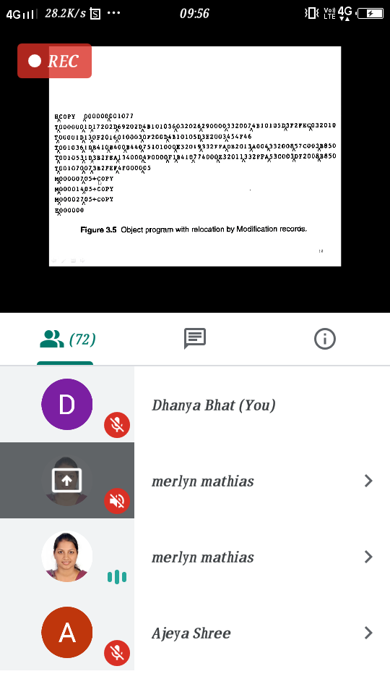

Today in this session I studied some concept of SSCD.

Coding Challenges Details: (Attach the snapshot and briefly write the report for the same)

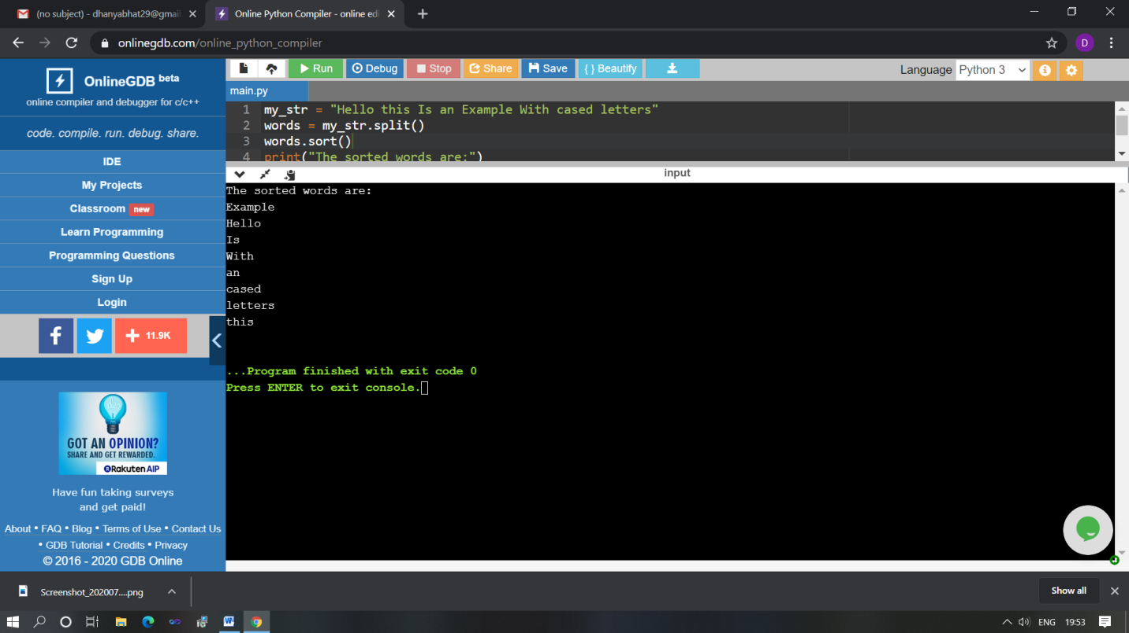

The above Programs were written and executed and the output of the same is displayed above. The code for those 1 programs have been uploaded to the github repository and the link to the same is provided on the form.