**DAILY ASSESSMENT**

|  |  |  |  |
| --- | --- | --- | --- |
| **Date:** | **10/07/2020** | **Name:** | **Dhavala** |
| **Course:** | **Introduction to internet of things** | **USN:** | **4AL17EC027** |
| **Topic:** | * **Educational and Business oppurtunities** | **Semester & Section:** | **6TH SEM & A Section** |
| **Github Repository:** | **Dhavala27** |  |  |

|  |
| --- |
| **SESSION DETAILS**      **Challenges in the digitized world**  The IoT provides many benefits but at the same time it presents many challenges. Since the IoT is a transformational technology, we are now faced with an ever expanding collection of new technology that we must master. The IoT is changing every aspect of our lives.  This is not the first time we have experienced a technological development that has such an impact. Mechanization on the farm allowed increased productivity of available farmland and started the migration of the population from rural to urban areas. The development of the automobile allowed for greater mobility of the workforce and increased recreational activities. The personal computer allowed the automation of many routine tasks with improved accuracy and efficiency. The Internet started to break down geographic barriers and improve equality between people on a global scale. These are only a few of the transformational technologies that we have experienced in recent history.  Every one of these technologies presented major changes to an established society and was met with initial fear and apprehension. After the initial fear of the unknown was overcome and the technology was embraced, the inherent benefits became obvious. Each perceived challenge opens up many new opportunities.  **community of interest**  A community of interest is a group of people who share a common interest or passion about a specific topic. These people get together to share information and ideas about this topic.  This shared interest allows the group to develop into a true community. Members of these communities are extremely knowledgeable and passionate about the topic being discussed and are willing to share their knowledge with other community members. This makes the community an excellent resource for the development of the area of interest.  The Internet allows these communities to exist virtually and span several geographic areas and time zones. Members can share files and technology in real time.Some communities are supported by industry and provide a place to help development of their products and technology, as well as those of their business partners. Two such communities provided by Cisco are the Cisco Learning Network and Cisco DevNet.  The Cisco Learning Network is a collection of resources, information, and discussion forums. It is designed for people who wish to develop their skills in various Cisco technologies and pursue Cisco certification. To see what the Cisco Learning Network has to offer and to become a member, visit their website at [learningnetwork.cisco.com](https://learningnetwork.cisco.com/welcome).  When looking for a degree to pursue at a community college or university that will pertain to the skillsets needed for a career in the IoT, watch for some of the following degrees:   * Business Intelligence * Computer Information Systems * Computer Programming * Computer Science * Database Administration * Electromechanical Automation * Electronics Engineering * Linux Networking * Machining * Network Administration * System Analysis * Web Server Administrator   This is not an exhaustive list. Even traditional degree programs such as supply chain management, business, and project management are helpful for careers in IoT. Computer-Aided Design (CAD), drafting, math, and physics are applicable and show a diverse education, which is perfect for an IoT career.  IT, opportunities may be specific to fog computing, developing new processes, or a specialization in a discipline that has not yet been realized. These jobs reflect skills spanning multiple disciplines that include computer science, computer engineering (a blend of computer science and electrical engineering), and software engineering. There are broad categories that summarize the job opportunities that exist in the evolving digitized world:  • **Enablers** – These jobs develop and implement the underlying technology.  • **Engagers** –These jobs design, create, integrate, and deliver IoT services to customers.  • **Enhancers** – These jobs devise their own value-added services, on top of the services provided by Engagers, which are unique to the Internet of Things.  An entrepreneurial workforce is needed that specializes in both information science and software or computer engineering. The Cisco Networking Academy Program has trained more than five million students to date. Many graduates have gone on to successful IT careers in a variety of industries, while others have harnessed the entrepreneurial spirit and knowledge they acquired to start their own businesses and create new jobs. Go to [www.netacad.com](http://www.netacad.com/) to see the variety of courses offered.  There are two basic types of certification available: vendor-specific and vendor-neutral. Vendor-specific certifications are tailored to technologies offered by a company to prove that an individual is qualified to deploy and manage that technology. Vendor-neutral certifications are offered by many different organizations. Certifications can show an employer that an individual has the appropriate skills for a job. Community college or university degrees can show that a person has gained a broad understanding in a field of study. This broad understanding creates a solid foundation for emerging career opportunities in the IoT. |

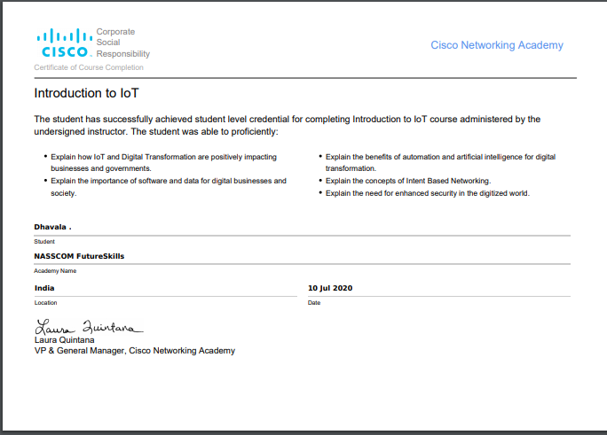

**DAILY ASSESSMENT**

|  |  |  |  |
| --- | --- | --- | --- |
| **Date:** | **10/07/2020** | **Name:** | **Dhavala** |
| **Course:** | **Coursera**  **Mathematics for Machine learning: Linear algebra** | **USN:** | **4AL17EC027** |
| **Topic:** | **Introduction to Linear Algebra and to Mathematics for Machine Learning** | **Semester & Section:** | **6TH SEM & A Section** |
| **Github Repository:** | **Dhavala27** |  |  |

|  |
| --- |
| **SESSION DETAILS**          **Machine learning**  Machine learning is a set of powerful mathematical tools that enable us, to represent, interpret, and control the complex world around us. However, even just the word mathematics makes some people feel uneasy and unwelcome to explore the topic. The purpose of this specialization is to take you on a tour through the basic maths underlying these methods, focusing in particular on building your intuition rather than worrying too much about the details. Thanks to the amazing machine learning community, it's actually possible to apply many powerful machine learning methods without understanding very much about the underpinning mathematics, by using open source libraries. This is great, but problems can arise and without some sense of the language and meaning of the relevant maths, you can struggle to work out what's gone wrong or how to fix it. The ideal outcome of this specialization is that it will give you the confidence and motivation to immediately dive into one of the hundreds of boolean applied machine learning courses already available online, and not be intimidated by the matrix notation or the calculus. We want to open up machine learning to as many people as possible, and not just leave all the fun to computer scientists.    **Motivations for linear algebra**  The first problem I might think of is one of price discovery. Say I go shopping on two occasions, and I buy apples and bananas, and the first time I buy two apples and three bananas and they cost eight Euros. And the second time I buy say, ten apples and one banana, and the cost is 13 Euros. And the As and the Bs here, are the price of a single apple and a single banana. And what I'm going to have to do is solve these what we call  simultaneous equations in order to discover the price of individual apples and bananas.  Now in the general case of lots of different types of items and lots of shopping trips,  then finding out the prices might be quite hard. It might be quite difficult to solve all these equations by hand. So, we might want a computer algorithm to do it for us, in the general case. Now, this is an example of a Linear Algebra problem. I have some constant linear coefficients here, these numbers 2, 10, 3, 1, that relate the input variables A and B,  to the output 8 and 13, that is if I think about a vector [a,b], that describes the prices of apples and bananas.   Then this gets translated into a cost, to find out how many I might want to buy, and the cost happens to be 8 on the first trip, and 13 Euros on the second trip.  And I can write this down as a matrix problem where the 2, 3 is my first trip, and the 10, 1 is my second trip, and then these are then matrices, that's a matrix then, and these are vectors, and what we're going to do over the course of modules one to three, is build up,  Looking at these different types of mathematical objects, and understanding what they are and how to work with them, these vectors and these matrices. And then, we'll come back and figure out how to solve this problem in the general case. Another type of problem we might be interested in is fitting an equation to some data. In fact, with neural networks and machine learning, we want the computer in effect not only to fit the equation, but to figure out what equation to use.   That's a highly inexact description really of what's going on,  but it gives the right sort of flavor. But let's say, we have some data like this histogram here. This looks like a population with an average and some variation here, some width.  Another type of problem we might want to solve, as well as the apples and bananas problem, is how to find the optimal value of the parameters in the equation describing this line. The ones that fit the data in the histogram best. That might be really handy, then using that equation we'd have an easy portable description of the population we could carry around, without needing all the original data which would free us, for example, from privacy concerns. **Getting a handle on vectors** If we could find what the steepest way down the hill was, then we could go down this set of contours, this sort of landscape here towards the minimum point, towards the point where get the best possible fit. And what we're doing here, these are vectors, these are little moves around space. They're not moves around a physical space, they're moves around a parameter space, but it's the same thing. So if we understand vectors and we understand how to get down hills, that sort of curviness of this value of goodness, that's calculus.  Then once we got calculus and vectors, we'll be able to solve this sort of problem. So we can see that vectors don't have to be just geometric objects in the physical order of space.  They can describe directions along any sorts of axes. So we can think of vectors as just being lists. If we thought of the space of all possible cars, for example. So here's a car.  There's its back, there's its window, there's the front, something like that. There's a car, there's the window. We could write down in a vector all of the things about the car.  We could write down its cost in euros. We could write down its emissions performance in grams of CO2 per 100 kilometers. We could write down its Nox performance, how much it polluted our city and killed people due to air pollution. We could write down its Euro NCAP star rating, how good it was in a crash. We could write down its top speed. And write those all down in a list that was a vector. That'd be more of a computer science view of vectors,  whereas the spatial view is more familiar from physics. In my field, metallurgy, I could think of any alloy as being described by a vector that describes all of the possible components,  all the compositions of that alloy. Einstein, when he conceived relativity, conceived of time as just being another dimension. So space-time is a four dimensional space, three dimension of metres, and one of time in seconds. And he wrote those down as a vector of space-time of x, y, z, and time which he called space-time. When we put it like that, it's not so crazy to think of the space of all the fitting parameters of a function, and then of vectors as being things that take us around that space. And what we're trying to do then is find the location in that space, where the badness is minimized, the goodness is maximized, and  the function fits the data best. If the badness surface here was like a contour map of a landscape, we're trying to find the bottom of the hill, the lowest possible point in the landscape. So to do this well, we'll want to understand how to work with vectors and  then how to do calculus on those vectors in order to find gradients in these contour maps and minima and all those sorts of things. Then we'll be able to go and do optimizations, enabling us to go and work with data and do machine learning and data science. |