**DAILY ASSESSMENT**

|  |  |  |  |
| --- | --- | --- | --- |
| **Date:** | **13/07/2020** | **Name:** | **Dhavala** |
| **Course:** | **Revision** | **USN:** | **4AL17EC027** |
| **Topic:** | **AMES** | **Semester & Section:** | **6TH SEM & A Section** |
| **Github Repository:** | **Dhavala27** |  |  |

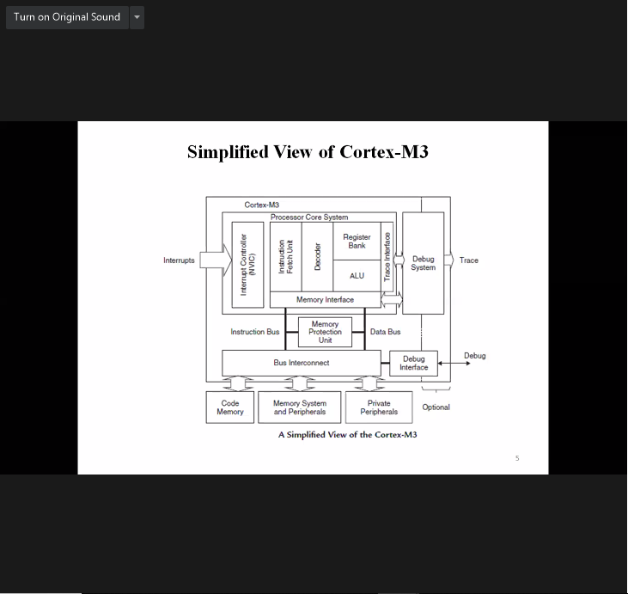

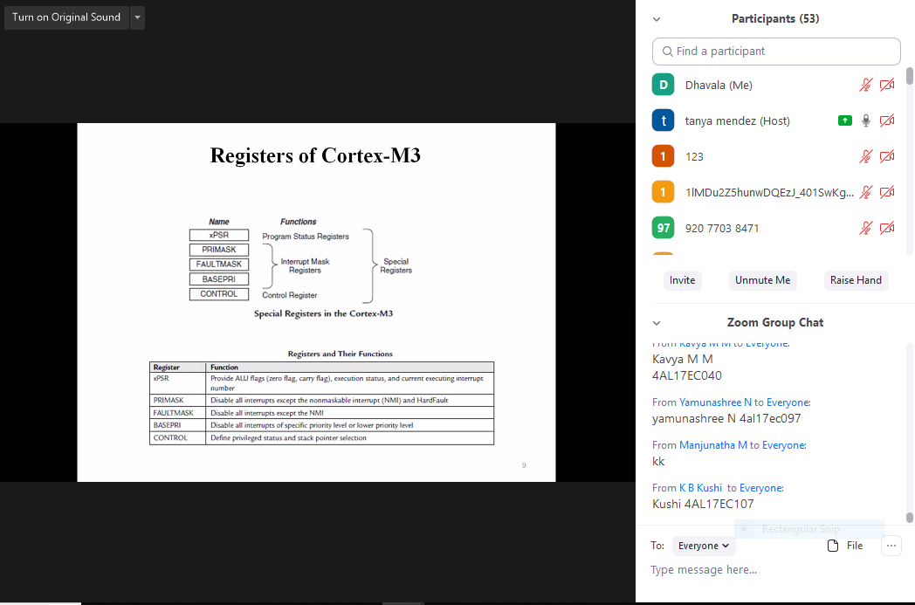

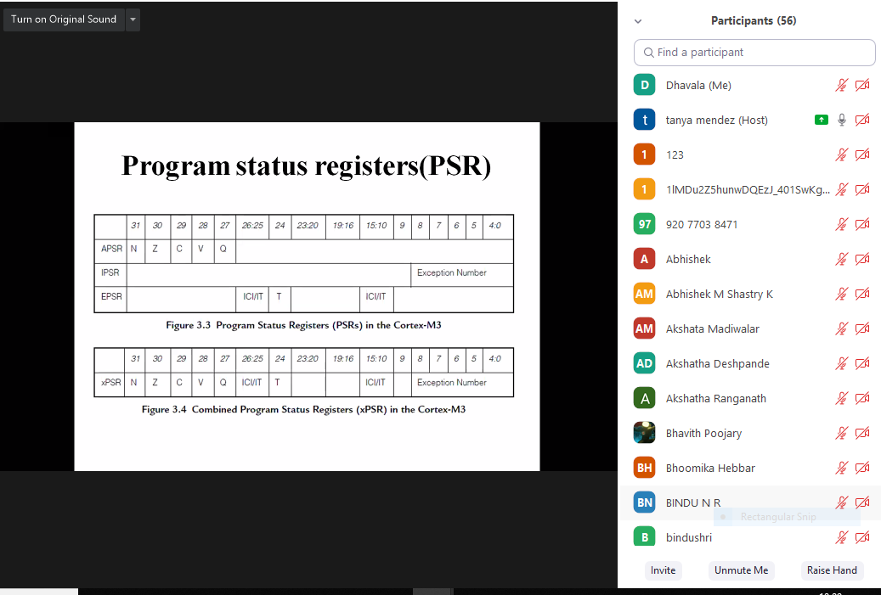

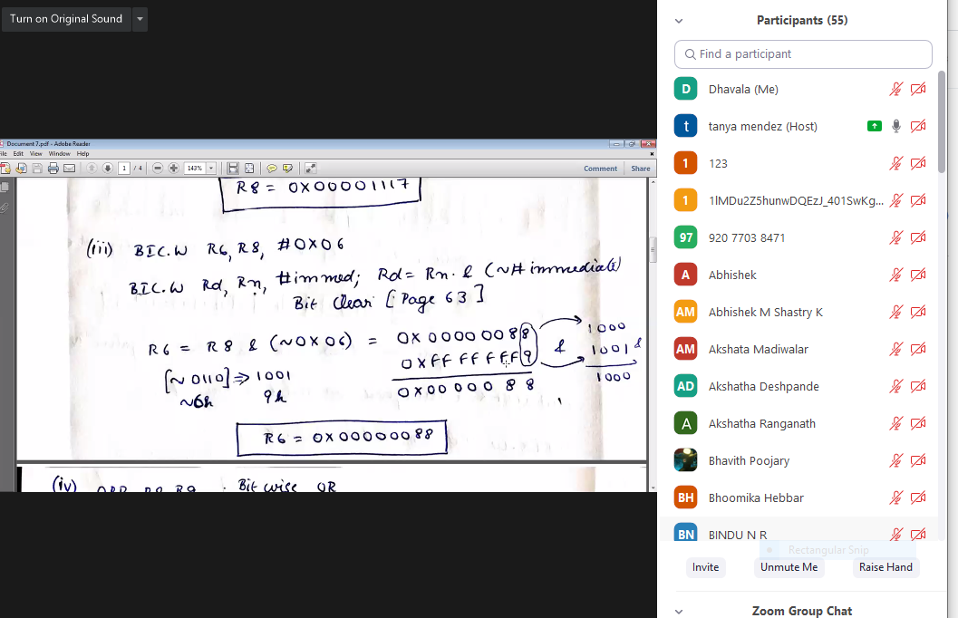

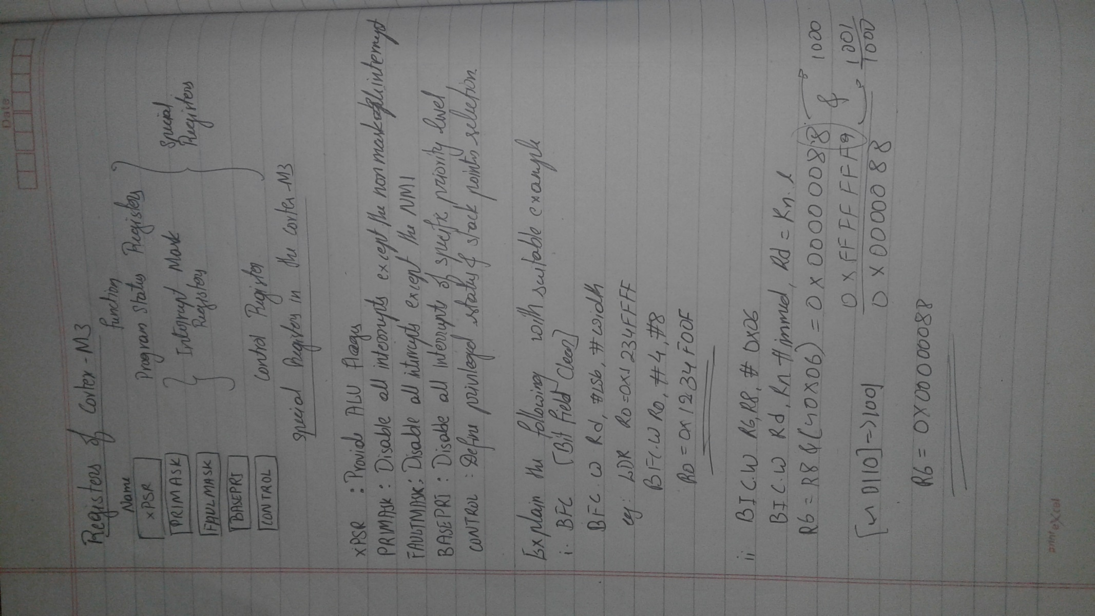

**DAILY ASSESSMENT**

|  |  |  |  |
| --- | --- | --- | --- |
| **Date:** | **13/07/2020** | **Name:** | **Dhavala** |
| **Course:** | **Coursera**  **Mathematics for Machine learning: Linear algebra** | **USN:** | **4AL17EC027** |
| **Topic:** | **Introduction to Linear Algebra and to Mathematics for Machine Learning** | **Semester & Section:** | **6TH SEM & A Section** |
| **Github Repository:** | **Dhavala27** |  |  |

|  |
| --- |
| **SESSION DETAILS**          **Machine learning**  Machine learning is a set of powerful mathematical tools that enable us, to represent, interpret, and control the complex world around us. However, even just the word mathematics makes some people feel uneasy and unwelcome to explore the topic. The purpose of this specialization is to take you on a tour through the basic maths underlying these methods, focusing in particular on building your intuition rather than worrying too much about the details. Thanks to the amazing machine learning community, it's actually possible to apply many powerful machine learning methods without understanding very much about the underpinning mathematics, by using open source libraries. This is great, but problems can arise and without some sense of the language and meaning of the relevant maths, you can struggle to work out what's gone wrong or how to fix it. The ideal outcome of this specialization is that it will give you the confidence and motivation to immediately dive into one of the hundreds of boolean applied machine learning courses already available online, and not be intimidated by the matrix notation or the calculus. We want to open up machine learning to as many people as possible, and not just leave all the fun to computer scientists.    **Motivations for linear algebra**  The first problem I might think of is one of price discovery. Say I go shopping on two occasions, and I buy apples and bananas, and the first time I buy two apples and three bananas and they cost eight Euros. And the second time I buy say, ten apples and one banana, and the cost is 13 Euros. And the As and the Bs here, are the price of a single apple and a single banana. And what I'm going to have to do is solve these what we call  simultaneous equations in order to discover the price of individual apples and bananas.  Now in the general case of lots of different types of items and lots of shopping trips,  then finding out the prices might be quite hard. It might be quite difficult to solve all these equations by hand. So, we might want a computer algorithm to do it for us, in the general case. Now, this is an example of a Linear Algebra problem. I have some constant linear coefficients here, these numbers 2, 10, 3, 1, that relate the input variables A and B,  to the output 8 and 13, that is if I think about a vector [a,b], that describes the prices of apples and bananas.   Then this gets translated into a cost, to find out how many I might want to buy, and the cost happens to be 8 on the first trip, and 13 Euros on the second trip.  And I can write this down as a matrix problem where the 2, 3 is my first trip, and the 10, 1 is my second trip, and then these are then matrices, that's a matrix then, and these are vectors, and what we're going to do over the course of modules one to three, is build up,  Looking at these different types of mathematical objects, and understanding what they are and how to work with them, these vectors and these matrices. And then, we'll come back and figure out how to solve this problem in the general case. Another type of problem we might be interested in is fitting an equation to some data. In fact, with neural networks and machine learning, we want the computer in effect not only to fit the equation, but to figure out what equation to use.   That's a highly inexact description really of what's going on,  but it gives the right sort of flavor. But let's say, we have some data like this histogram here. This looks like a population with an average and some variation here, some width.  Another type of problem we might want to solve, as well as the apples and bananas problem, is how to find the optimal value of the parameters in the equation describing this line. The ones that fit the data in the histogram best. That might be really handy, then using that equation we'd have an easy portable description of the population we could carry around, without needing all the original data which would free us, for example, from privacy concerns. **Getting a handle on vectors** If we could find what the steepest way down the hill was, then we could go down this set of contours, this sort of landscape here towards the minimum point, towards the point where get the best possible fit. And what we're doing here, these are vectors, these are little moves around space. They're not moves around a physical space, they're moves around a parameter space, but it's the same thing. So if we understand vectors and we understand how to get down hills, that sort of curviness of this value of goodness, that's calculus.  Then once we got calculus and vectors, we'll be able to solve this sort of problem. So we can see that vectors don't have to be just geometric objects in the physical order of space.  They can describe directions along any sorts of axes. So we can think of vectors as just being lists. If we thought of the space of all possible cars, for example. So here's a car.  There's its back, there's its window, there's the front, something like that. There's a car, there's the window. We could write down in a vector all of the things about the car.  We could write down its cost in euros. We could write down its emissions performance in grams of CO2 per 100 kilometers. We could write down its Nox performance, how much it polluted our city and killed people due to air pollution. We could write down its Euro NCAP star rating, how good it was in a crash. We could write down its top speed. And write those all down in a list that was a vector. That'd be more of a computer science view of vectors,  whereas the spatial view is more familiar from physics. In my field, metallurgy, I could think of any alloy as being described by a vector that describes all of the possible components,  all the compositions of that alloy. Einstein, when he conceived relativity, conceived of time as just being another dimension. So space-time is a four dimensional space, three dimension of metres, and one of time in seconds. And he wrote those down as a vector of space-time of x, y, z, and time which he called space-time. When we put it like that, it's not so crazy to think of the space of all the fitting parameters of a function, and then of vectors as being things that take us around that space. And what we're trying to do then is find the location in that space, where the badness is minimized, the goodness is maximized, and  the function fits the data best. If the badness surface here was like a contour map of a landscape, we're trying to find the bottom of the hill, the lowest possible point in the landscape. So to do this well, we'll want to understand how to work with vectors and  then how to do calculus on those vectors in order to find gradients in these contour maps and minima and all those sorts of things. Then we'll be able to go and do optimizations, enabling us to go and work with data and do machine learning and data science. |

**DAILY ASSESSMENT**

|  |  |  |  |
| --- | --- | --- | --- |
| **Date:** | **13/07/2020** | **Name:** | **Dhavala** |
| **Course:** |  | **USN:** | **4AL17EC027** |
| **Topic:** | * **Meet the Salesforce Platform** | **Semester & Section:** | **6TH SEM & A Section** |
| **Github Repository:** | **Dhavala27** |  |  |

|  |
| --- |
| **SESSION DETAILS**     Meet the Salesforce Platform At Salesforce, we group our services by clouds. There’s Sales Cloud for CRM, Service Cloud for customer support, and a handful of other clouds that help companies support their business functions. And while each of these clouds serves a unique purpose, there’s one thing they all have in common: the power of the Salesforce platform.  What is the Salesforce platform, exactly?  Like any platform, the Salesforce platform is a group of technologies that supports the development of other technologies on top of it. What makes it unique is that the platform supports not only all the Salesforce clouds, but it also supports custom functionality built by our customers and partners. This functionality ranges from simple page layouts to full-scale applications.  If you’re here today, we’re assuming you know a bit about software development. Throughout this module, we’re going to give you an overview of development on the Salesforce platform. We talk about some of the pillars of Salesforce development and how they work together to create a robust system. We even touch on some common questions that developers new to the platform run into as they get started.  **Platform Building Blocks**  As we mentioned, the platform not only forms the foundation of core Salesforce products like Sales Cloud and Service Cloud, but it also lets you build your own functionality. Building your own functionality can mean customizing existing Salesforce offerings or it can mean building something from scratch. Let’s focus on that latter part and talk about what the Salesforce platform offers developers.  Our core platform lets you develop custom data models and applications for desktop and mobile. And with the platform behind your development, you can build robust systems at a rapid pace. And then there’s the Heroku platform. Heroku gives developers the power to build highly scalable web apps and back-end services using Python, Ruby, Go, and more. It also provides database tools to sync seamlessly with data from Salesforce.  And then there’s the host of Salesforce APIs. These let developers integrate and connect all their enterprise data, networks, and identity information. And then there’s the Mobile SDK. The Mobile SDK is a suite of technologies that lets you build native, HTML5, and hybrid apps that have the same reliability and security as the Salesforce app. The problem with the platform and all its parts is that listing them out takes a really long time. And just talking about them doesn’t help you understand everything they do. Let’s take a different approach and talk about what we can do with the platform. Or, more precisely, what we can build with it. |