**DAILY ASSESSMENT**

|  |  |  |  |
| --- | --- | --- | --- |
| **Date:** | **07/07/2020** | **Name:** | **Dhavala** |
| **Course:** | **Matlab** | **USN:** | **4AL17EC027** |
| **Topic:** | * **Indexing into and Modifying Arrays** * **Array Calculations** | **Semester & Section:** | **6TH SEM & A Section** |
| **Github Repository:** | **Dhavala27** |  |  |

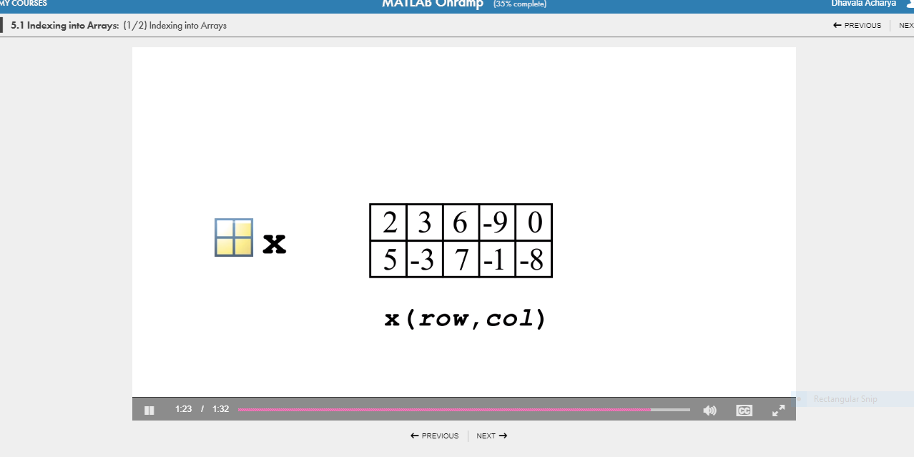

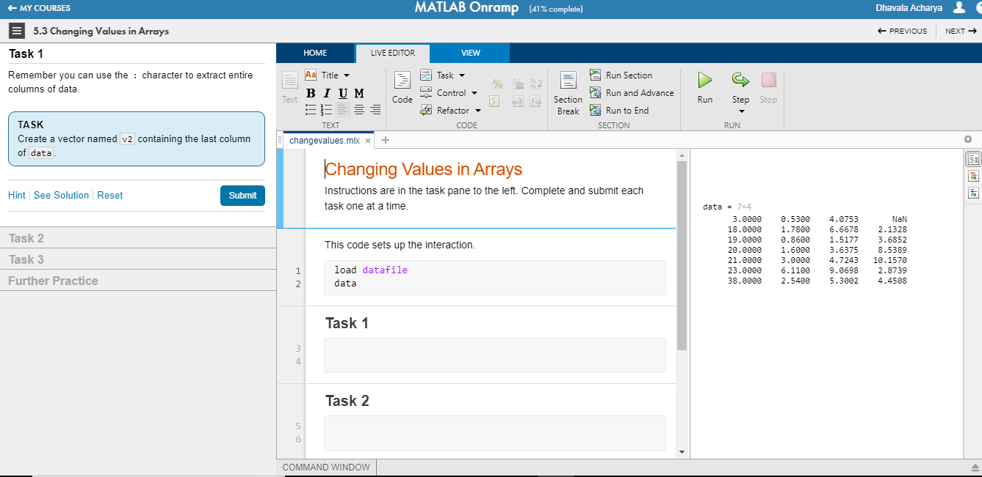

|  |
| --- |
| **SESSION DETAILS**  Vectors and matrices combine separate scalar data into a single, multidimensional signal. Modify individual elements or perform arithmetic on entire vectors and matrices. In C charts, use MATLAB functions to perform standard matrix multiplication and division.  MATLAB is an abbreviation for "matrix laboratory." While other programming languages mostly work with numbers one at a time, MATLAB® is designed to operate primarily on whole matrices and arrays.  All MATLAB variables are multidimensional arrays, no matter what type of data. A  Matrix is a two-dimensional array often used for linear algebra.  a = [1 2 3 4]  a = 1×4  1 2 3 4  a = [1 2 3; 4 5 6; 7 8 10]  a =  3×3  1 2 3  4 5 6  7 8 10  Another way to create a matrix is to use a function, such as ones, zeros, or rand  For example, create a 5-by-1 column vector of zeros.  z = zeros(5,1)  z = 5×1  0  0  0  0  0  Array indexing  Every variable in MATLAB is an array that can hold many numbers. When you want to access selected elements of an array, use indexing.  For example, consider the 4-by-4 magic square A  A = magic(4)  A = 4×4  16 2 3 13  5 11 10 8  9 7 6 12  4 14 15 1  A(4,2)  ans = 14  Less common, but sometimes useful, is to use a single subscript that traverses down each column in order:  A(8)  ans = 14  Using a single subscript to refer to a particular element in an array is called  linear indexing.  . |

|  |  |  |  |
| --- | --- | --- | --- |
| **Date:** | **07/07/2020** | **Name:** | **Dhavala** |
| **Course:** | **Introduction to IOT** | **USN:** | **4AL17EC027** |
| **Topic:** | * Introduction * Everything is connected * Everything becomes programmable | **Semester & Section:** | **6TH SEM & A Section** |
| **Github Repository:** | **Dhavala27** |  |  |

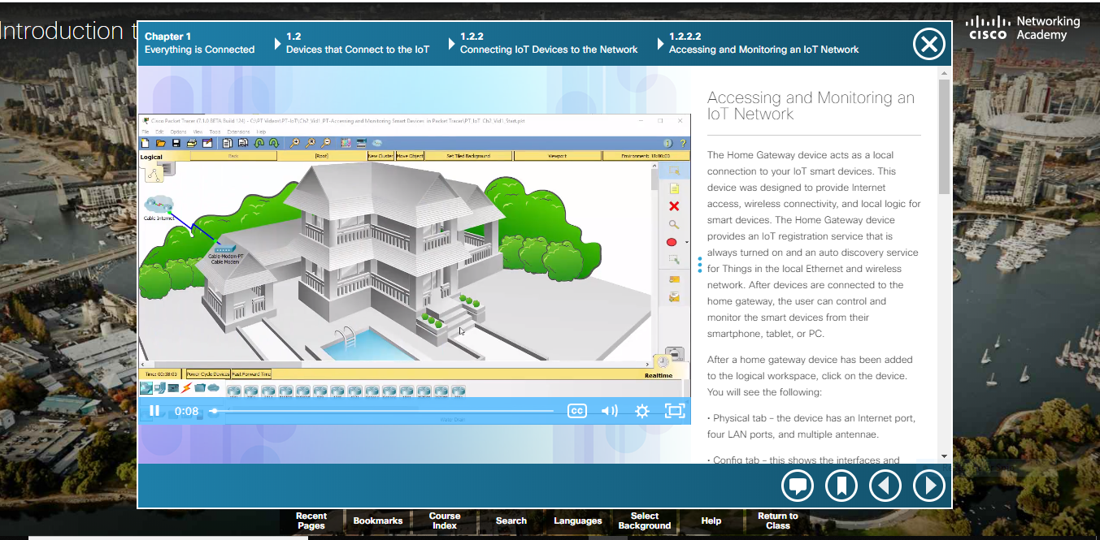

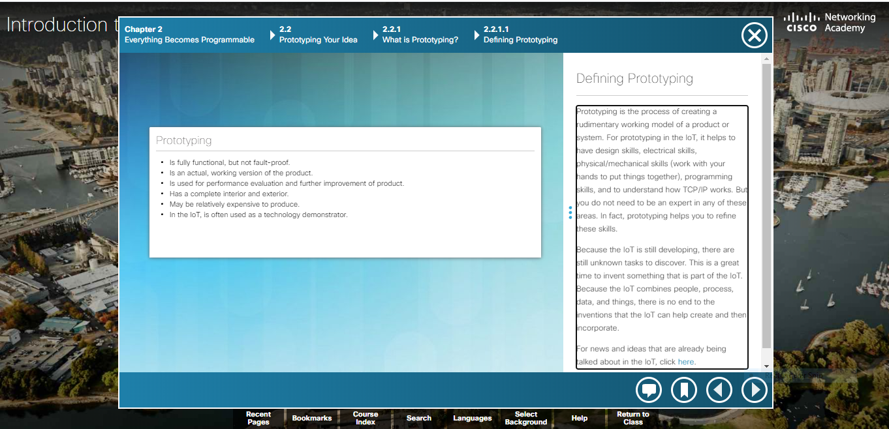

|  |
| --- |
| **SESSION DETAILS**  The Evolution of Digital Transformation  In our world today, there are more smart devices than there are people. A growing number of people are connected to the Internet, in one way or another, 24 hours a day. An ever-increasing number of people have, and rely on, three, four, or more smart devices. These might include smartphones, exercise and health monitors, e-readers, and tablets. As shown in Figure 1, by 2020, it is forecast that each consumer will have an average of 6.58 smart devices.  How is it possible for so many devices to be connected? Modern digital networks make all of this possible. The world is quickly being covered with networks that allow digital devices to interconnect and transmit. Think of the mesh of networks like a digital skin surrounding the planet, as illustrated in Figure 2. With this digital skin, mobile devices, electronic sensors, electronic measuring devices, medical devices, and gauges are all able to connect. They monitor, communicate, evaluate, and in some cases automatically adjust to the data that is being collected and transmitted.  As society embraces these digital devices, as digital networks continue to grow around the world, and as the economic benefits of digitization continue to grow, we are seeing a digital transformation. Digital transformation is the application of digital technology to provide the stage for business and industry to innovate. This digital innovation is now being applied to every aspect of human society.  How are IOT Devices connected to the network?  A sensor needs to be connected to a network so that the gathered data can be stored and shared. This requires either a wired Ethernet connection or a wireless connection to a controller. Controllers are responsible for collecting data from sensors and providing network or Internet connectivity. Controllers may have the ability to make immediate decisions, or they may send data to a more powerful computer for analysis. This more powerful computer might be in the same LAN as the controller or might only be accessible through an Internet connection.  Sensors often work together with a device called an actuator. Actuators take electrical input and transform the input into physical action. As an example, if a sensor detects excess heat in a room, the sensor sends the temperature reading to the microcontroller. The microcontroller can send the data to an actuator which would then turn on the air conditioner.  The majority of new devices such as fitness wearables, implanted pacemakers, air meters in a mine shaft, and water meters in a farm field all require wireless connectivity. Because many sensors are “out in the field” and are powered by batteries or solar panels, consideration must be given to power consumption. Low-powered connection options must be used to optimize and extend the availability of the sensor.  Prototyping  Prototyping is the process of creating a rudimentary working model of a product or system. For prototyping in the IoT, it helps to have design skills, electrical skills, physical/mechanical skills (work with your hands to put things together), programming skills, and to understand how TCP/IP works. But you do not need to be an expert in any of these areas. In fact, prototyping helps you to refine these skills.  The world is quickly being covered with networks which allow digital devices to interconnect and transmit. As digital networks continue to grow around the world, and as the economic benefits of digitization continue to grow, we are seeing a digital transformation. Digital transformation is the application of digital technology to provide the stage for business and industry to innovate.  Sensors are now everywhere, collecting and transmitting massive amounts of data. The generated data can be stored and analyzed at a later date, or it can be analyzed and used immediately. Sensors can be in the home, on traffic lights, in farm fields, and on our bodies. The analyzed data is used by governments, cities, businesses, and individuals to effect changes such as monitoring the environment, forecasting population growth, controlling waste management, or securing a home.  Networks form the foundation of the digitized world. There are many types of networks that are characterized by their geographic size, by the number of devices or networks that they connect, and by whether they support mobile devices or not. Networks can also be characterized by their function and purpose.   * PAN: Bluetooth * LAN * WAN: Internet, the cloud, fog computing * Wireless: Wi-Fi, Cellular   A sensor typically connects to a controller using a wireless connection. Controllers collect data from sensors and send the data for storage or analysis. Controllers may have the ability to make immediate decisions, or they may work together with a device called an actuator. Actuators take electrical input and transform the input into physical action.  Networks are now connecting billions of sensors and have the ability to make changes to physical environments without human intervention. The future of networking will revolve around artificial intelligence (AI) and intent-based networking (IBN). If programmed appropriately, smart devices are able to evaluate data that is provided to them and modify processes or settings. If they are provided with sufficient data, they can “learn” and modify their own code based on the new parameters. |