**DAILY ASSESSMENT**

|  |  |  |  |
| --- | --- | --- | --- |
| **Date:** | **08/07/2020** | **Name:** | **Dhavala** |
| **Course:** | **Matlab** | **USN:** | **4AL17EC027** |
| **Topic:** | * **Calling Functions** * **Obtaining Help** * **Plotting Data** * **Review Problems** * **Importing Data** * **Logical Arrays** * **Programming** * **Final Project** * **Conclusion** | **Semester & Section:** | **6TH SEM & A Section** |
| **Github Repository:** | **Dhavala27** |  |  |

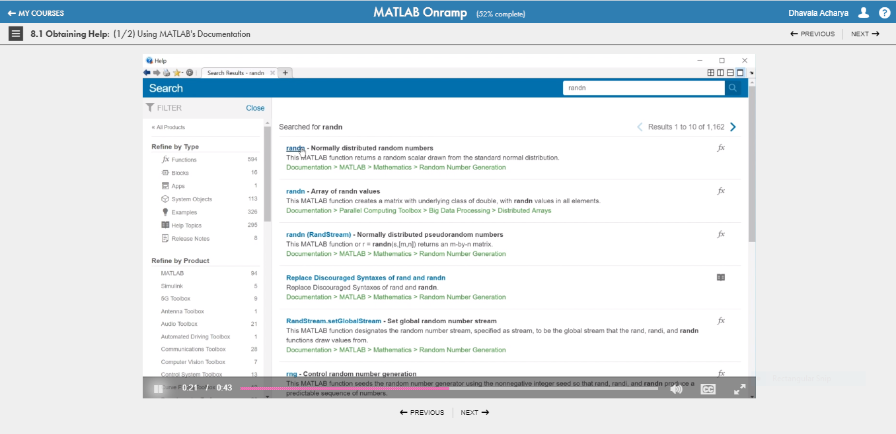

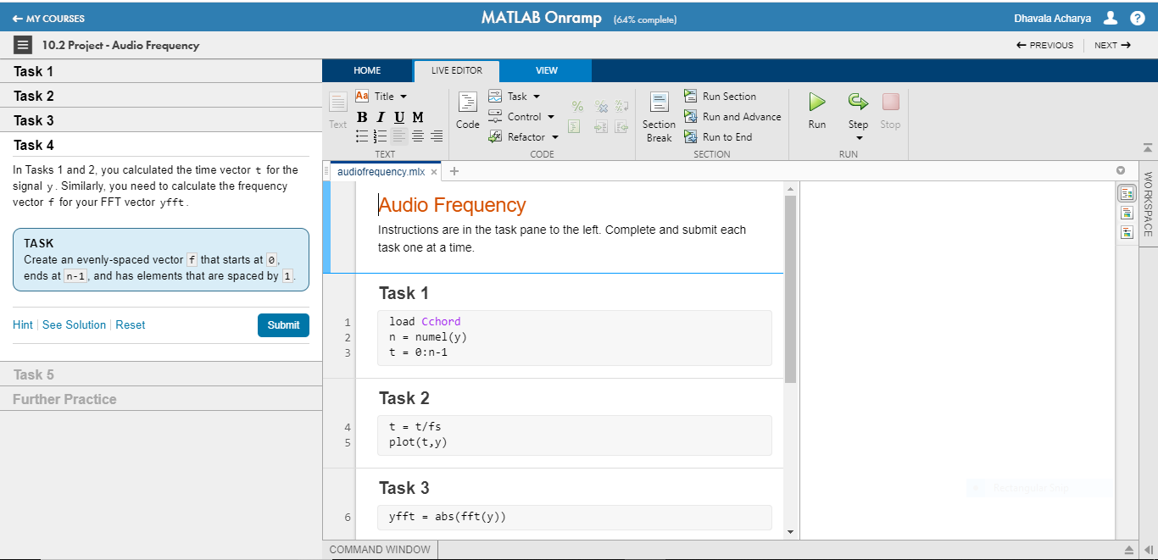

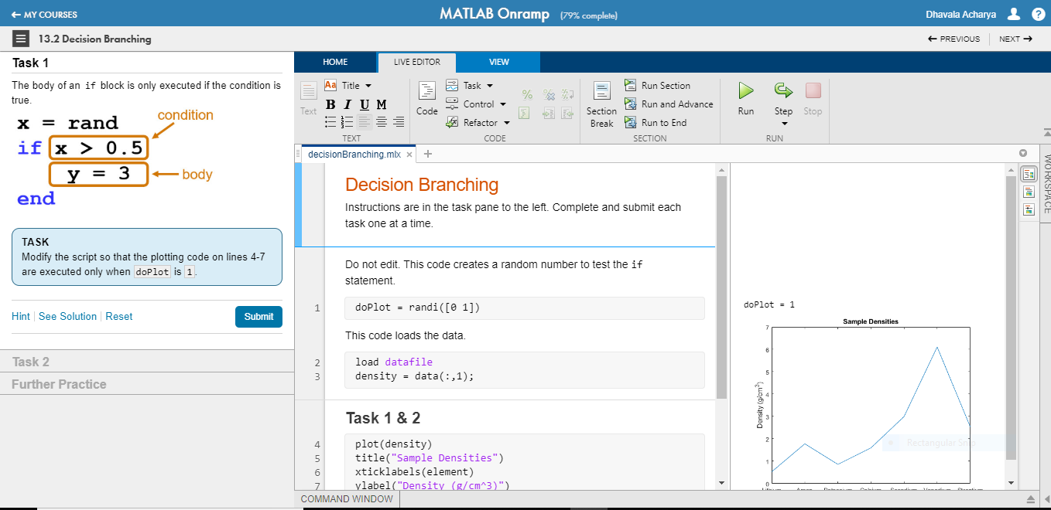

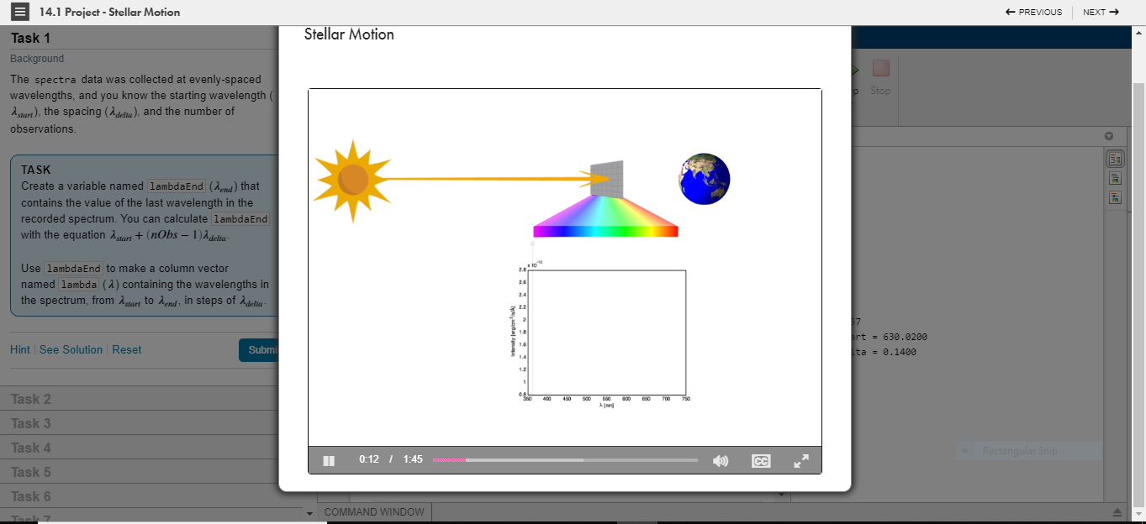

|  |
| --- |
| **SESSION DETAILS**  **Calling Functions**  The size function can be applied to an array to produce a single output variable containing the array size. s = size(x)  The size function can be applied to a matrix to produce either a single output variable or two output variables. Use square brackets ([ ]) to obtain more than one output. [xrow,xcol] = size(x)  The maximum value of a vector and its corresponding index value can be determined using the max function. The first output from the max function is the maximum value of the input vector. When called with two outputs, the second output is the index value. [xMax,idx] = max(x)  **Obtaining Help**  The MATLAB documentation contains examples and information that can help you when working on your own problems.  **Plotting Data**  Two vectors of the same length can be plotted against each other using the plot function.  plot(x,y) The plot function accepts an additional argument that allows you to specify the color, line style, and marker style using different symbols in single quotes. plot(x,y,"r--o")  The command above plots a red (r) dashed (--) line with a circle (o) as a marker. You can learn more about the symbols available in the documentation for [Line Specification](http://www.mathworks.com/help/matlab/ref/linespec.html). While the hold state is on, plots will continue to go on the same axes. To return to the default plot behavior, where each plot gets its own axes, enter hold off.  When you plot a single vector by itself, MATLAB uses the vector values as the *y-axis* data and sets the *x-axis* data to range from 1 to n (the number of elements in the vector)  **Annotating Plots**  Labels can be added to plots using plot annotation functions, such as title. The input to these functions is a string. Strings in MATLAB are enclosed in double quotes ("). title("Plot Title")  You can add a legend to your plot using the legend function. legend("a","b","c")  **Review Problems**  In MATLAB, NaN (or, "Not a Number") is used to represent missing data.  The usage data was collected annually between the years 1991 to 2013. The yrs variable you create will help you to plot the data over a meaningful range  **Audio Frequency**  Audio signals are usually comprised of many different frequencies. For example, in music, the note 'middle C' has a fundamental frequency of 261.6 Hz, and most music consists of several notes (or frequencies) being. In this project, you will analyze the frequency content of an organ playing the C chord.  The C chord consists of the C (261.6 Hz), E (329.6 Hz), and G (392.0 Hz) notes. The highlighted points in this frequency plot correspond to each note.  The C chord recording is stored in a file named Cchord.mat. This file contains two variables:   * y: signal from recording * fs: sampling frequency   This task uses the numel function to return the number of elements in an array.  In the plot, notice that y is periodic, but it's not a simple sine wave. It's made up of multiple sine waves with different frequencies. A Fourier transform will return information about the frequency content of the signal. The location of the dominant frequencies will show what notes are contained in the chord. You can use the fft function to compute the discrete Fourier transform of a vector. fft(y)  The output values from fft are complex numbers. You can use the abs function to get the magnitude.  The vector f now contains n points. To convert these points to frequencies, you can multiply the entire vector by the sampling frequency (fs) and divide it by the number of points (n). f will contain frequences from 0 to fs. The dominant frequencies are located at the beginning of f. You can use the xlim function to zoom in on the area of interest. xlim([*xmin* *xmax*])  **Importing Data**  To extract a variable from the table, you can use *dot notation*:  *data.VariableName*  If you are working with a table, you might want to keep related data together. Instead of creating separate variables, you can assign the result of a calculation to a table. *data.HeightMeters* = *data.HeightYards*\*0.9144  If the variable *data.HeightMeters* doesn't exist, MATLAB will create a new variable in the table with the name HeightMeters.  You can interact with a table by clicking on it in the output pane of a live script. For example, you can sort a table using one of its variables.  Once you are happy with your table, you can make the changes permanent by updating the code in your script. |

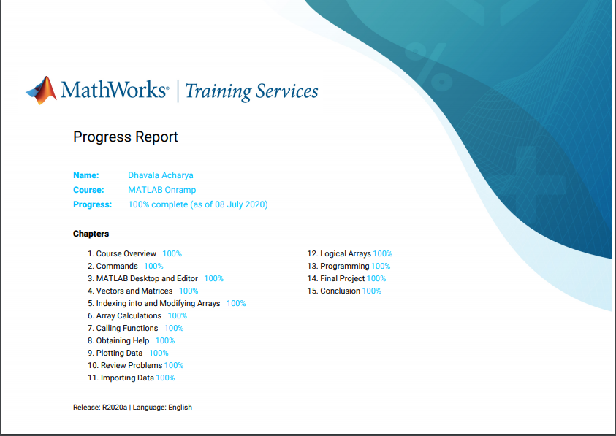

**DAILY ASSESSMENT**

|  |  |  |  |
| --- | --- | --- | --- |
| **Date:** | **08/07/2020** | **Name:** | **Dhavala** |
| **Course:** | **Introduction to internet of things** | **USN:** | **4AL17EC027** |
| **Topic:** | * **Everything generates data** * **Everything can be automated** | **Semester & Section:** | **6TH SEM & A Section** |
| **Github Repository:** | **Dhavala27** |  |  |

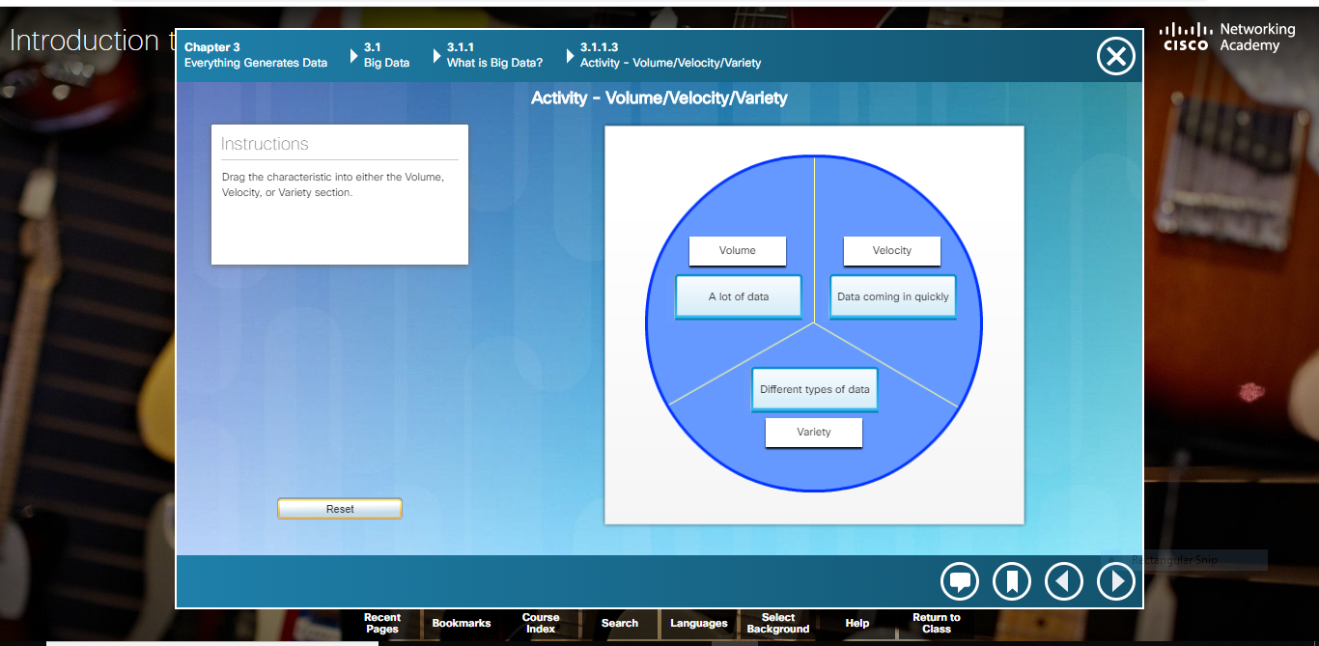

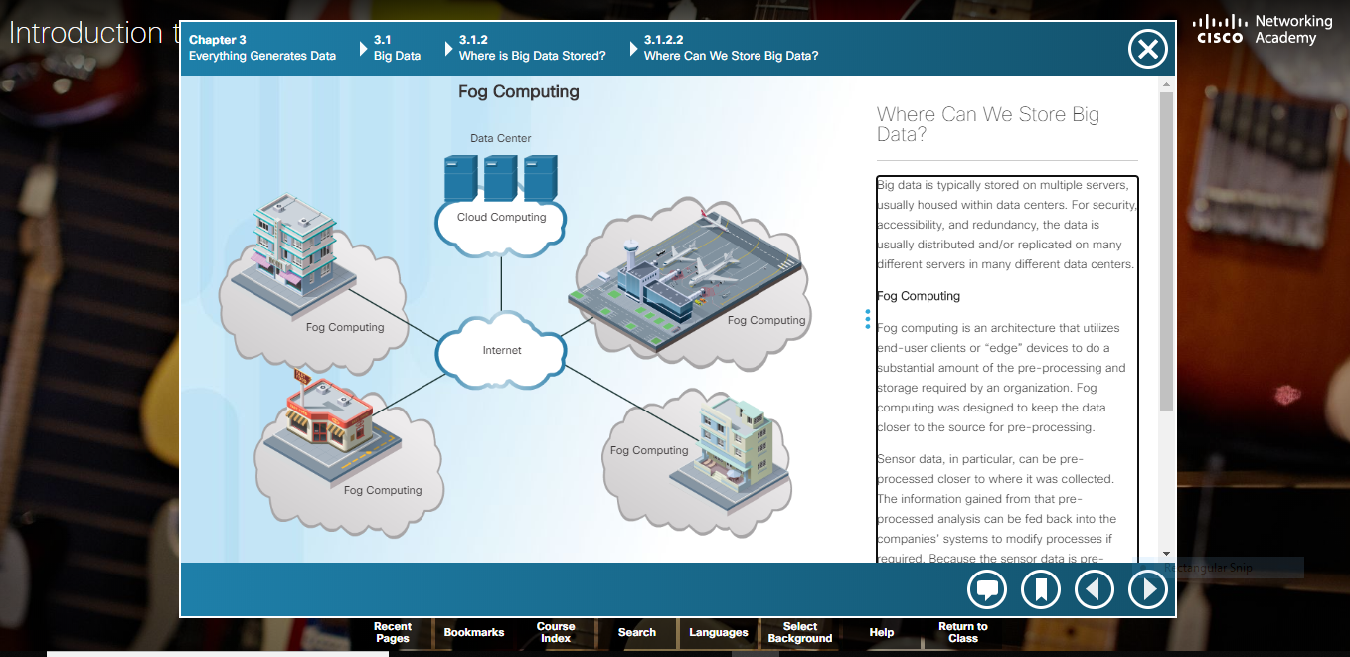

|  |
| --- |
| **SESSION DETAILS**  **What is big data**  Data is information that comes from a variety of sources, such as people, pictures, text, sensors, and web sites. Data also comes from technology devices like cell phones, computers, kiosks, tablets, and cash registers. Most recently, there has been a spike in the volume of data generated by sensors. Sensors are now installed in an ever growing number of locations and objects. These include security cameras, traffic lights, intelligent cars, thermometers, and even grape vines!  **Large datasets**  Companies do not necessarily have to generate their own Big Data. Smaller organizations might not have the sensors, the volume of customers, or the ability to generate the variety of information that could benefit their company. There are sources of free data sets available, ready to be used and analyzed by anyone willing to look for them  **Where can we store big data?**  Big data is typically stored on multiple servers, usually housed within data centers. For security, accessibility, and redundancy, the data is usually distributed and/or replicated on many different servers in many different data centers.  **Fog Computing**  Fog computing is an architecture that utilizes end-user clients or “edge” devices to do a substantial amount of the pre-processing and storage required by an organization. Fog computing was designed to keep the data closer to the source for pre-processing.  Sensor data, in particular, can be pre-processed closer to where it was collected. The information gained from that pre-processed analysis can be fed back into the companies’ systems to modify processes if required. Because the sensor data is pre-processed by end devices within the company system, communications to and from the servers and devices would be quicker. This requires less bandwidth than constantly going out to the cloud.  **The cloud and cloud computing**  As mentioned before, the cloud is a collection of data centers or groups of connected servers. Access to software, storage, and services available on the servers is obtained through the Internet via a browser interface. Cloud services are provided by many large companies such as Google, Microsoft, and Apple. Cloud storage services are provided by different vendors such as: Google Drive, Apple iCloud, Microsoft OneDrive, and Dropbox.  Data mining is the process of turning raw data into meaningful information by discovering patterns and relationships in large data sets. Data visualization is the process of taking the analyzed data and using charts such as line, column, bar, pie, or scatter to present meaningful information. A strategy helps a business determine the type of analysis required and the best tool to do the analysis. A strategy also helps to determine the most effective way to present the results for management.  **What is automation**  Automation is any process that is self-driven and reduces, then eventually eliminates, the need for human intervention. Automation was once confined to the manufacturing industry. Highly repetitive tasks such as automobile assembly were turned over to machines and the modern assembly line was born. Machines are excellent at repeating the same task without fatigue and without the errors that humans are prone to make in such jobs. This results in greater output, because machines can work 24 hours a day without breaks. Machines also provide a more uniform product. The IoT opens up a new world in which tasks previously requiring human intervention can become automated. As we have seen, the IoT allows the collection of vast amounts of data that can be quickly analyzed to provide information that can help guide an event or process.  **Artificial Intelligence**  Artificial Intelligence (AI) is the intelligence demonstrated by machines. This is in contrast to natural intelligence which is the intelligence displayed by living organisms. AI uses intelligent agents that can perceive their environment and make decisions that maximize the probability of obtaining a specific goal or objective. AI refers to systems that mimic cognitive functions normally associated with human minds such as learning and problem solving.  Some of the tasks that currently are deemed to require a degree of AI are autonomous cars, intelligent routing in content delivery networks, strategic game playing, and military simulations. As technology develops, many of the tasks that at one time required AI have become routine. Many of these tasks have migrated from AI to Machine Learning (ML). ML is a subset of AI that uses statistical techniques to give computers the ability to “learn” from their environment. This enables computers to improve on a particular task without being specifically programmed for that task.  **ML in IOT**  One of the features of the IoT is that it enables the collection of extremely large pools of data that can “teach” programs how to respond in certain conditions. Some of the more common uses of ML technology include:   * **Speech Recognition**- Many different companies now offer digital assistants which allow you to use speech to communicate with a computer system. Apple, Microsoft, Google and Amazon all offer this service. These companies not only allow commands to be given verbally, but offer speech-to-text capabilities. * **Product Recommendation**- Systems build up a customer profile and recommend products or services based on previous patterns. Users of Amazon and eBay receive recommendations on products. Organizations such as LinkedIn, Facebook, and GooglePlus recommend users you may wish to connect with. * **Shape Recognition**- Programs exist that allow crude hand-drawn diagrams and notes to be converted to more formal diagrams and text. This allows the shapes and lines of hand writing to be converted to more formal text which can then be searched and analyzed. * **Credit Card Fraud Detection**- A profile is constructed about the purchasing patterns of a client. Any deviation from these patterns triggers an alert and the system automatically takes action. This action ranges from denying the transaction to notifying the authorities. Some of the events that are detected and could indicate a fraudulent transaction include purchasing products not normally purchased, purchases in a different geographic area, rapidly purchasing many different products, and purchasing large-ticket items. * **Facial Recognition**- Security cameras are everywhere, from stores and streets to airports and transportation hubs. These cameras continually scan the crowds, normally watching for dangerous or illegal activities, but they can also be used to identify and track individuals. The system builds a pattern of specific facial features and then watches for a match to these facial patterns triggering some action. |