**DAILY ONLINE ACTIVITIES SUMMARY**

|  |  |  |  |  |  |  |  |  |
| --- | --- | --- | --- | --- | --- | --- | --- | --- |
| **Date:** | **12-06-2020** | | | | | **Name:** | **Shetty Disha Ravindra** | |
| **Sem & Sec** | **VI B sec** | | | | | **USN:** | **4a17cs087** | |
| **Online Test Summary** | | | | | | | | |
| **Subject** | | - | | | | | | |
| **Max. Marks** | | - | | **Score** | | | - | |
| **Certification Course Summary** | | | | | | | | |
| **Course** | **Java Programming: Complete Beginner to Advanced** | | | | | | | |
| **Certificate Provider** | | | **Udemy** | | **Duration** | | | **2 hours** |
| **Coding Challenges** | | | | | | | | |
| **Problem Statement:1.** Write a Python program to implement Magic Square | | | | | | | | |
| **Status:executed** | | | | | | | | |
| **Uploaded the report in Github** | | | | | **Yes** | | | |
| **If yes Repository name** | | | | | **Disha_Shetty** | | | |
| **Uploaded the report in slack** | | | | | **Yes** | | | |
| **PYTHON ASSIGNMENT PROGRAM**  **1**] **Python program to Count the Number of Vowels Present in a String using Sets** | | | | | | | | | |

Online Test Details: (Attach the snapshot and briefly write the report for the same)

Certification Course Details: (Attach the snapshot and briefly write the report for the same)

Coding Challenges Details: (Attach the snapshot and briefly write the report for the same)

Online test

Certification progress

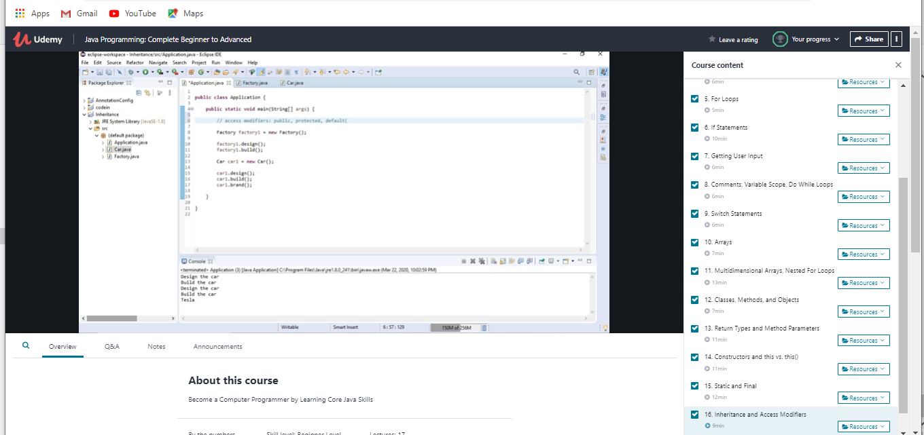

Coding challenge output

1] Write a Python program to implement Magic Square

