**DAILY ONLINE ACTIVITIES SUMMARY**

|  |  |  |  |  |  |  |  |  |
| --- | --- | --- | --- | --- | --- | --- | --- | --- |
| **Date:** | **07-06-2020** | | | | | **Name:** | **Shetty Disha Ravindra** | |
| **Sem & Sec** | **VI B sec** | | | | | **USN:** | **4a17cs087** | |
| **Online Test Summary** | | | | | | | | |
| **Subject** | | System Software and Compiler Design | | | | | | |
| **Max. Marks** | | 30 | | **Score** | | | 23 | |
| **Certification Course Summary** | | | | | | | | |
| **Course** | Data Visualization using Tableau | | | | | | | |
| **Certificate Provider** | | | **-** | | **Duration** | | | 11.5hrs |
| **Coding Challenges** | | | | | | | | |
| **Problem Statement:1]**  Python program the first and last 5 elements | | | | | | | | |
| **Status:executed** | | | | | | | | |
| **Uploaded the report in Github** | | | | | **Yes** | | | |
| **If yes Repository name** | | | | | **Disha_Shetty** | | | |
| **Uploaded the report in slack** | | | | | **Yes** | | | |
| **PYTHON ASSIGNMENT PROGRAM**  **1]** **Python Program to Copy the Contents of One File into Another**  Screenshot (91).png  Screenshot (112).png | | | | | | | | | |

Online Test Details: (Attach the snapshot and briefly write the report for the same)

Certification Course Details: (Attach the snapshot and briefly write the report for the same)

Coding Challenges Details: (Attach the snapshot and briefly write the report for the same)

Online test

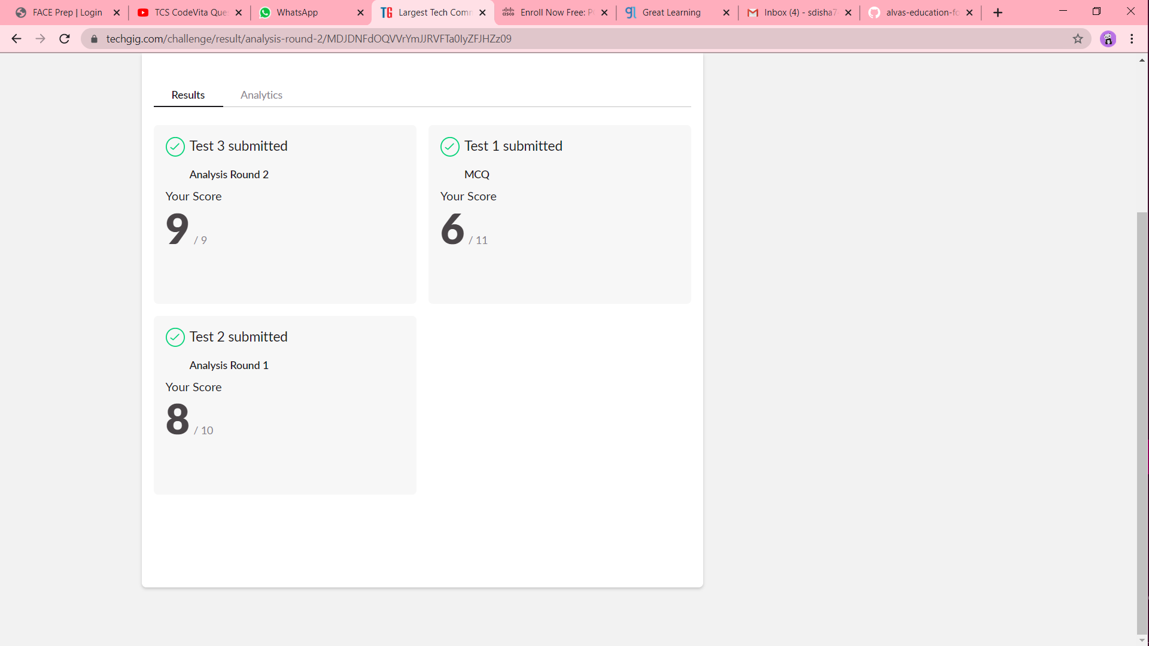

Certification progress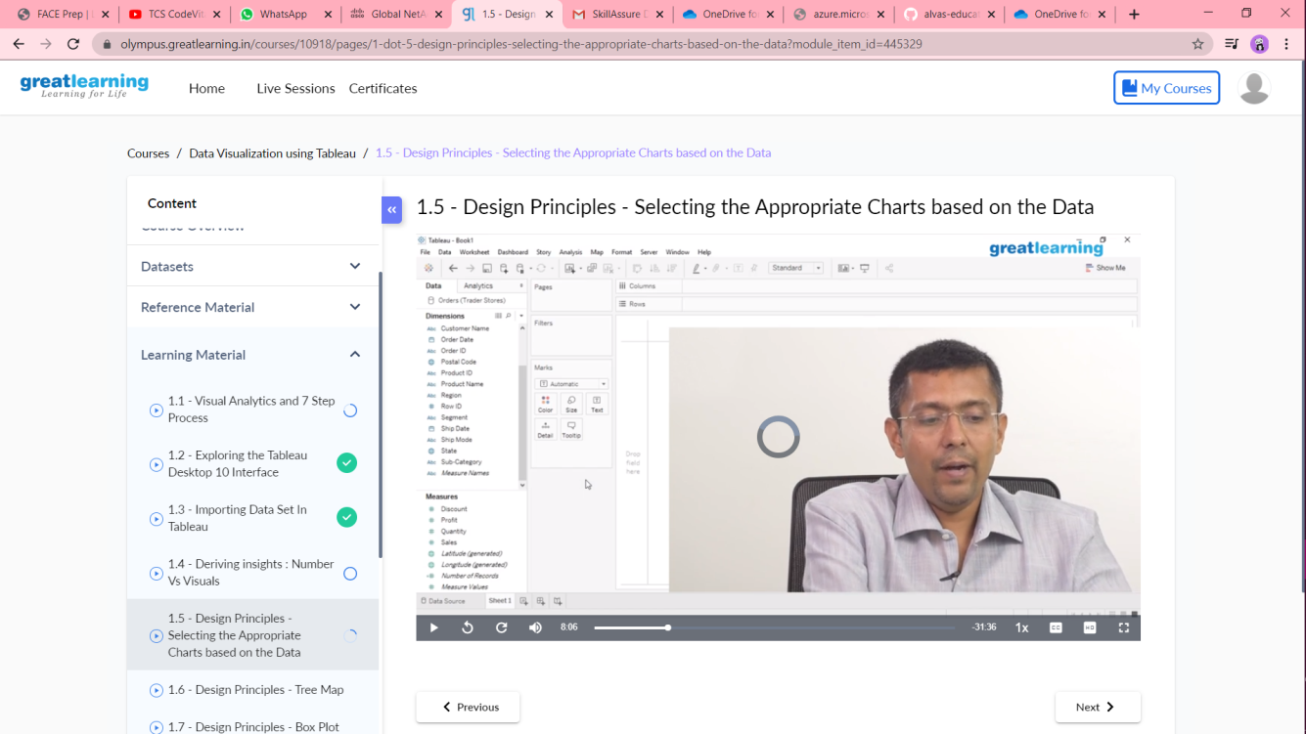

Coding challenge output