**DAILY ONLINE ACTIVITIES SUMMARY**

|  |  |  |  |  |  |  |  |  |
| --- | --- | --- | --- | --- | --- | --- | --- | --- |
| **Date:** | **28-05-2020** | | | | | **Name:** | **Shetty Disha Ravindra** | |
| **Sem & Sec** | **VI B sec** | | | | | **USN:** | **4a17cs087** | |
| **Online Test Summary** | | | | | | | | |
| **Subject** | | **Operating System** | | | | | | |
| **Max. Marks** | | **30** | | **Score** | | | **24** | |
| **Certification Course Summary** | | | | | | | | |
| **Course** | **Full Stack web Development** | | | | | | | |
| **Certificate Provider** | | | **Udemy** | | **Duration** | | | **19.5hrs** |
| **Coding Challenges** | | | | | | | | |
| **Problem Statement:1]** Given an array arr[] of the positive integers of size N, the task is to find the largest element on the left side of each index which is smaller than the element present at that index. Note: If no such element is found then print -1.  2] Python program to find digital root of a number | | | | | | | | |
| **Status:executed** | | | | | | | | |
| **Uploaded the report in Github** | | | | | **Yes** | | | |
| **If yes Repository name** | | | | | <https://github.com/alvas-education-foundation/Disha_Shetty> | | | |
| **Uploaded the report in slack** | | | | | **Yes** | | | |

Online Test Details: (Attach the snapshot and briefly write the report for the same)

Certification Course Details: (Attach the snapshot and briefly write the report for the same)

Coding Challenges Details: (Attach the snapshot and briefly write the report for the same)

Online test

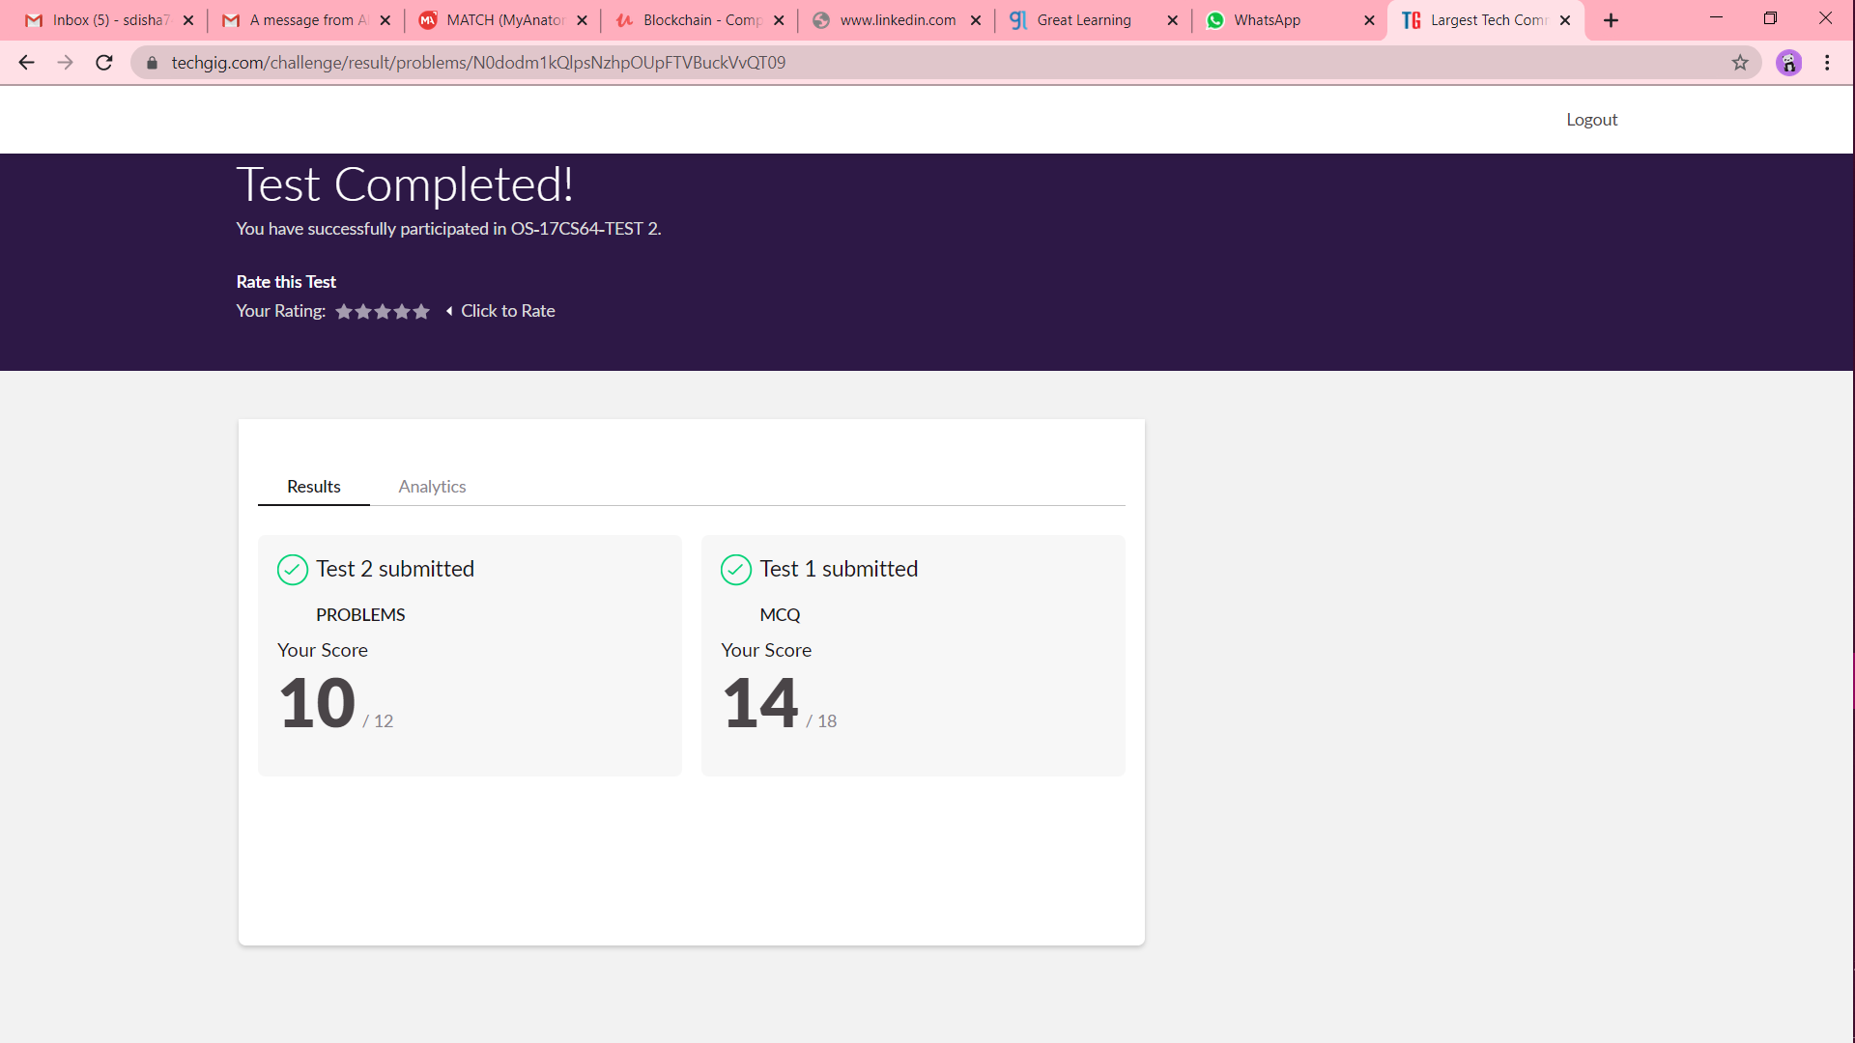

Certification progress





Coding challenge output

1]

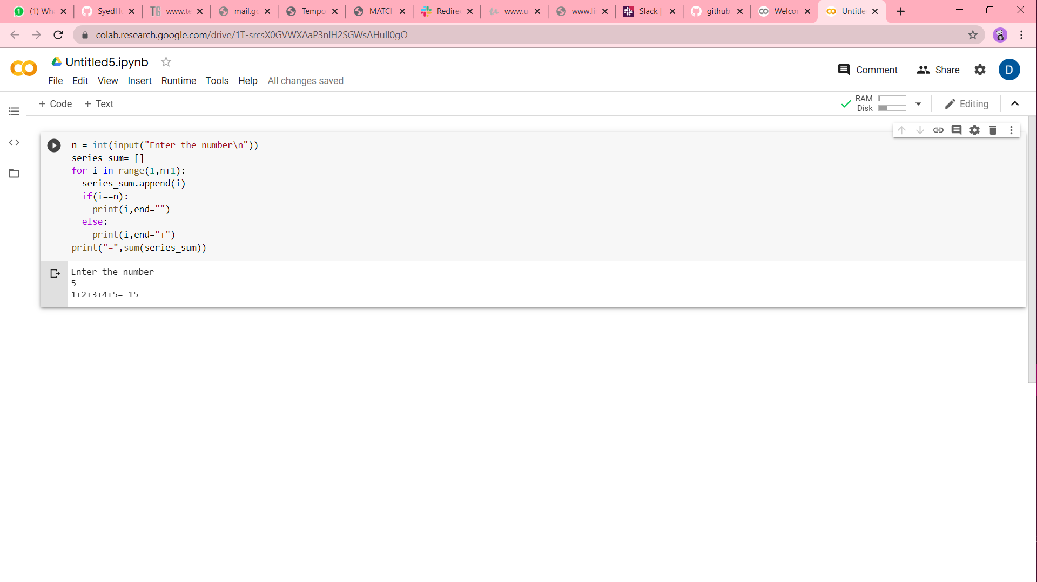

2]

