**DAILY ONLINE ACTIVITIES SUMMARY**

|  |  |  |  |  |  |  |  |  |
| --- | --- | --- | --- | --- | --- | --- | --- | --- |
| **Date:** | **18-05-2020** | | | | | **Name:** | **Shetty Disha Ravindra** | |
| **Sem & Sec** | **VI B** | | | | | **USN:** | **4al17cs087** | |
| **Online Test Summary** | | | | | | | | |
| **Subject** | | **Crptography Network security and Cyber Laws** | | | | | | |
| **Max. Marks** | | **60** | | **Score** | | | **30** | |
| **Certification Course Summary** | | | | | | | | |
| **Course** | **Full stack web developmet** | | | | | | | |
| **Certificate Provider** | | | **Udemy** | | **Duration** | | | **19.5hrs** |
| **Coding Challenges** | | | | | | | | |
| **Problem Statement:** 1]Using methods charAt() & length() of String class, write a program to print the frequency of each character in a string.  **2]** Write down a java program to print even and odd numbers series respectively from two threads: t1 and t2 synchronizing on a shared object  Let t1 print message “ping — >” and t2 print message “,—-pong”.  Take as command line arguments, the following inputs to the program: Sleep Interval for thread t1     |  |  | | --- | --- | |  |  | | | | | | | | | |
| **Status:** executed | | | | | | | | |
| **Uploaded the report in Github** | | | | | **yes** | | | |
| **If yes Repository name** | | | | | **Disha_Shetty** | | | |
| **Uploaded the report in slack** | | | | | **yes** | | | |

Online Test Details: (Attach the snapshot and briefly write the report for the same)

Certification Course Details: (Attach the snapshot and briefly write the report for the same)

Coding Challenges Details: (Attach the snapshot and briefly write the report for the same)

Online test

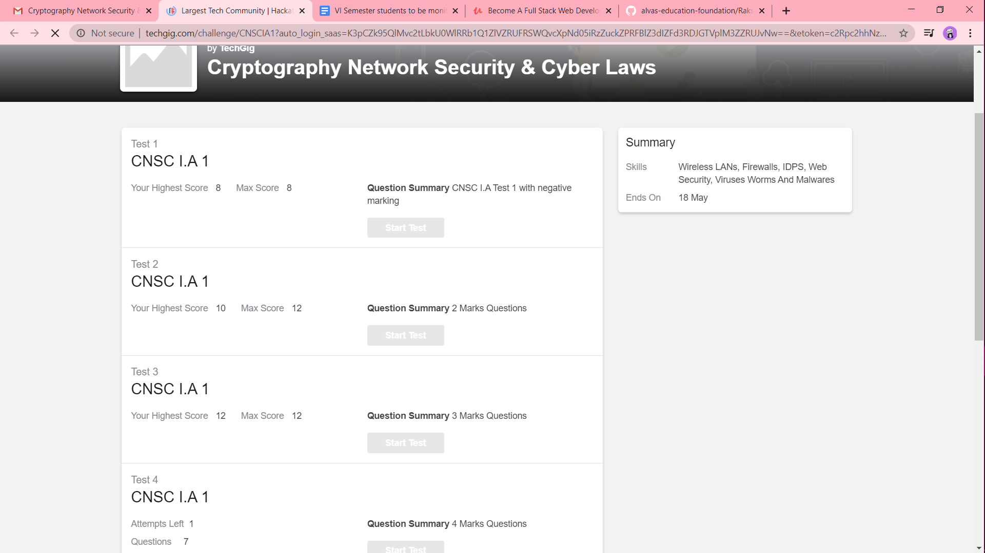

Attempted three sections successfully but couldn’t attempt the last section due to network error.

Certification progress

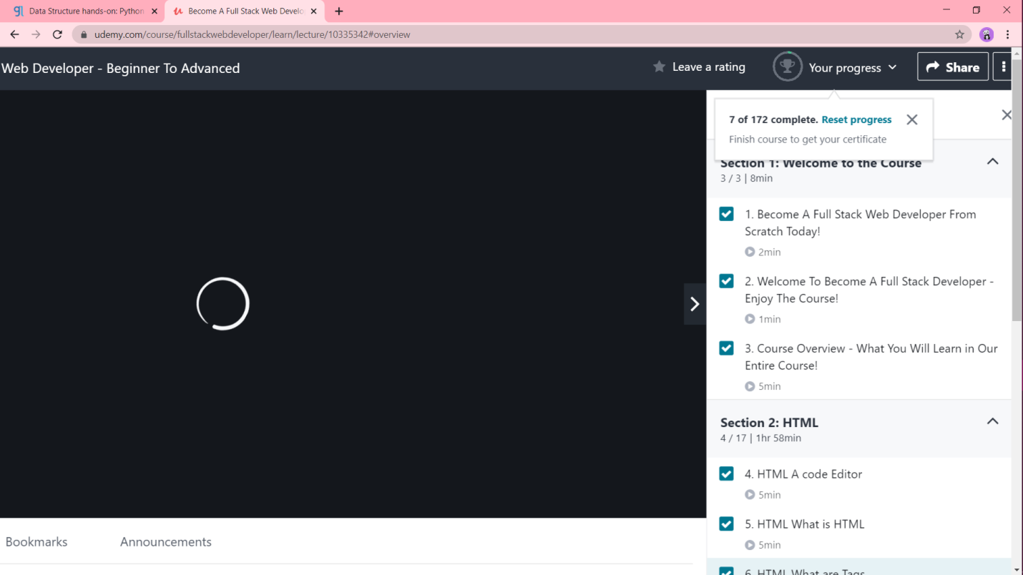

Coding challenge output

**1]**

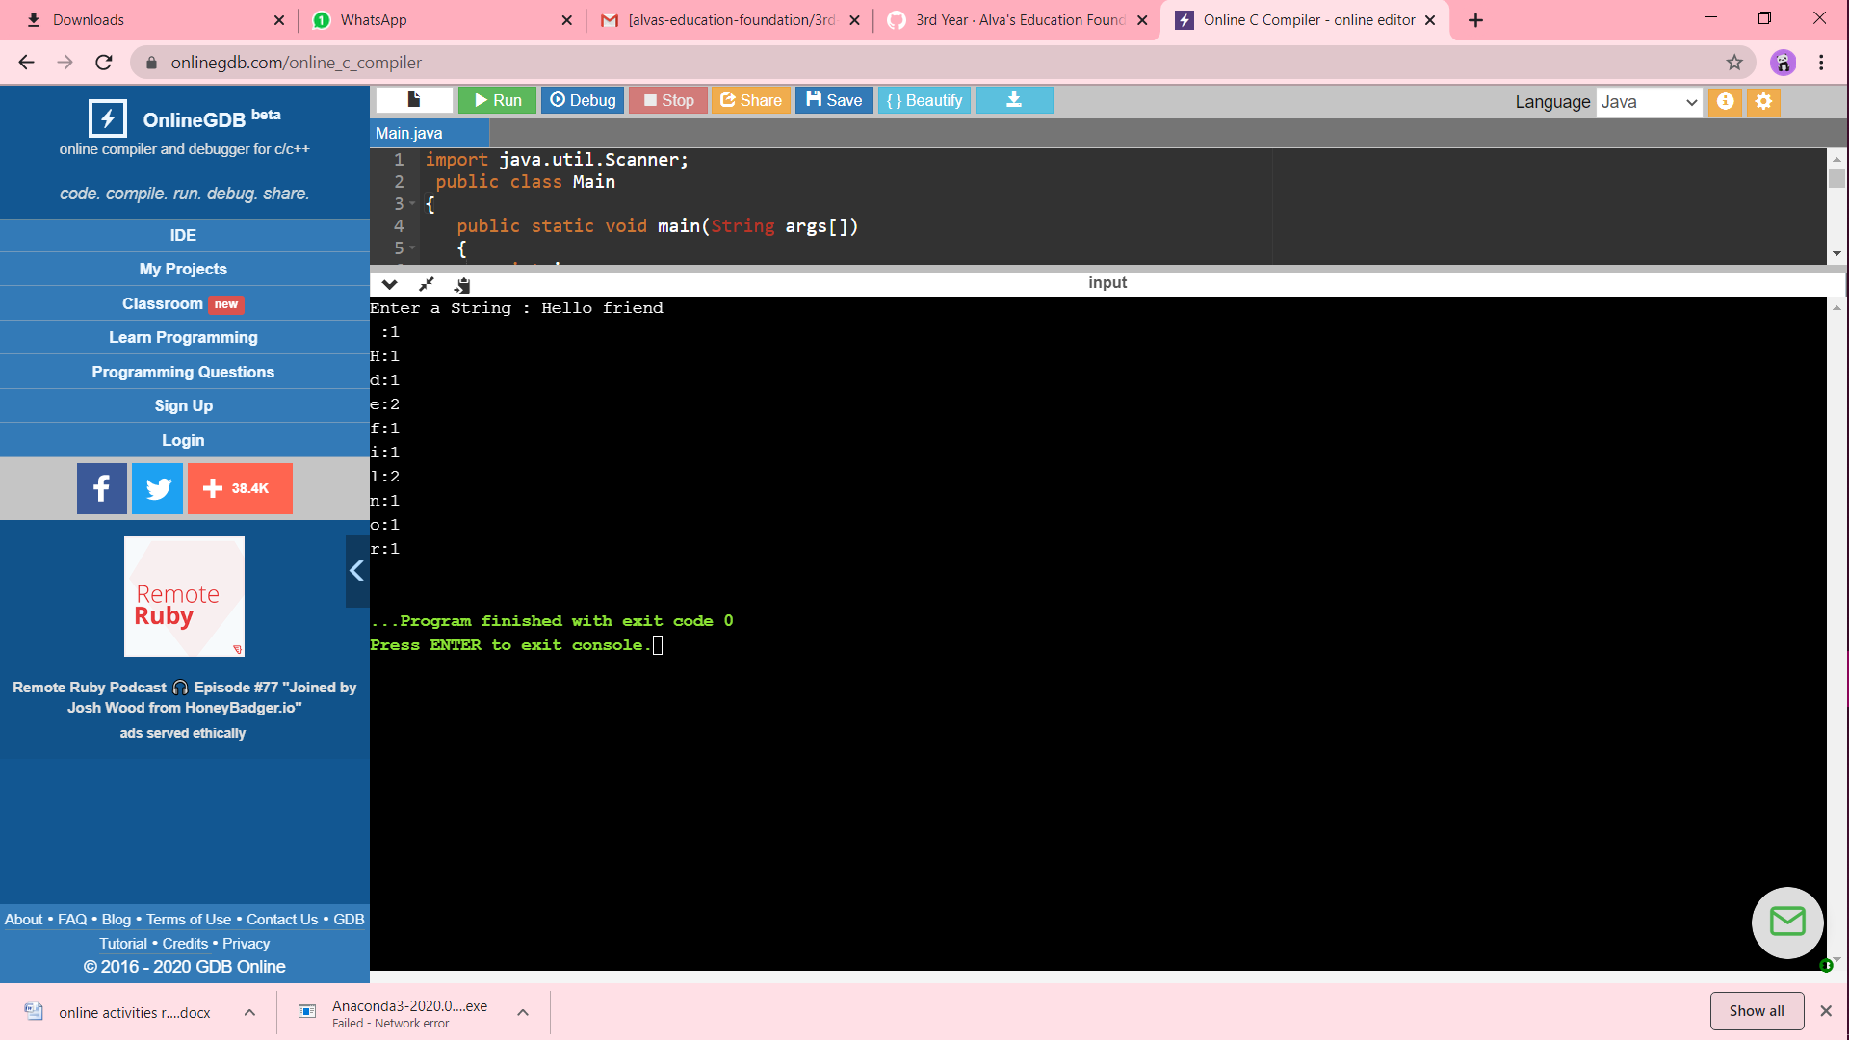

2]