**DAILY ONLINE ACTIVITIES SUMMARY**

|  |  |  |  |  |  |  |  |  |
| --- | --- | --- | --- | --- | --- | --- | --- | --- |
| **Date:** | **18th May 2020** | | | | | **Name:** | **Dsouza Elston Ronald** | |
| **Sem & Sec** | **6th A section** | | | | | **USN:** | **4AL17CS029** | |
| **Online Test Summary** | | | | | | | | |
| **Subject** | | **Cryptography,Network security and Cyber laws(CNSC)** | | | | | | |
| **Max. Marks** | | **60** | | **Score** | | | **39** | |
| **Certification Course Summary** | | | | | | | | |
| **Course** | **Full Stack Web Developer-Beginner to Advanced** | | | | | | | |
| **Certificate Provider** | | | **Udemy** | | **Duration** | | | **20 hours** |
| **Coding Challenges** | | | | | | | | |
| 1. . **Problem Statement:** Using methods charAt() & length() of String class, write a program to print the frequency of each character in a string.   “Hello friend”  Output should be -: 1 d: 1 e: **2** f: 1 (continued for all character in the string)   1. Write down a java program to print even and odd numbers series respectively from two threads: t1 and t2 synchronizing on a shared object   Let t1 print message “ping — >” and t2 print message “,—-pong”.  Take as command line arguments, the following inputs to the program: Sleep Interval for thread t1 Write down a java program to print even and odd numbers series respectively from two threads: t1 and t2 synchronizing on a shared object  Let t1 print message “ping — >” and t2 print message “,—-pong”.  Take as command line arguments, the following inputs to the program:  Sleep Interval for thread t1  Sleep Interval for thread t2  Message per cycle  No of cycles | | | | | | | | |
| **Status: Completed** | | | | | | | | |
| **Uploaded the report in Github** | | | | | **Yes** | | | |
| **If yes Repository name** | | | | | <https://github.com/alvas-education-foundation/Elston-Dsouza-4al17cs029-> | | | |
| **Uploaded the report in slack** | | | | | **Yes** | | | |

Online Test Details: (Attach the snapshot and briefly write the report for the same)

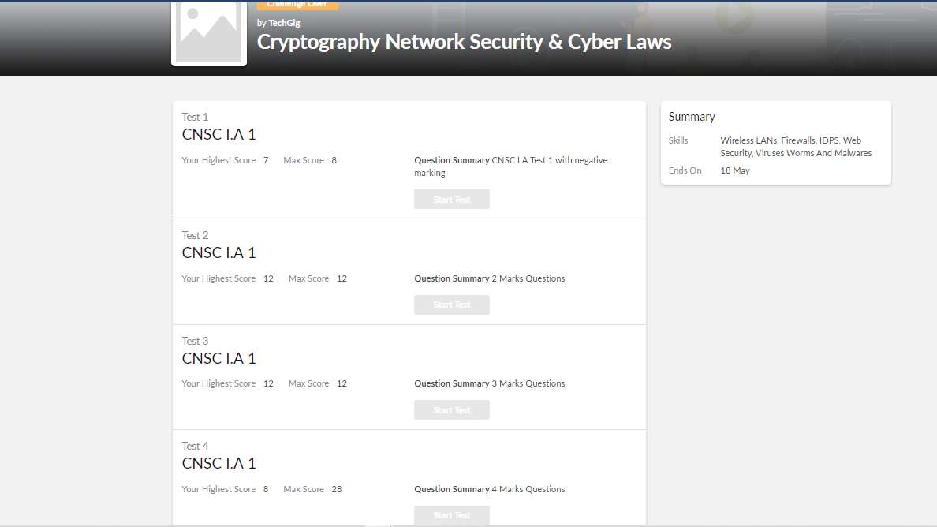

The above assessment was done by me on 18th May 2020 from 9 to 10 am and the details of assessment is as above.

Certification Course Details: (Attach the snapshot and briefly write the report for the same)

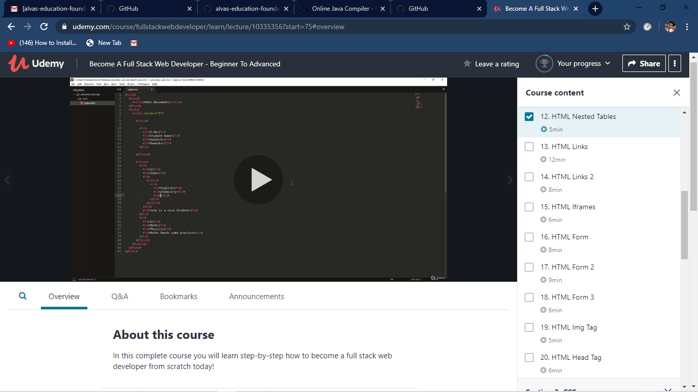

The above course is being taken up by me which is based on full stack web development. The course has started with the HTML basics as well as the various concepts in HTML. The details of the course and certificate provider is mentioned in the above form.

Coding Challenges Details: (Attach the snapshot and briefly write the report for the same)

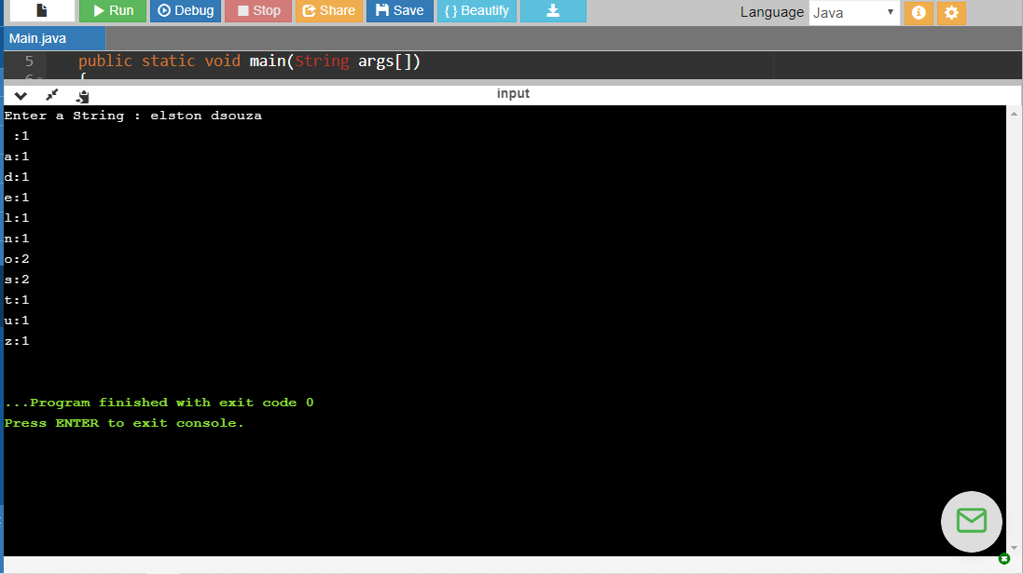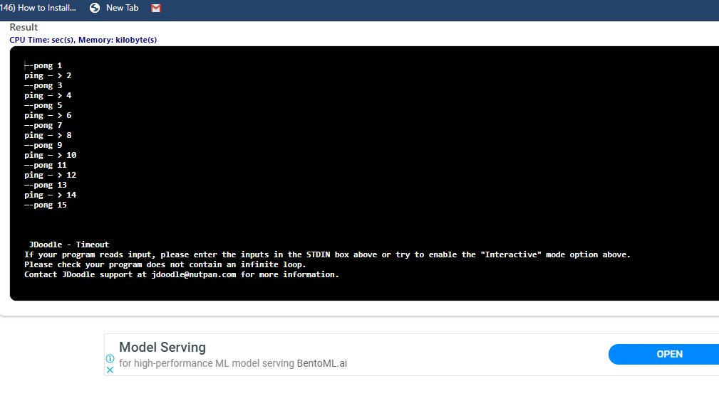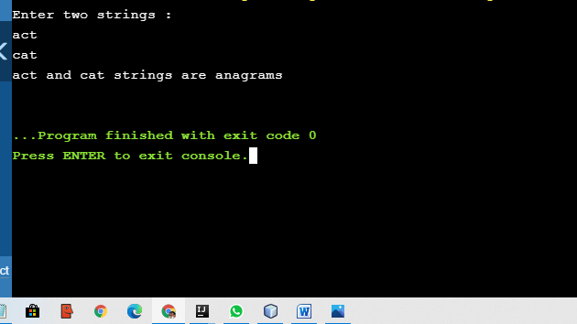

The above the programs were written and executed and the output of the same is displayed above. The code for the given 3 programs have been uploaded to the github repository and the link to the same is provided on the form.