**1. Write a C program to count distinct element in an array**

Program:

#include <stdio.h>

void main()

{

int arr1[100], n,ctr=0;

int i.j.k;

printf("\n\nPrint all unique elements of an array:\n");

printf("------------------------------------------\n");

printf("Input the number of elements to be stored in the array :");

scanf("%d",&n);

printf("Input %d elements in the array :\n",n);

for(i=0;i<n;i++)

{

printf("element - %d : ",i);

scanf("%d",&arr1[i]);

}

/*Checking duplicate elements in the array */

printf("\nThe unique elements found in the array are : \n");

for(i=0; i<n; i++)

{

ctr=0;

/*Check duplicate bifore the current position and increase counter by 1 if found.*/

for(j=0; j<i-1; j++)

{

/*Increment the counter when the seaarch value is duplicate.*/

if(arr1[i]==arr1[j])

{

ctr++;

}

}

/*Check duplicate after the current position and

increase counter by 1 if found.*/

for(k=i+1; k<n; k++){

/*Increment the counter when the seaarch value is duplicate.*/

if(arr1[i]==arr1[k])

{

ctr++;

}

}

/*Print the value of the current position of the array as unique value when counter remain contains its initial value.*/

if(ctr==0)

{

printf("%d ",arr1[i]);

}

}

printf("\n\n");

}

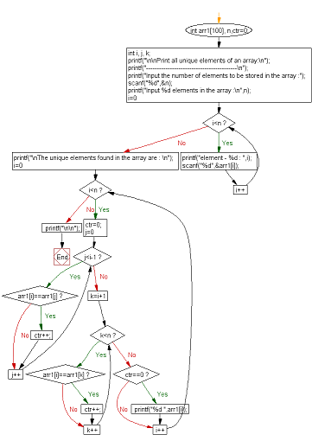

Algorithm:

1. Declare and variables and array
2. Input the number of elements
3. Input the array elements.
4. Traverse the array from beginning.
5. Check if the current element is found in the array,
6. If it is found, then do not print that element.
7. Else print the element and continue.