**Consider the below Worker table:**

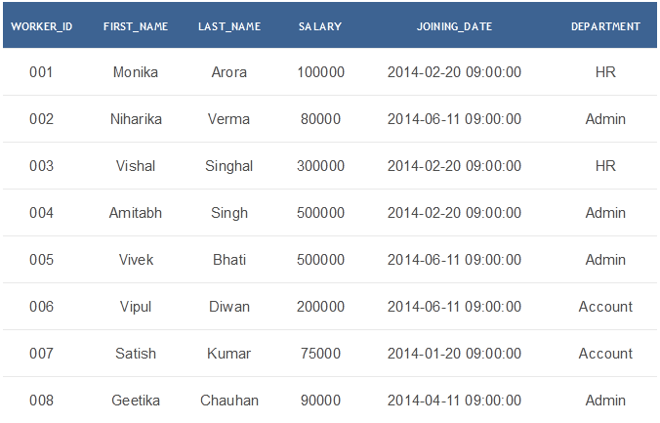

**Challenge-1:** Write an SQL query to print all Worker details from the Worker table order by FIRST_NAME Ascending and DEPARTMENT Descending.

**Challenge-2:** Write an SQL query to print details of workers excluding first names, “Vipul” and “Satish” from Worker table.

**Challenge-3:** Write an SQL query to print details of the Workers whose SALARY lies between 100000 and 500000.

**Challenge-4:** Write an SQL query to print details of the Workers who have joined in Feb’2014.

**Challenge-5:** Write an SQL query to fetch worker names with salaries >= 50000 and <= 100000.