**Consider the below Worker table:**

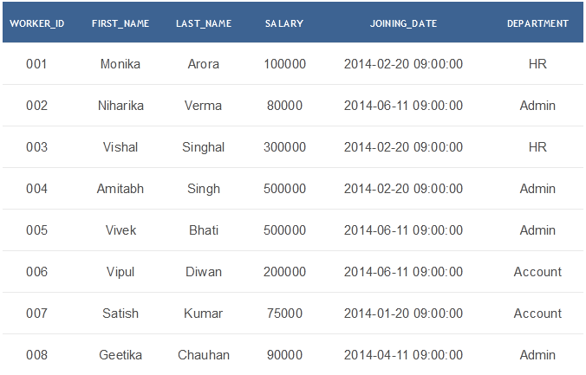

#### Challenge-1: Write an SQL query to determine the 5th highest salary.

#### Challenge-2: Write an SQL query to fetch the list of employees with the same salary.

#### Challenge-3: Write an SQL query to fetch the departments that have less than five people in it.

#### Challenge-4: Write an SQL query to show all departments along with the number of people in there.