**Consider the below Worker table:**

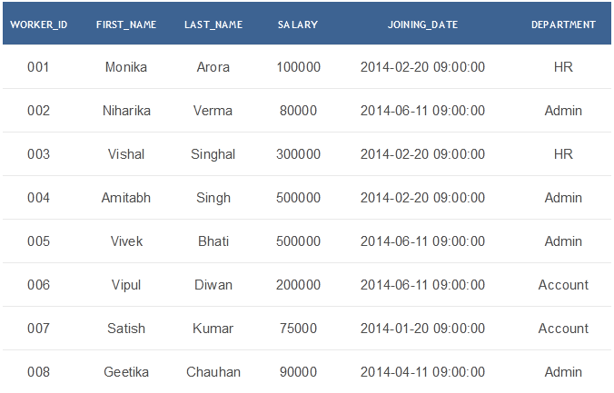

#### Challenge-1: Write an SQL query to show one row twice in results from a table

#### Challenge-2: Write an SQL query to fetch the last five records from a table.

#### Challenge-3: Write an SQL query to show the last record from a table.

#### Challenge-4: Write an SQL query to print the name of employees having the highest salary in each department.