**DAILY ONLINE ACTIVITIES SUMMARY**

|  |  |  |  |  |  |  |  |  |
| --- | --- | --- | --- | --- | --- | --- | --- | --- |
| **Date:** | **26-06-2020** | | | | | **Name:** | **Jayalakshmi M** | |
| **Sem & Sec** | **VI A** | | | | | **USN:** | **4AL17CS035** | |
| **Online Test Summary** | | | | | | | | |
| **Subject** | | **Cyber Security and Data Structure with C** | | | | | | |
| **Max. Marks** | | **--** | | **Score** | | | **--** | |
| **Certification Course Summary** | | | | | | | | |
| **Course** | **Placement Training** | | | | | | | |
| **Certificate Provider** | | | **--** | | **Duration** | | | **--** |
| **Coding Challenges** | | | | | | | | |
| **Problem Statement:1 program** | | | | | | | | |
| **Status: solved** | | | | | | | | |
| **Uploaded the report in Github** | | | | | **yes** | | | |
| **If yes Repository name** | | | | | <https://github.com/alvas-education-foundation/Jayalakshmi_M> | | | |
| **Uploaded the report in slack** | | | | | **yes** | | | |

Class and Quiz Snapshots:

Cyber Security:

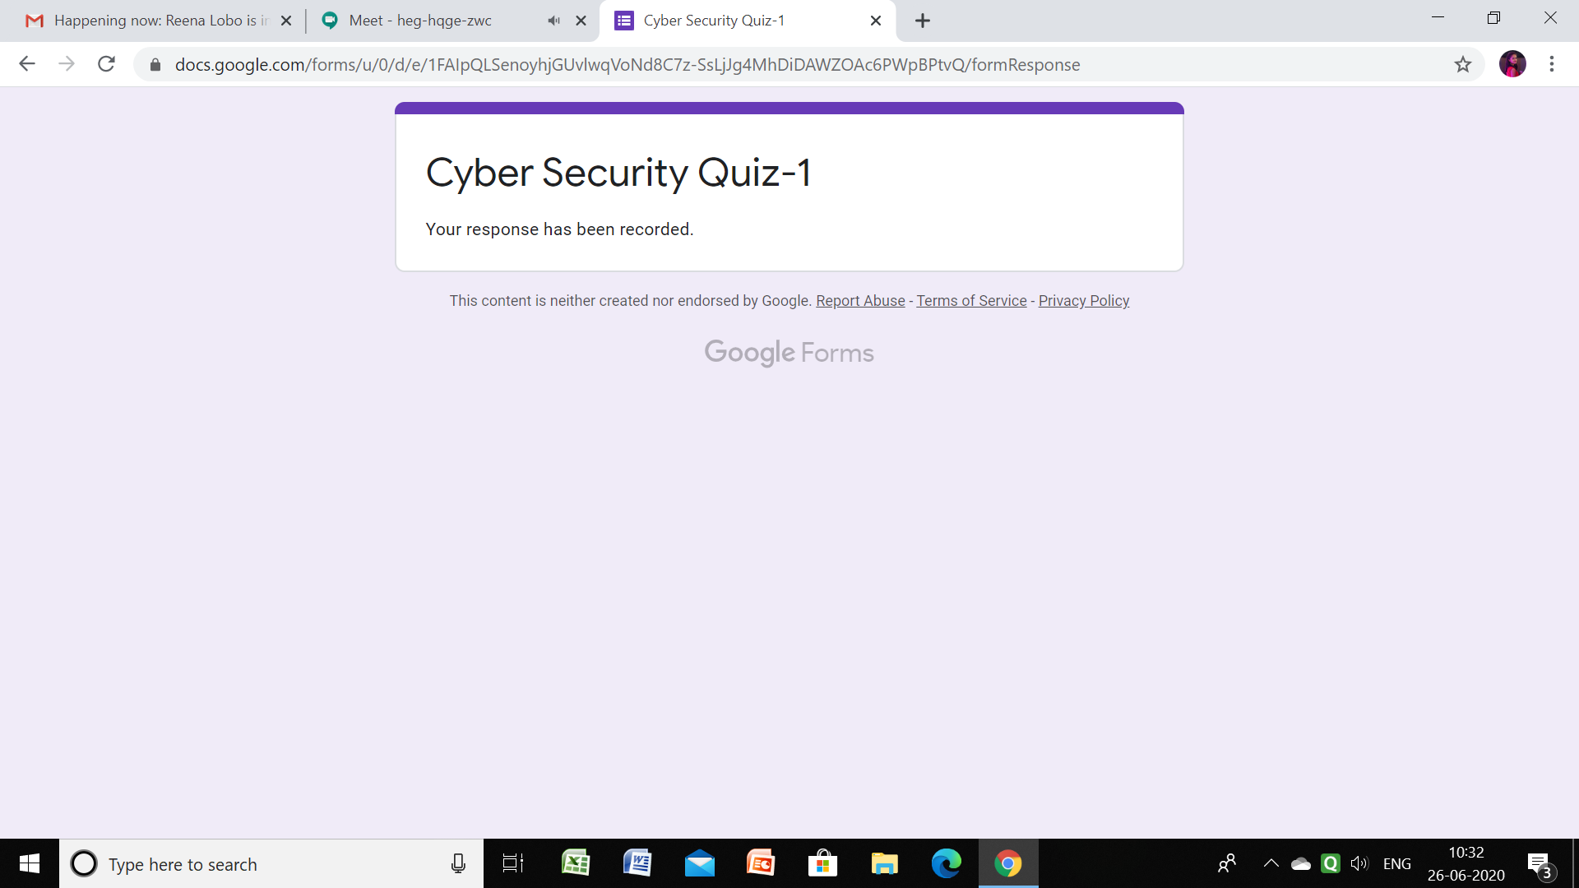

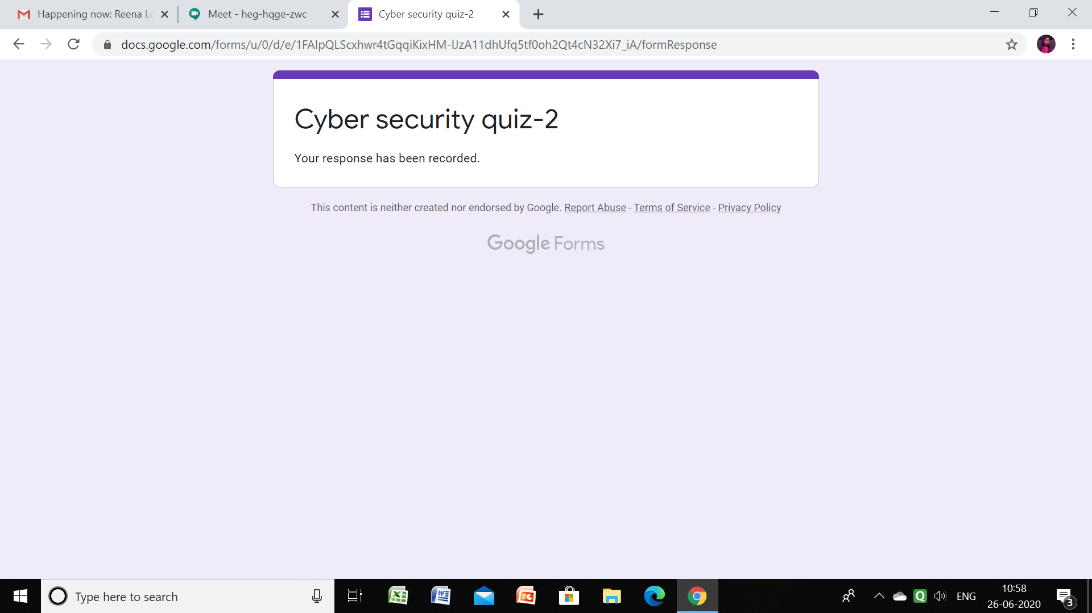

Data Structure with C:

