**DAILY ONLINE ACTIVITIES SUMMARY**

|  |  |  |  |  |  |  |  |  |
| --- | --- | --- | --- | --- | --- | --- | --- | --- |
| **Date:** | 06-07-2020 | | | | | **Name:** | K S Prajwal | |
| **Sem & Sec** | IV A sec | | | | | **USN:** | 4AL18CS032 | |
| **Online Test Summary** | | | | | | | | |
| **Subject** | | Engineering Mathematics - 4 | | | | | | |
| **Time limit** | | 45 min | | **Score** | | | 27 | |
| **Certification Course Summary** | | | | | | | | |
| **Course** | Front-End Web UI Frameworks and Tools: Bootstrap 4 | | | | | | | |
| **Certificate Provider** | | | coursera | | **Duration** | | | **3 hr** |
| **Coding Challenges** | | | | | | | | |
| **Problem Statement:**  1: Given an array of integer arr[] and an integer k, the task is to find the median of each window of size k starting from the left and moving towards the right by one position each time. | | | | | | | | |
| **Status:** completed | | | | | | | | |
| **Uploaded the report in Github** | | | | | yes | | | |
| **If yes Repository name** | | | | | <https://github.com/alvas-education-foundation/KS_Prajwal> | | | |
| **Uploaded the report in slack** | | | | | yes | | | |

Online Test Details: (Attach the snapshot and briefly write the report for the same)

Certification Course Details: (Attach the snapshot and briefly write the report for the same)

Coding Challenges Details: (Attach the snapshot and briefly write the report for the same)

**Online Test Details:** The test was from module 1 and there were 3 questions to solve. The time limit was 45 minutes. We had to write the test in A4 sheet and had to upload in Google classroom.

Snapshot of certification course:

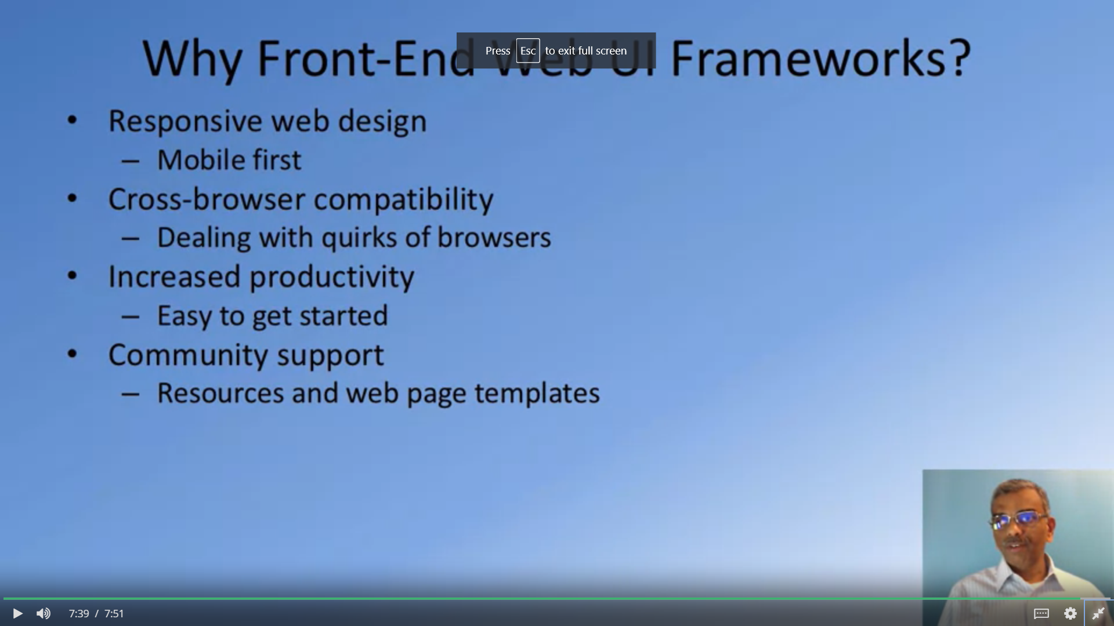

This course is about the front end technology, specifically Bootstrap. In todays section it was about the introduction to the course and explanation of full stack development and its roll in it

**Online coding:**

Problem 1: (using JAVA) Given an array of integer arr[] and an integer k, the task is to find the median of each window of size k starting from the left and moving towards the right by one position each time.

