**DAILY ONLINE ACTIVITIES SUMMARY**

|  |  |  |  |  |  |  |  |  |
| --- | --- | --- | --- | --- | --- | --- | --- | --- |
| **Date:** | 08-07-2020 | | | | | **Name:** | K S Prajwal | |
| **Sem & Sec** | IV A sec | | | | | **USN:** | 4AL18CS032 | |
| **Online Test Summary** | | | | | | | | |
| **Subject** | | Design and Analysis of Algorithms | | | | | | |
| **Time limit** | | 1hr | | **Score** | | | -- | |
| **Certification Course Summary** | | | | | | | | |
| **Course** | Front-End Web UI Frameworks and Tools: Bootstrap 4 | | | | | | | |
| **Certificate Provider** | | | coursera | | **Duration** | | | **3 hr** |
| **Coding Challenges** | | | | | | | | |
| **Problem Statement:**  1: Given the participants' score sheet for your University Sports Day, you are required to find the runner-up score. You are given scores. Store them in a list and find the score of the runner-up. | | | | | | | | |
| **Status:** completed | | | | | | | | |
| **Uploaded the report in Github** | | | | | yes | | | |
| **If yes Repository name** | | | | | <https://github.com/alvas-education-foundation/KS_Prajwal> | | | |
| **Uploaded the report in slack** | | | | | yes | | | |

Online Test Details: (Attach the snapshot and briefly write the report for the same)

Certification Course Details: (Attach the snapshot and briefly write the report for the same)

Coding Challenges Details: (Attach the snapshot and briefly write the report for the same)

**Online Test Details:** The test was from module 1 of DAA. There were 3 questions given to us to write within 45 minutes. We had to scan the answers that we have written in A4 sheets and make it as a pdf and submit it in Google classroom.

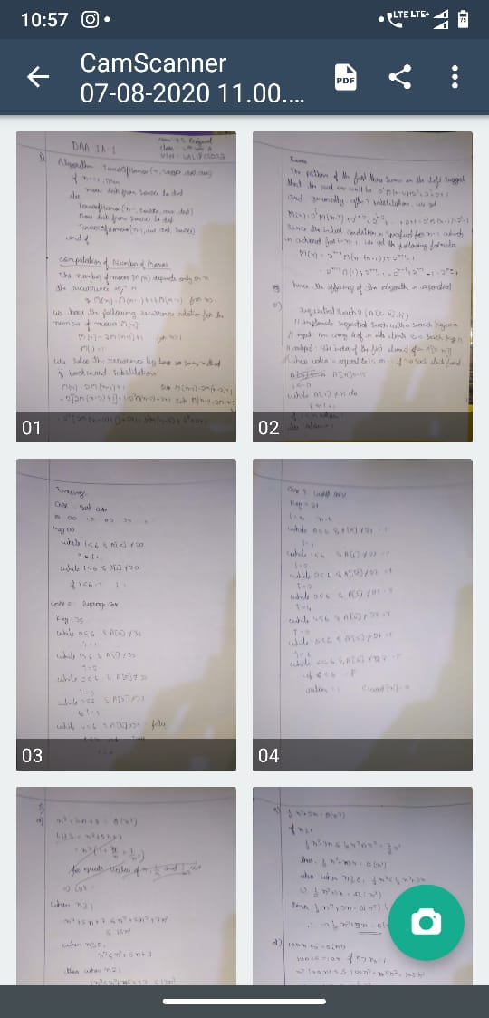

Snapshot of certification course:

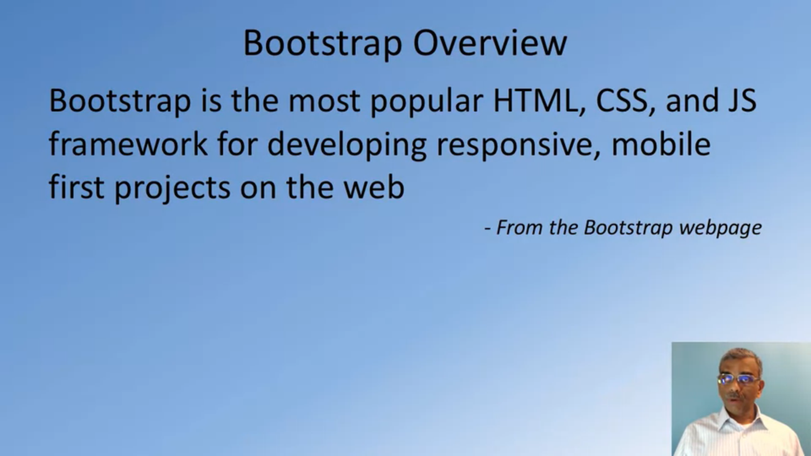

This course is about the front-end technology, specifically Bootstrap. In todays section it was about the introduction to bootstrap and using its classes

**Online coding:**

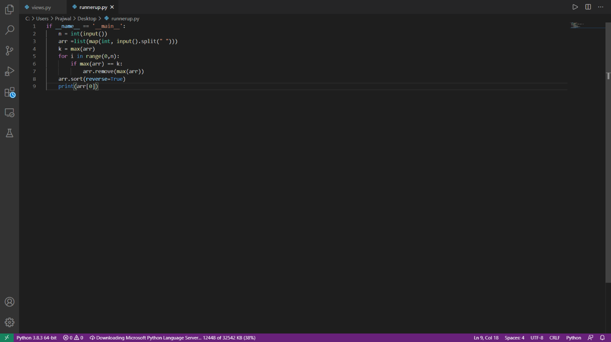Problem 1: (using Python) Given the participants' score sheet for your University Sports Day, you are required to find the runner-up score. You are given scores. Store them in a list and find the score of the runner-up.