DAILY ASSESSMENT REPORT

Date: | 20th July 2020 | Name: | K B KUSHI
Subject: | Basic statistics | USN: | 4AL17EC107
Topic: | Introduction | Semester & Section: | 6th B
GitHub  Repository: | KUSHI-COURSES

FORENOON SESSION DETAILS
Image of session

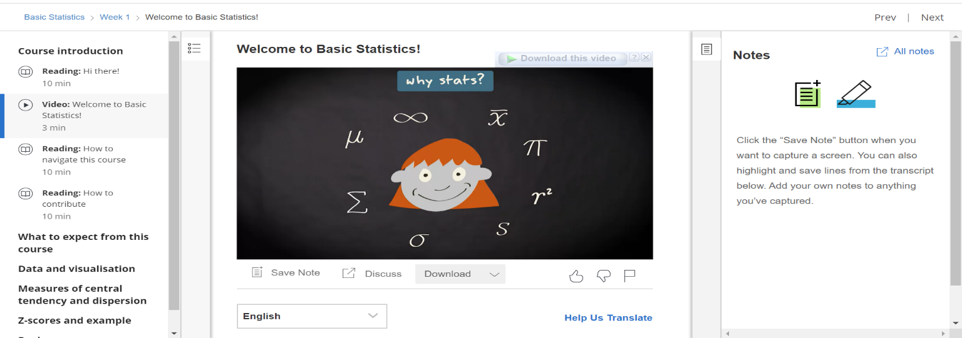
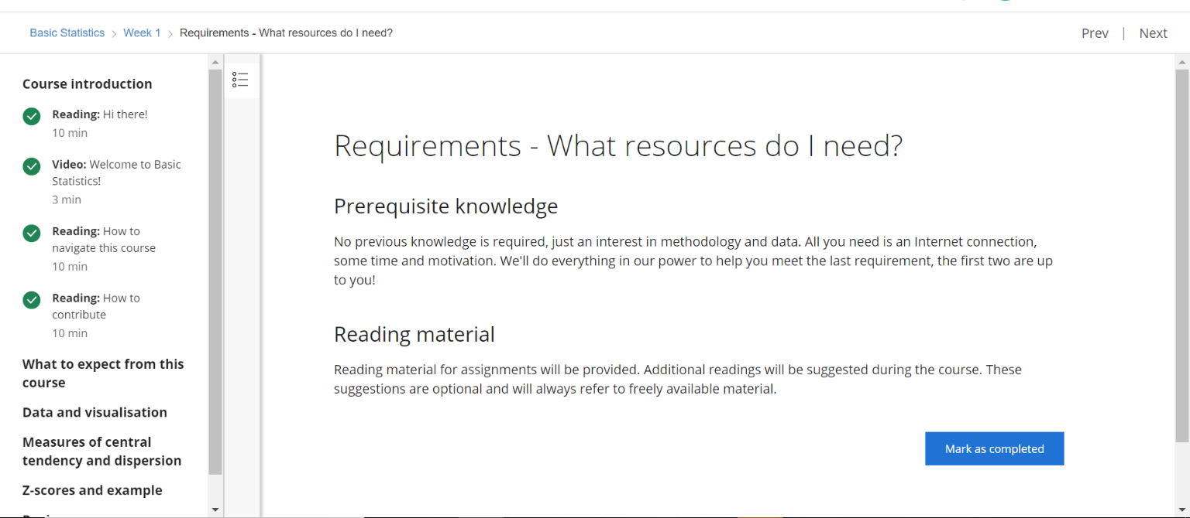

Report:
Understanding statistics is essential to understand research in the social and behavioral sciences. In this course you will learn the basics of statistics; not just how to calculate them, but also how to evaluate them. This course will also prepare you for the next course in the specialization - the course Inferential Statistics.
In the first part of the course we will discuss methods of descriptive statistics. You will learn what cases and variables are and how you can compute measures of central tendency (mean, median and mode) and dispersion (standard deviation and variance). Next, we discuss how to assess relationships between variables, and we introduce the concepts correlation and regression.
The second part of the course is concerned with the basics of probability: calculating probabilities, probability distributions and sampling distributions. You need to know about these things in order to understand how inferential statistics work.
The third part of the course consists of an introduction to methods of inferential statistics - methods that help us decide whether the patterns we see in our data are strong enough to draw conclusions about the underlying population we are interested in. We will discuss confidence intervals and significance tests.
You will not only learn about all these statistical concepts, you will also be trained to calculate and generate these statistics yourself using freely available statistical software.

