**DAILY ASSESSMENT FORMAT**

|  |  |  |  |
| --- | --- | --- | --- |
| **Date:** | **01/06/2020** | **Name:** | **Kirti B S** |
| **Course:** | **Network Theory** | **USN:** | **4AL18EC026** |
| **Topic:** | **1.Network Terminology**  **2.Basic circuit analysis**  **3.Different types of matrix & its application** | **Semester & Section:** | **4th Sem**  **‘A’ Section** |
| **Github Repository:** | **Kirti BS** |  |  |

**FORENOON SESSION**

**Image of the session**

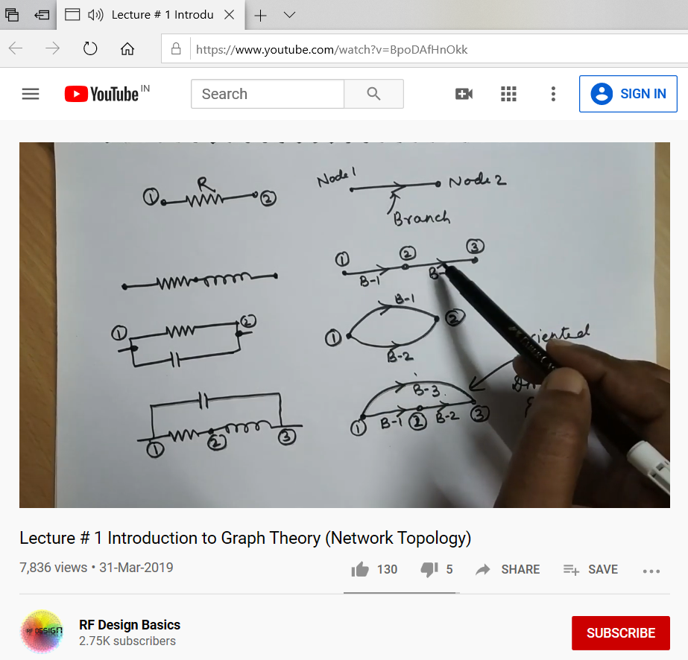

**REPORT**

* **Network terminology**
* **Nodes**
* **Branches**
* **Loops or meshes**
* **Branch currents & mesh currents**
* **Node voltages & Junction node voltages**
* **Basic circuit analysis & network topology**
* **Overview of analysis**
* **Serial/parallel reduction**
* **Voltage/current division**
* **Ladder circuit**
* **Network topology is a graphical representation of electric circuits.**
* **It is useful for analyzing complex electric circuits by converting them into network graphs. Network topology is also called as Graph theory.**
* **Graph of a network**
* **Network graph is simply called as graph.**
* **It consists of a set of nodes connected by branches. In graphs, a node is a common point of two or more branches. Sometimes, only a single branch may connect to the node. A branch is a line segment that connects two nodes.**
* **Incidence matrix**
* **An Incidence Matrix represents the graph of a given electric circuit or network. Hence, it is possible to draw the graph of that same electric circuit or network from the incidence matrix.**
* **Formation of tie-set and cut-set matrix**
* **Tie-Set: It is a unique set with respect to a given tree at a connected graph containing on chord and all of the free branches contained in the free path formed between two vertices of the chord.**
* **Cut-Set: It is that set of elements or branches of a graph that separated two parts of a network. If any branch of the cut-set is not removed, the network remains connected. The term cut-set is derived from the property designated by the way by which the network can be divided in to two parts.**
* **Tie-set & cut-set matrix applications in KVL & KCL were also discussed.**

**AFTERNOON SESSION**

**Image of the session**

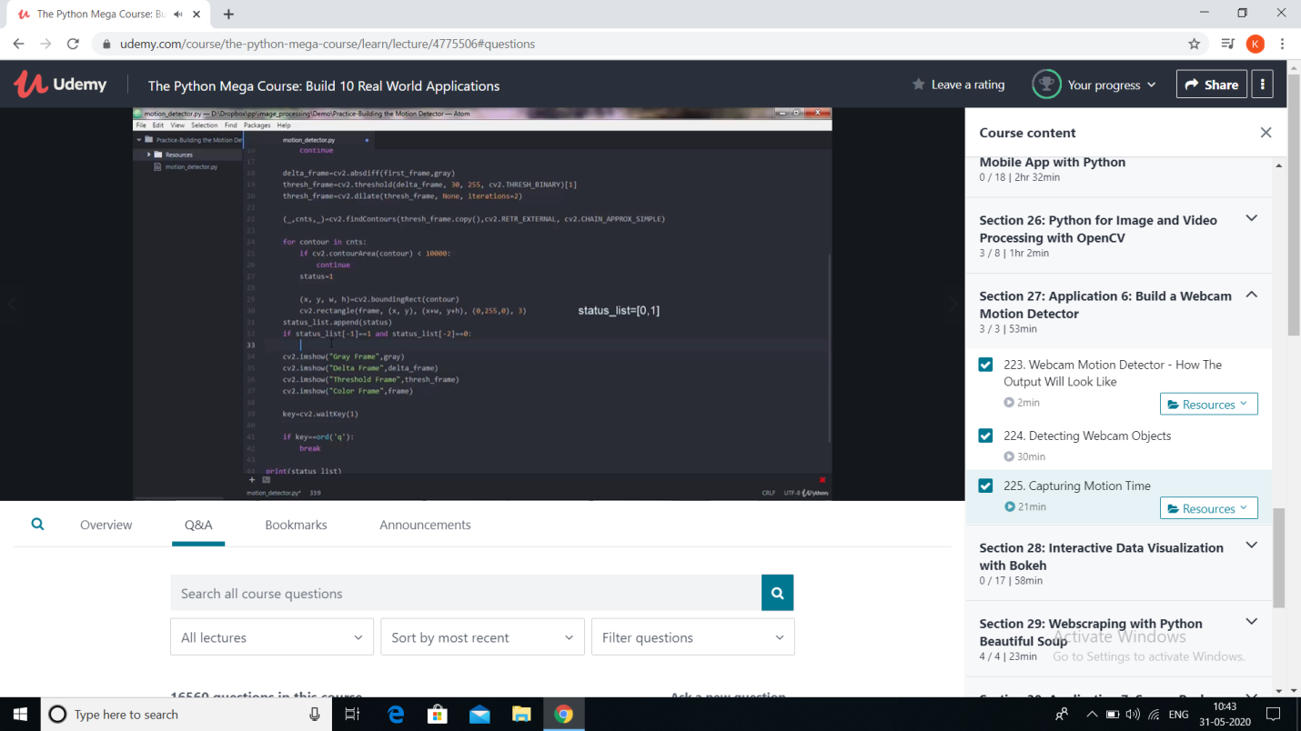

**REPORT**

* **Application 6: Build a webcam motion detector**

**●Introduction -**

**★This python program will allow you to detect motion and also store the time interval of the motion.**

**★Videos can be treated as stack of pictures called frames.**

**★We compare two images by comparing the intensity value of each pixel.**

**●After running the code there 4 new windows will appear on screen,**

**★Gray Frame**

**★Difference Frame**

**★Threshold Frame**

**★Color Frame**

**●Detecting Webcam Objects**

**●Capturing Motion Time**

**★Motion Capture is the process of capturing the movement of a real object and mapping it onto a computer generated object**