**DAILY ASSESSMENT FORMAT**

|  |  |  |  |
| --- | --- | --- | --- |
| **Date:** | **02/06/2020** | **Name:** | **Kirti B S** |
| **Course:** | **Network Theory** | **USN:** | **4AL18EC026** |
| **Topic:** | **Network Theorems** | **Semester & Section:** | **4th Sem**  **‘A’ Section** |
| **Github Repository:** | **Kirti BS** |  |  |

**FORENOON SESSION**

**Image of the session**

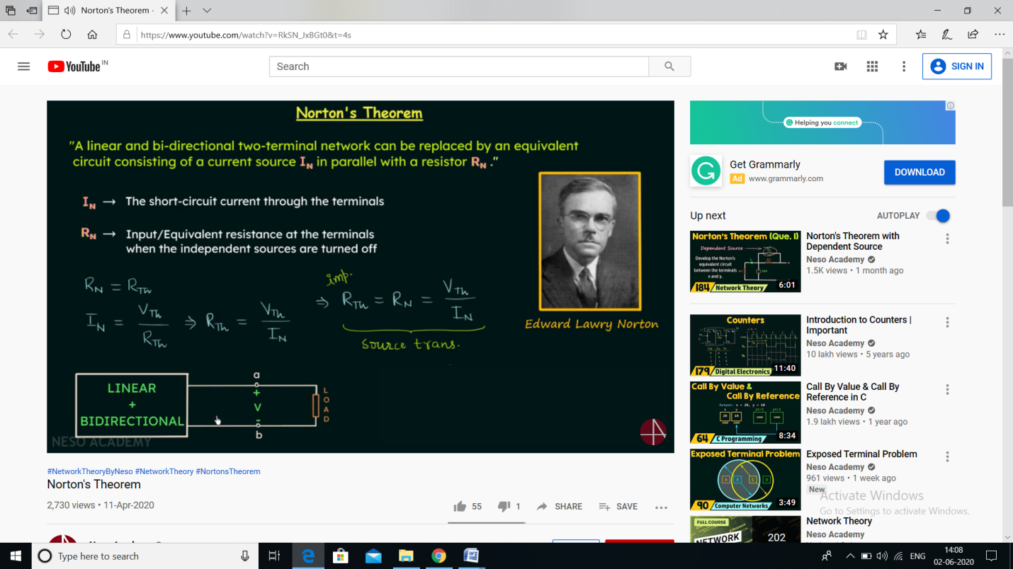

**REPORT**

* **Network Theorems**
* **Intro -In case of complex network, tedious competition will get involved**
* **To handle this complex network, theorems are used by the Engineers**
* **There are 9 theorems which are discussed below**
* **Superposition theorem**
* **How to use this theorem to do the analysis of linear Bidirectional network**
* **Note**
* **The dependent sources are left as they are**
* **The Superposition theorem is not valid in case of non-linear circuit**
* **Discussed with example problem**
* **Thevenin’s theorem**
* **Was given by Leon Charles Thevenin who was a French Engineer, developed on 1883**
* **Why this theorem is needed**
* **If often happens that the element in a circuit is variable while the other elements are fixed, each time the variable element is changed the entire circuit must be analyzed again**
* **To avoid this problem, we replace fixed part of the circuit by an Thevenin’s equivalent circuit**
* **Discussed with example problem**
* **Norton’s theorem**
* **Norton's Theorem states that it is possible to simplify any linear circuit, no matter how complex, to an equivalent circuit with just a single current source and parallel resistance connected to a load**
* **Need of this theorem**
* **The Norton equivalent circuit is used to represent any network of linear sources and impedances at a given frequency.**
* **Norton's theorem and its dual, Thevenin’s theorem, are widely used for circuit analysis simplification and to study circuit's initial-condition and steady-state response**
* **Reciprocity theorem**
* **Need of Reciprocity theorem**
* **Reciprocity theorems are used in many electromagnetic applications, such as analyzing electrical networks and antenna systems**
* **The Reciprocity Theorem is applicable for both AC and DC Circuits**
* **While applying Reciprocity Theorem, the circuit does not have time varying element**
* **Millman’s theorem**
* **Millman’s theorem is a method to simplify the solution of a circuit**
* **Specifically, Millman’s theorem is used to compute the voltage at the ends of a circuit made up of only branches in parallel**
* **It is named after Jacob Millman, who proved the theorem**
* **Max Power Transfer theorem**
* **The maximum amount of power will be dissipated by a load resistance if it is equal to the Thevenin or Norton resistance of the network supplying power**
* **Compensation theorem**
* **In Compensation Theorem, the source voltage (VC) opposes the original current**
* **Can be stated as – the resistance of any network can be replaced by a voltage source, having the same voltage as the voltage drop across the resistance which is replaced**
* **Tellegen’s theorem**
* **Tellegen's Theorem states that the summation of power delivered is zero for each branch of any electrical network at any instant of time**
* **It is mainly applicable for designing the filters in signal processing**
* **It is also used in complex operating systems for regulating stability**
* **Resonance**
* **Series RLC Circuits**
* **Parallel RLC Circuits**

**DAILY ASSESSMENT FORMAT**

|  |  |  |  |
| --- | --- | --- | --- |
| **Date:** | **02/06/2020** | **Name:** | **Kirti B S** |
| **Course:** | **Python** | **USN:** | **4AL18EC026** |
| **Topic:** | **Interactive Data Visualization with Bokeh** | **Semester & Section:** | **4th Sem**  **‘A’ Section** |
| **Github Repository:** | **Kirti BS** |  |  |

**AFTERNOON SESSION**

**Image of the session**

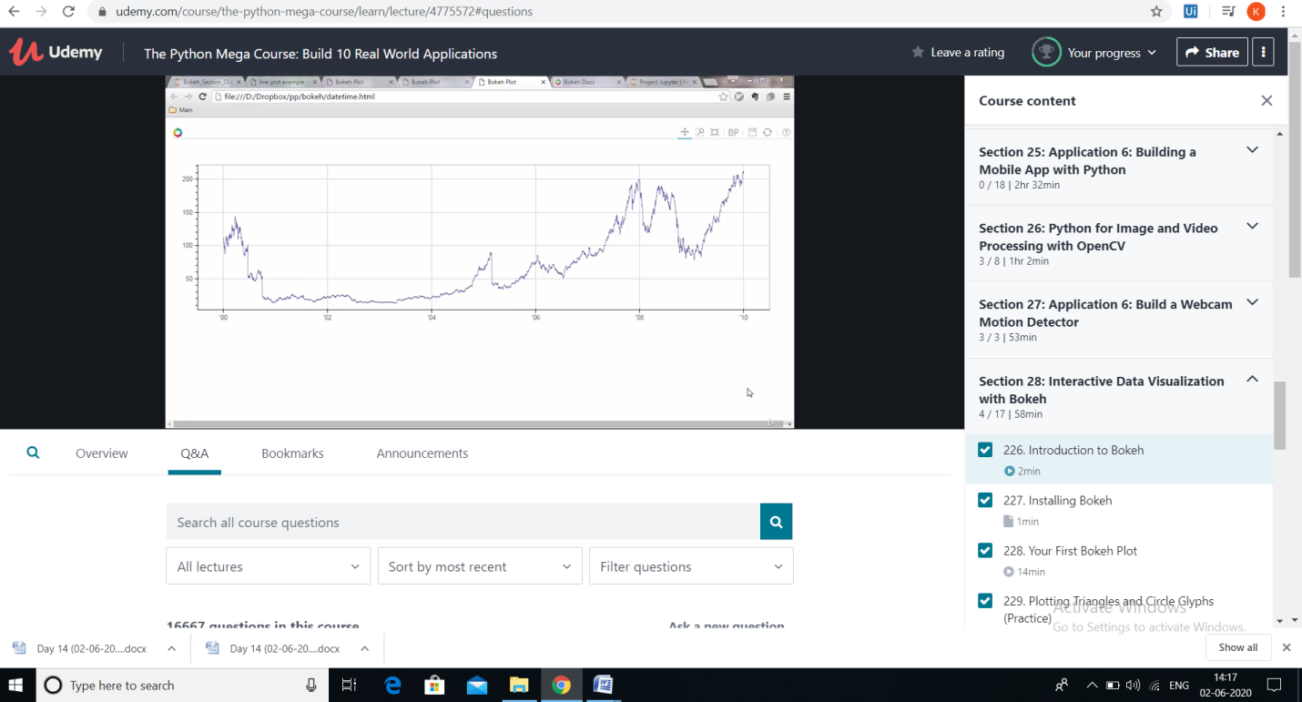

**REPORT**

**Interactive Data Visualization with Bokeh**

* **Introduction to Bokeh**

**Bokeh is a Python interactive visualization library that targets modern web browsers for presentation providing elegant, concise construction of novel graphics with high-performance interactivity over very large or streaming datasets in a quick and easy way.**

**Offering both powerful and flexible features to enable very advanced customizations in one hand and simplicity on the other, Bokeh exposes different interface levels to the users: A ​*low-level*​ ​[bokeh.models](https://docs.bokeh.org/en/0.10.0/docs/reference/models.html" \l "bokeh-models)​ interface that provides the most flexibility to application developers. An *intermediate-level***[**​**](https://docs.bokeh.org/en/0.10.0/docs/reference/plotting.html#bokeh-plotting)[**bokeh.plottin**](https://docs.bokeh.org/en/0.10.0/docs/reference/plotting.html#bokeh-plotting)**​** [**g**](https://docs.bokeh.org/en/0.10.0/docs/reference/plotting.html#bokeh-plotting) **interface that is centered around​ composing visual glyphs. A ​*high-level***[**​**](https://docs.bokeh.org/en/0.10.0/docs/reference/charts.html#bokeh-charts) **​[bokeh.charts](https://docs.bokeh.org/en/0.10.0/docs/reference/charts.html" \l "bokeh-charts)​****interface that can be used to build complex statistical plots as quickly and as simply as possible. This Quickstart focuses on the ​[bokeh.plotting](https://docs.bokeh.org/en/0.10.0/docs/reference/plotting.html" \l "bokeh-plotting)​****interface**

* **Installing Bokeh**
* **First Bokeh Plot**

**Plots are a central concept in Bokeh. They are containers that hold all the various objects (renderers, guides, data, and tools) that comprise the final visualization that is presented to users**

* **Using Bokeh with Pandas**
* **Plot properties**
* **Plotting weather data**
* **Visual attributes**
* **Time-series plots**
* **Plotting time intervals of the motion**
* **Hover tool implementation**