**DAILY ASSESSMENT FORMAT**

|  |  |  |  |
| --- | --- | --- | --- |
| **Date:** | **03/06/2020** | **Name:** | **Kirti B S** |
| **Course:** | **Network Theory** | **USN:** | **4AL18EC026** |
| **Topic:** | **1.Intial and final conditions in RC,RL,RLC circuits**  **2.Two port networks** | **Semester & Section:** | **4th Sem**  **‘A’ Section** |
| **Github Repository:** | **Kirti BS** |  |  |

**FORENOON SESSION**

**Image of the session**

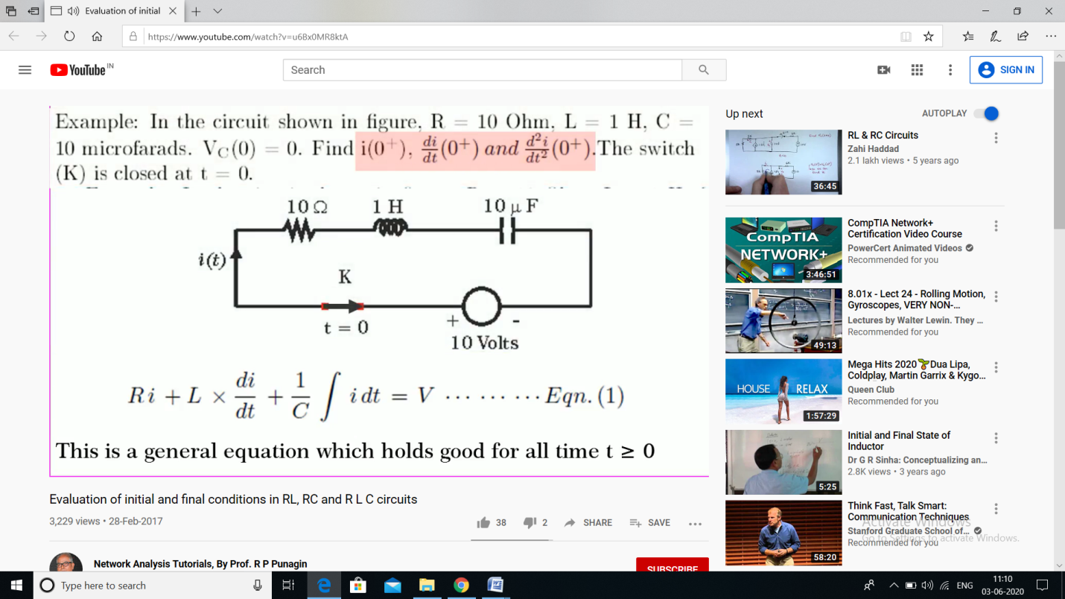

**REPORT**

* **Evaluation of initial and final condition in RL, RC and RLC circuits**
* **Initial conditions describe the energy stored in every capacitor and every inductor**
* **Initial conditions are completely specified only when both voltage and current for all capacitors and all inductors is known**
* **The final condition (steady state condition) equivalent circuit of an inductor is derived from the basic relationship v =L di/dt**
* **Under steady state condition di/dt=0**
* **This means v =0 and hence L acts as a short circuit at t = ∞ (final or steady state)**
* **Procedures for evaluating initial and final conditions**
* **Explained with some Numerical**
* **2 port networks**
* **Port – is a pair of terminals which connects the electrical circuit or network to the external circuit**
* **Types**
* **Multi-Port Network**
* **Two Port Network**
* **Any linear circuit with two pair of terminals can be regraded as two port networks, if it does not contain independent source and satisfies the port condition**
* **Six different parameters can be defined for the two-port network**
* **Y-Parameters**
* **h-Parameters**
* **ABCD or Transmission-Parameters**
* **Inverse Hybrid-Parameters**
* **Inverse Transmission-Parameters**

**All these parameters were explained with suitable numerical examples**

**AFTERNOON SESSION**

|  |  |  |  |
| --- | --- | --- | --- |
| **Date:** | **03/06/2020** | **Name:** | **Kirti B S** |
| **Course:** | **Python** | **USN:** | **4AL18EC026** |
| **Topic:** | **Scrape Real Estate Property Data from the Web** | **Semester & Section:** | **4th Sem**  **‘A’ Section** |
| **Github Repository:** | **Kirti BS** |  |  |

**Image of the session**

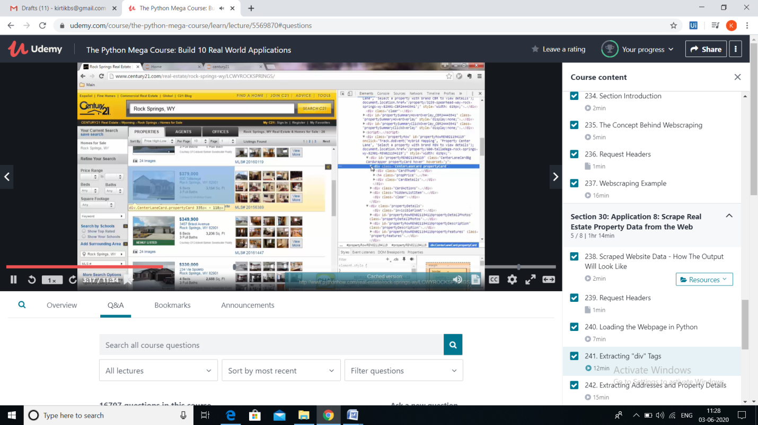

**REPORT**

* **Scrape Real Estate Property Data from the Web**
* **Intro –**
* **process of sorting through overwhelming amounts of data, refine the user's searches and provide a list of relevant information**
* **In a realtor's case, it is the go-to tool for organized property listings**
* **Request Headers**
* **HTTP header that can be used in an HTTP request, and that doesn't relate to the content of the message**
* **Under this session**
* **Loading the Webpage in Python**
* **Extracting “div” Tags**
* **Extracting Addresses, Property Details and elements without Unique Identifiers**
* **Saving the Extracted Data in CSV Files**
* **Crawling through Webpages**
* **The session was very informative and relevant topics were covered.**