**DAILY ASSESSMENT FORMAT**

|  |  |  |  |
| --- | --- | --- | --- |
| **Date:** | **05/06/2020** | **Name:** | **Kirti B S** |
| **Course:** | **Network Theory** | **USN:** | **4AL18EC026** |
| **Topic:** | **Online open source circuit simulation** | **Semester & Section:** | **4th Sem**  **‘A’ Section** |
| **Github Repository:** | **Kirti BS** |  |  |

**FORENOON SESSION**

**Image of the session**

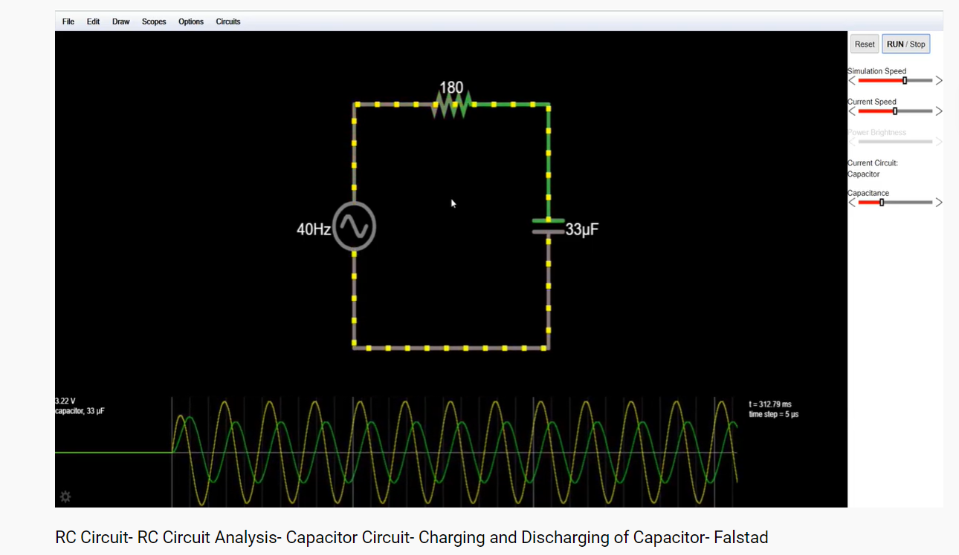

* **Online open source circuit simulation**
* **Series RLC**
* **Resonance occurs in a series circuit when the supply frequency causes the voltages across L and C to be equal and opposite in phase**
* **The inductive reactance is “Proportional” to frequency and is small at low frequencies and high at higher frequencies**
* **parallel RLC**
* **The Parallel RLC Circuit is the exact opposite to the series circuit**
* **In a parallel RLC circuit containing a resistor, an inductor and a capacitor the circuit current IS is the phasor sum made up of three components, IR, IL and IC with the supply voltage common to all three. Since the supply voltage is common to all three components it is used as the horizontal reference when constructing a current triangle**
* **RL AND RC series circuits frequency response**
* **Make inference of the response of the circuit for the**
* **Change in frequency**
* **Change in parameter values (R, L,C)**

**AFTERNOON SESSION**

|  |  |  |  |
| --- | --- | --- | --- |
| **Date:** | **05/06/2020** | **Name:** | **Kirti B S** |
| **Course:** | **Python** | **USN:** | **4AL18EC026** |
| **Topic:** | **Data collector web app with PostGreSQL and Flask** | **Semester & Section:** | **4th Sem**  **‘A’ Section** |
| **Github Repository:** | **Kirti BS** |  |  |

**Image of the session**

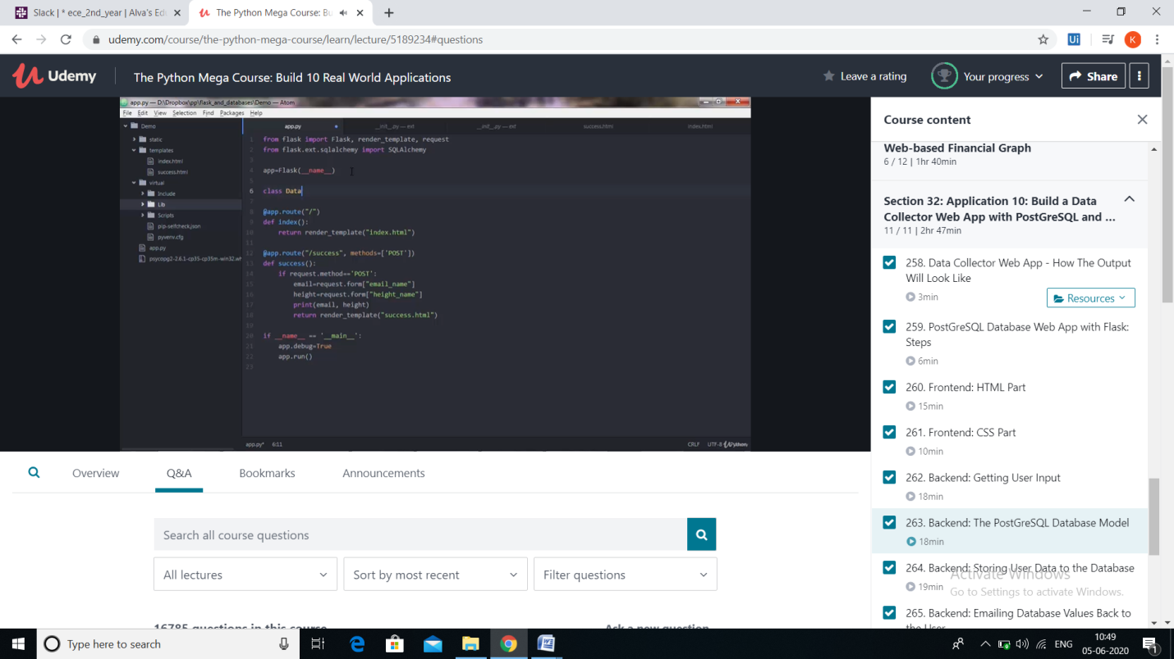

**REPORT**

* **Building a Data collector web app with PostGreSQL and Flask**
* **Overview of the output**
* **PostGreSQL Database Web app with Flask steps**
* **Frontend: HTML Part**
* **Frontend: CSS Part**
* **Backend: Getting User Input**
* **Backend: The PostGreSQL Database model**
* **Backend: Storing user data to the database**
* **Backend: Emaiing database values back to the user**
* **Deploying the web application to a live server**
* **The session was very informative**