**DAILY ASSESSMENT REPORT**

|  |  |  |  |
| --- | --- | --- | --- |
| **Date:** | **08/06/2020** | **Name:** | **Kirti B S** |
| **Course:** | **Management and Leadership** | **USN:** | **4AL18EC026** |
| **Github Repositry:** | **Kirti BS** | **Semester & Section:** | **4TH Semester**  **‘A’ Section** |

**FORENOON SESSION**

**Image of the session**

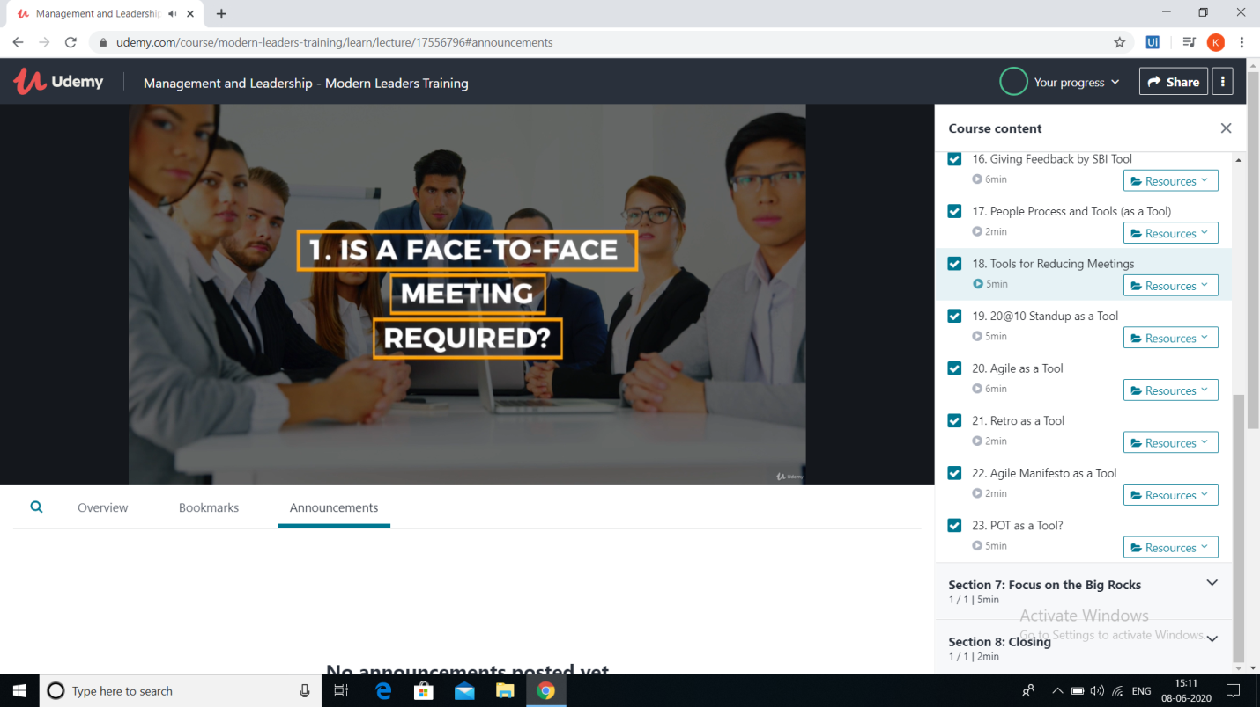

**REPORT**

**Course covered:**

* **Introduction**
* **Leader Definition**
* **Leader vs. Manager**
* **Become an everyday leader**
* **Leadership styles**
* **The important context**
* **Leaders in career, family and community**
* **Leaders Triangle**
* **Learning to lead**
* **Learn by doing**
* **Tools for leading teams**
* **Focus on the Big Rocks**
* **Conclusion**

**AFTERNOON SESSION**

|  |  |  |  |
| --- | --- | --- | --- |
| **Date:** | **08/06/2020** | **Name:** | **Kirti B S** |
| **Course:** | **Beginner PHP and MySQL** | **USN:** | **4AL18EC026** |
| **Github Repositry:** | **Kirti BS** | **Semester & Section:** | **4TH Semester**  **‘A’ Section** |

**Image of the session**

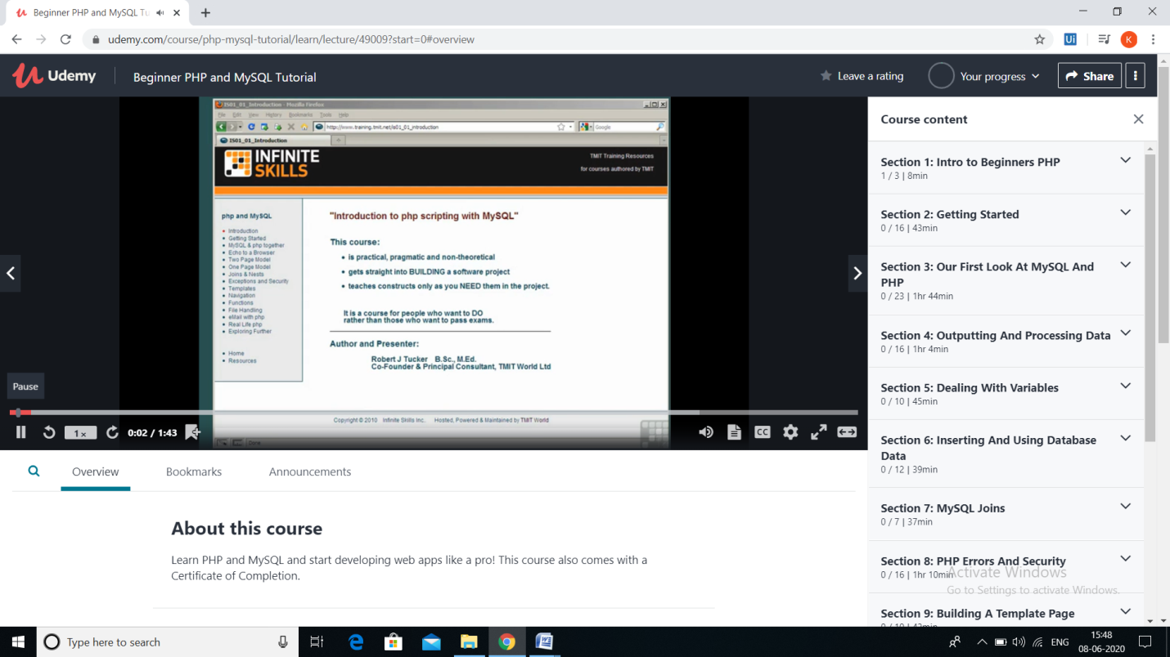

**REPORT**

* **Introduction to beginners PHP**
* **Getting Started**
* **XAMPP- Introduction, downloading, installation, setup**
* **Setting up a PHP editor- bluefish**
* **The bluefish interface**
* **Downloading PHP snippets**
* **PHP comments**
* **My first PHP page**
* **Using PHP snippets**
* **Introduction to MySQL Databases**
* **Into phpMyAdmin**
* **The session was very informative.**