**DAILY ASSESSMENT REPORT**

|  |  |  |  |
| --- | --- | --- | --- |
| **Date:** | **10/06/2020** | **Name:** | **Kirti B S** |
| **Course:** | **PCB** | **USN:** | **4AL18EC026** |
| **GitHub Repository:** | **Kirti BS** | **Semester & Section:** | **4th Sem ‘A’ Sec** |

**FORENOON SESSION**

**Image of the session**

* **PCB**
* **Mounting holes**
* **Create a library and put your own component in that library**
* **Create PCB footprint component**

**AFTERNOON SESSION**

|  |  |  |  |
| --- | --- | --- | --- |
| **Date:** | **10/06/2020** | **Name:** | **Kirti B S** |
| **Course:** | **Beginner PHP and MySQL** | **USN:** | **4AL18EC036** |
| **GitHub Repository:** | **Kirti BS** | **Semester & Section:** | **4th Sem ‘A’ Sec** |

**Image of the session**

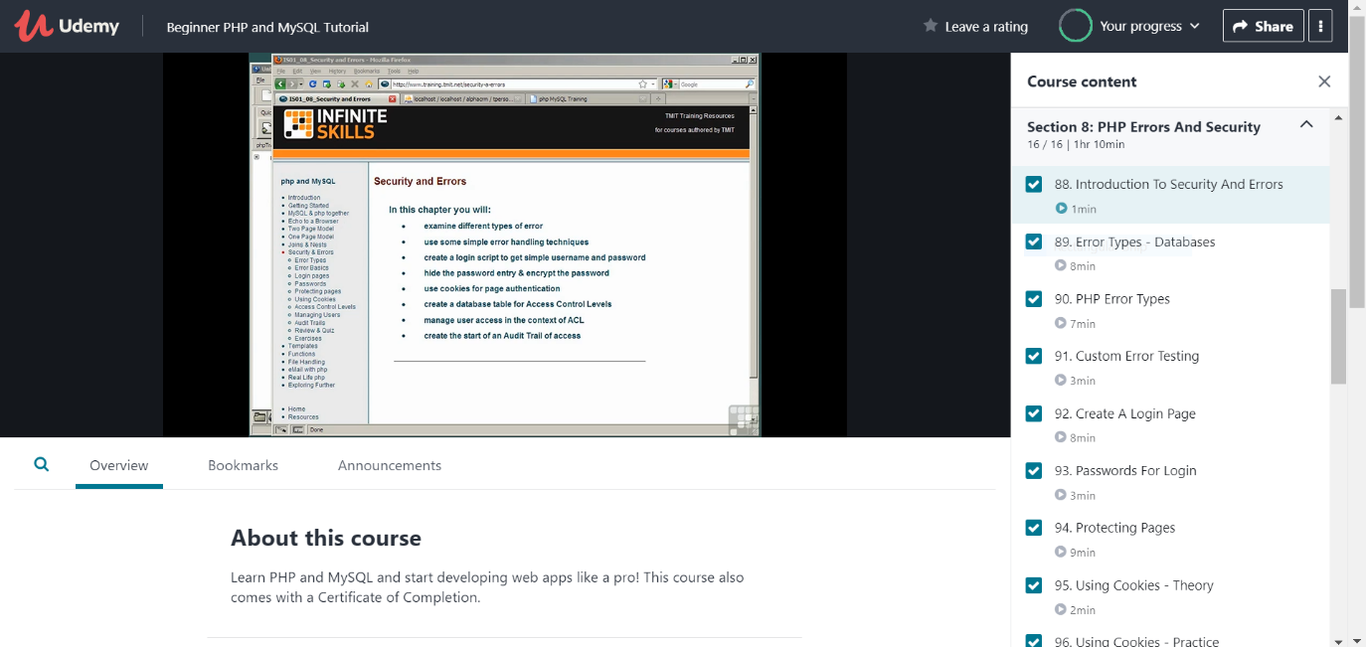

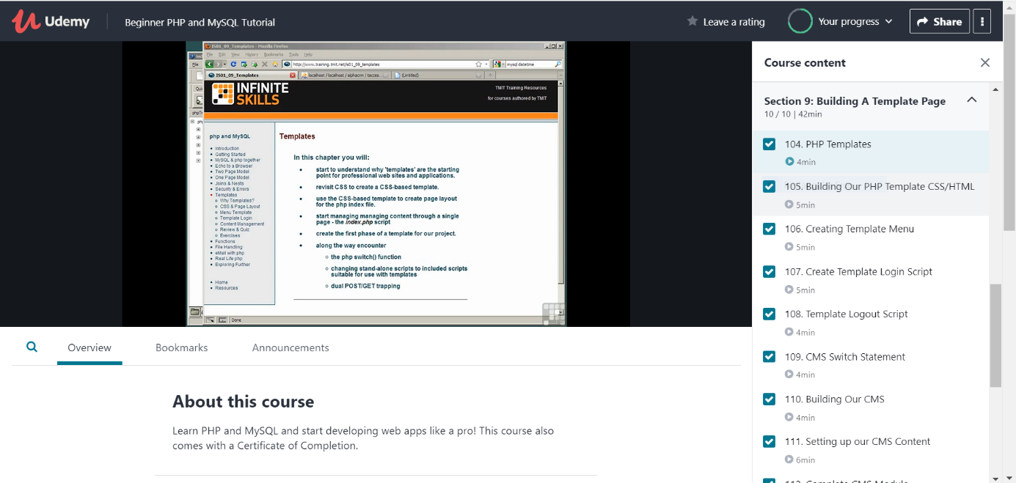

* **MySQL Joins**
* **MySQL Join Types - Examples**
* **MySQL Join Diagrams**
* **Creating Nested Lists**
* **MySQL Nested Processing**
* **Styling Our Lists**
* **Intro to Functions**
* **Included Files**
* **PHP Errors and security**
* **Introduction to Security and Errors**
* **Error Types - Databases**
* **PHP Error Types**
* **Custom Error Testing**
* **Create A Login Page**
* **Passwords for Login**
* **Protecting Pages**
* **Using Cookies**
* **Access Levels - Basic Restriction and Restrict Fields**
* **Managing Users – Structure and Create New**
* **Audit Trails - Access Function and Logging Logins**
* **Building a template page**
* **PHP Templates**
* **Building Our PHP Template CSS/HTML**
* **Creating Template Menu**
* **Create Template Login Script**
* **Template Logout Script**
* **CMS Switch Statement**
* **Building Our CMS**
* **Setting up our CMS Content**
* **Complete CMS Module**