**DAILY ASSESSMENT REPORT**

|  |  |  |  |
| --- | --- | --- | --- |
| **Date:** | **11/06/2020** | **Name:** | **Kirti B S** |
| **Course:** | **PCB** | **USN:** | **4AL18EC026** |
| **GitHub Repository:** | **Kirti BS** | **Semester & Section:** | **4th Sem ‘A’ Sec** |

**FORENOON SESSION**

**Image of the session**

* **PCB**
* **Add Footprint search path**
* **A footprint or land pattern is the arrangement of pads (in surface-mount technology) or through-holes (in through-hole technology) used to physically attach and electrically connect a component to a printed circuit board**
* **The land pattern on a circuit board matches the arrangement of leads on a component**
* **Prepare production files**

**AFTERNOON SESSION**

|  |  |  |  |
| --- | --- | --- | --- |
| **Date:** | **11/06/2020** | **Name:** | **Kirti B S** |
| **Course:** | **Beginner PHP and MySQL** | **USN:** | **4AL18EC026** |
| **GitHub Repository:** | **Kirti BS** | **Semester & Section:** | **4th Sem ‘A’ Sec** |

**Image of the session**

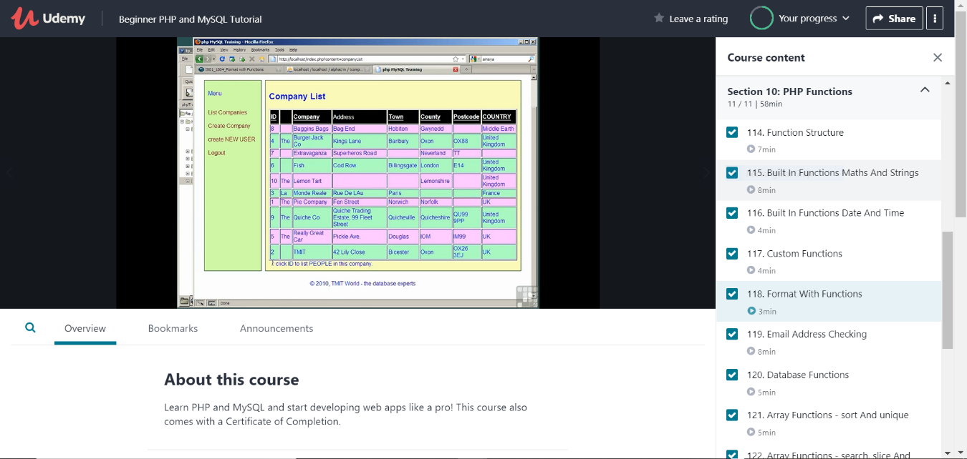

* **PHP functions**
* **Function Structure**
* **Built in Functions Math’s and Strings**
* **Built in Functions Date and Time**
* **Custom Functions**
* **Format with Functions**
* **Email Address Checking**
* **Database Functions**
* **Array Functions - sort and unique**
* **Array Functions - search, slice and merge**
* **Server Variables**
* **Browser Detection**
* **Using external files and images**
* **Reading Text Files**
* **Writing Text Files**
* **Working with Image Files - exit**
* **Creating Image Files with GD Library**
* **Managing Images with GD Library**
* **Resizing Images With PHP**
* **Uploading Files - Overview**
* **Uploading Files - In Action**
* **Remote File Parsing**