**DAILY ASSESSMENT REPORT**

|  |  |  |  |
| --- | --- | --- | --- |
| **Date:** | **15/06/2020** | **Name:** | **Kirti B S** |
| **Course:** | **Digital Marketing** | **USN:** | **4AL18EC026** |
| **GitHub Repository:** | **Kirti BS** | **Semester & Section:** | **4th Sem ‘A’ Section** |

**FORENOON SESSION**

**Image of the session**

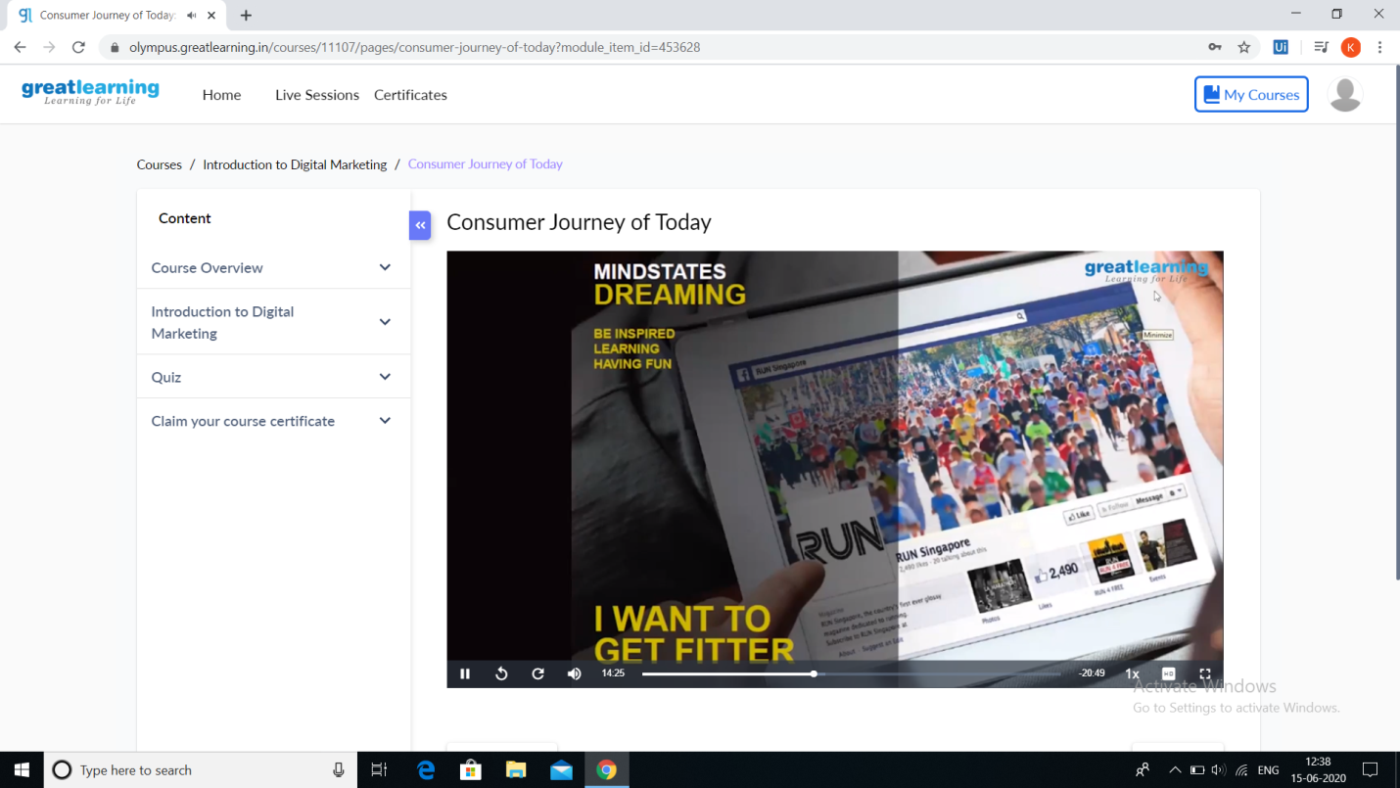

**REPORT**

* **Introduction to Digital Marketing**
* **Consumer journey of Today**
* **Explanation of New Medias**
* **Understanding Brand Purpose**
* **Introduction to Facebook Marketing**
* **Purpose of using Facebook marketing channel**
* **Facebook interfaces and Type of audience**
* **Adset setup guide**
* **What is custom audience?**
* **Types of ads**

**As digital platforms became increasingly incorporated into marketing plans and everyday life, and as people increasingly use digital devices instead of visiting physical shops, digital marketing campaigns have become prevalent, employing combinations of**[**search engine optimization**](https://en.wikipedia.org/wiki/Search_engine_optimization)**(SEO),**[**search engine marketing**](https://en.wikipedia.org/wiki/Search_engine_marketing)**(SEM),**[**content marketing**](https://en.wikipedia.org/wiki/Content_marketing)**,**[**influencer marketing**](https://en.wikipedia.org/wiki/Influencer_marketing)**, content automation, campaign marketing,**[**data**](https://en.wikipedia.org/wiki/Data)**-driven marketing, e-**[**commerce**](https://en.wikipedia.org/wiki/E-commerce)**marketing,**[**social media marketing**](https://en.wikipedia.org/wiki/Social_media_marketing)**,**[**social media optimization**](https://en.wikipedia.org/wiki/Social_media_optimization)**,**[**e-mail direct marketing**](https://en.wikipedia.org/wiki/Email_marketing)**,**[**display advertising**](https://en.wikipedia.org/wiki/Display_advertising)**,**[**e–books**](https://en.wikipedia.org/wiki/E-book)**, and**[**optical disks**](https://en.wikipedia.org/wiki/Optical_disc)**and games have become commonplace.**