**DAILY ASSESSMENT REPORT**

|  |  |  |  |
| --- | --- | --- | --- |
| **Date:** | **16/06/2020** | **Name:** | **Kirti B S** |
| **Course:** | **Statistical Learning** | **USN:** | **4AL18EC026** |
| **GitHub Repository:** | **Kirti BS** | **Semester & Section:** | **4th Sem ‘A’ Section** |

**FORENOON SESSION**

**Image of the session**

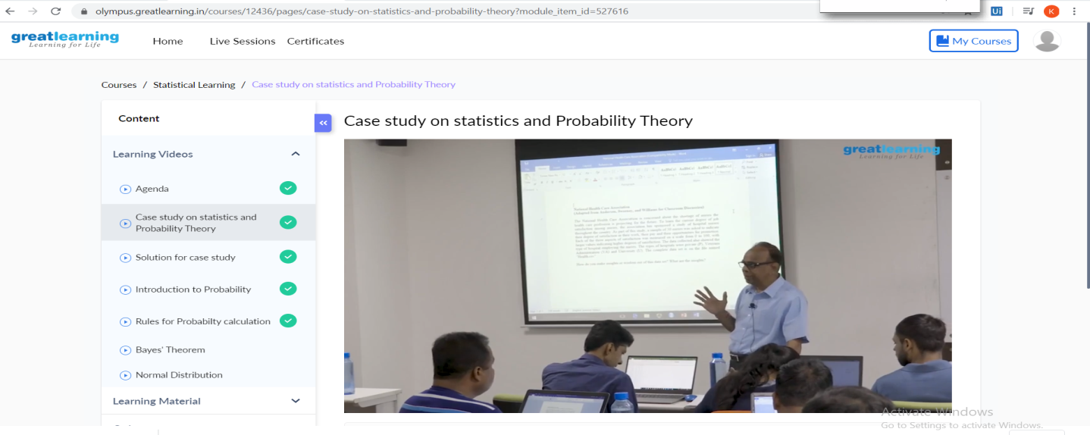

**REPORT**

* **Case study on statistics and probability theory**
* [**Statistics has a significant part in the field of**](https://www.mygreatlearning.com/blog/inferential-statistics-an-overview/#reference)[**data science**](https://www.mygreatlearning.com/blog/what-is-data-science/)**. It helps us in the collection, analysis and representation of data either by visualisation or by numbers into a general understandable format**
  + - **The mode for work**
    - **The three attributes has the highest mean satisfactory score / Lowest mean satisfactory score**
    - **The coefficients of variation for work, pay and promotions.**
    - **In the Histogram for promotion, which class has the highest concentration?**
    - **Is the shape of the box plot for work is skewed? If so, which direction?**
    - **The points are outliers in promotion box plot**
    - **If all the box plot for work are drawn for all the hospitals, which hospital type has the best median value?**
    - **If the box plots for work, pay, promotion are drawn in the same space, how many outliers are there for promotion and pay?**
* **The solutions for the same questions were discussed in this section.**