**DAILY ASSESSMENT REPORT**

|  |  |  |  |
| --- | --- | --- | --- |
| **Date:** | **17/06/2020** | **Name:** | **Kirti B S** |
| **Course:** | **Statistical Learning** | **USN:** | **4AL18EC026** |
| **GitHub Repository:** | **Kirti BS** | **Semester & Section:** | **4th Sem ‘A’ Section** |

**FORENOON SESSION**

**Image of the session**

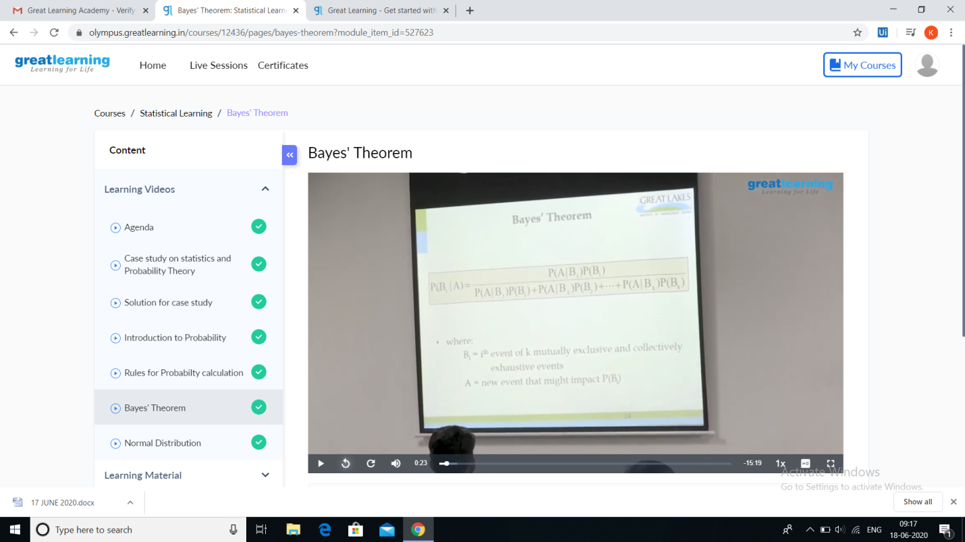

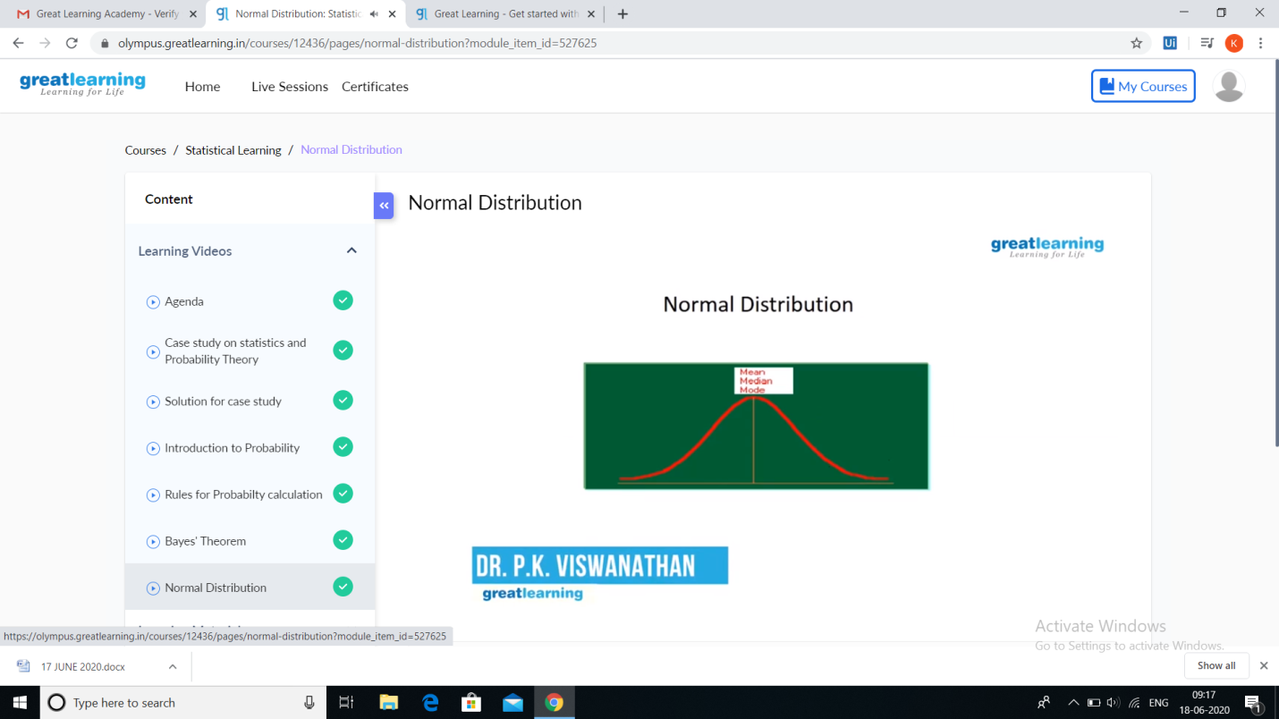

**REPORT**

* **Introduction to Probability: Probability an Introduction. Probability is the science of how likely events are to happen. At its simplest, it's concerned with the roll of a dice, or the fall of the cards in a game**
* **Rules for Probability Calculation: Rule of Addition The probability that Event A or Event B occurs is equal to the probability that Event A occurs plus the probability that Event B occurs minus the probability that both Events A and B occur.**
* **Bayes’ Theorem: in probability theory and statistics, Bayes ‘ theorem describes the probability of an event, based on prior knowledge of conditions that might be related to the event.**
* **Normal Distribution: Normal distribution, also known as the Gaussian distribution, is a probability distribution that is symmetric about the mean, showing that data near the mean are more frequent in occurrence than data far from the mean. In graph form, normal distribution will appear as a bell curve.**
* **The session was very informative.**