**DAILY ASSESSMENT FORMAT**

|  |  |  |  |
| --- | --- | --- | --- |
| **Date:** | **20/05/2020** | **Name:** | **Kirti B S** |
| **Course:** | **TCS iON** | **USN:** | **4AL18EC026** |
| **Topic:** | **1. Ace Corporate Interviews**  **2. Learn Corporate Etiquette**  **3. Write Effective Email** | **Semester & Section:** | **3rd Sem**  **‘A’ Section** |
| **Github Repository:** | **Kirti BS** |  |  |

|  |
| --- |
| **FORENOON SESSION** |
| **Image of the session** |

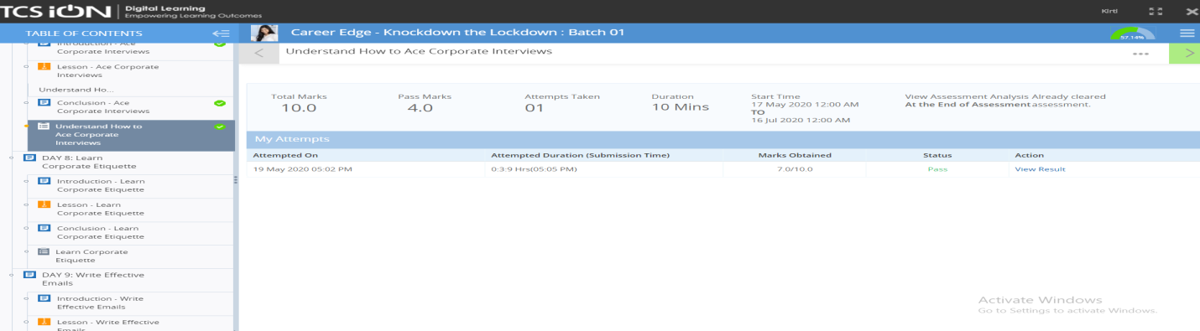

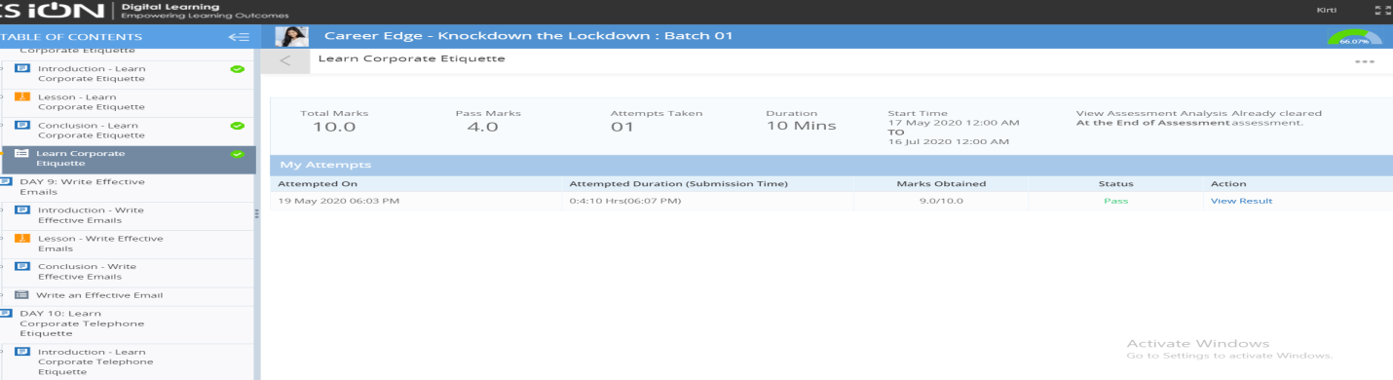

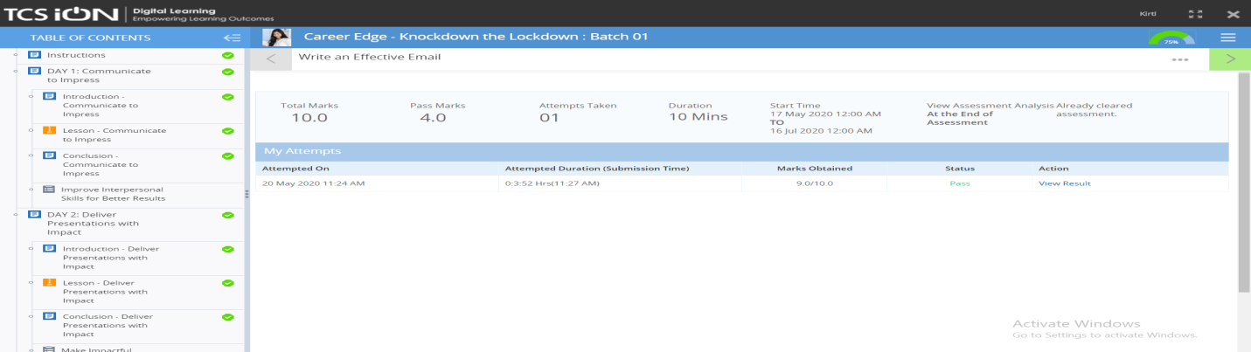

**REPORT**

**Ace Corporate Interviews**

* **Explained the importance of interview**
* **Imbibing the skills & expertise an interview requires**
* **Do’s & Don’ts of an effective interview**
* **Developing good opening & closing interview strategy**
* **Identifying your strength & weakness**

**Learn Corporate Etiquette**

* **The importance of Business Etiquette**
* **Basic rules of Corporate Etiquette**
* **Cubicle etiquette**
* **Internet etiquette**
* **Meeting etiquette**

**Write Effective Email**

* **Introduction to email etiquette**
* **Structure of an email**
* **Format of an email- effective subject line & text**
* **Do’s & Don’ts of an email**
* **Case study**

|  |
| --- |
| **AFTERNOON SESSION** |
| **Image of the session** |

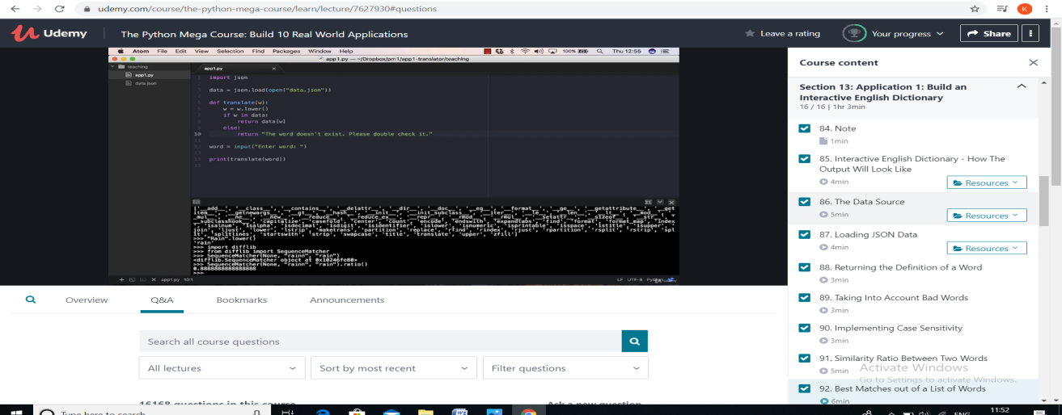

**REPORT**

**Topics covered,**

**Application: Build an interactive English dictionary**

* **It is a console application, made by using python programming language. It takes the word from the user and returns its definition from the data .json file. It also gives best-matched word when the user enters the word with the wrong spelling.**
* **PyDictionary is a Dictionary Module for Python 2/3 to get meanings, translations, synonyms and Antonyms of words. It uses WordNet for getting meanings, Google for translations, and thesaurus.com for getting synonyms and antonyms.**
* **TOPICS LEARNT:**

**•Interactive English dictionary - How the output will look like**

**•The data source**

**•Loading JSON data**

**•Returning the definitions of a word**

**•Implementing case sensitivity**

**•Similarity ratio between two words**

**•Best matches out of a list of words**

**•Confirmation from the user**

**•Optimizing the final output**

