**DAILY ASSESSMENT FORMAT**

|  |  |  |  |
| --- | --- | --- | --- |
| **Date:** | **21/05/2020** | **Name:** | **Kirti B S** |
| **Course:** | **TCS iON** | **USN:** | **4AL18EC026** |
| **Topic:** | |  |  | | --- | --- | | **1.Learn Corporate Telephone Etiquette** |  | | **2.Understand Accounting Fundamentals** | | | **3.Gain Foundational Skills in IT** | | | **Semester & Section:** | **3rd Sem**  **‘A’ Section** |
| **Github Repository:** | **Kirti BS** |  |  |

|  |
| --- |
| **FORENOON SESSION** |
| **Image of the session** |

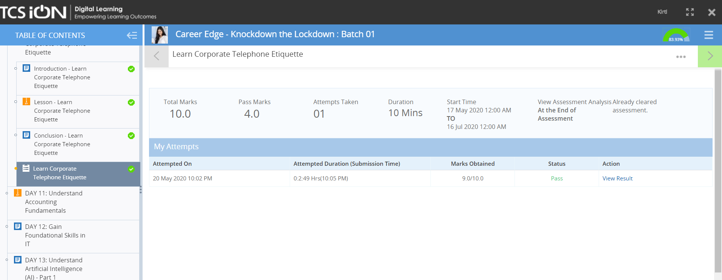

**REPORT**

* **Learn Corporate Telephone Etiquette**
* **Business Phone Etiquette-** Introduce yourself, Speak clearly, Listen to requests, Leave succinct voicemails.
* Treat callers the way you like to be treated on the phone.
* Phrases for – making & receiving phone calls.
* Taking message samples
* Voicemail etiquette
* Guidelines for telephone etiquette
* Telephone courtesies
* Be polite and professional in all types of communication
* **Understand Accounting Fundamentals**
* Basics of accounting
* Accounting cycle
* Double entry system of accounting
* Accounting classification- journals & ledgers
* Income statements, revenues , expenses
* Balance sheets
* Assets & liabilities
* Stockholder equity
* Debit & credit card rules
* **Gain Foundational Skills in IT**
* Basic IT skills
* IT competencies
* Demystify digital competencies
* Enhance problem solving skills
* Understand Algorithm Design Techniques
* Understand Code Optimization Techniques

|  |
| --- |
| **AFTERNOON SESSION** |
| **Image of the session** |

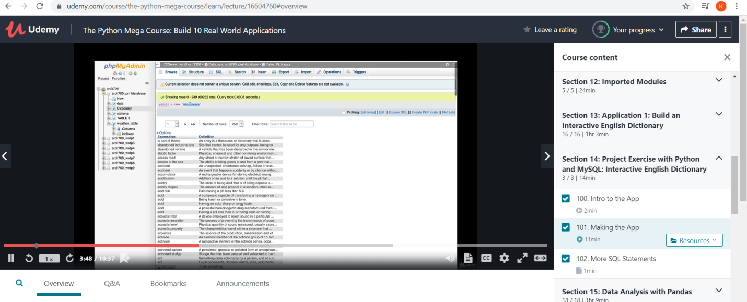

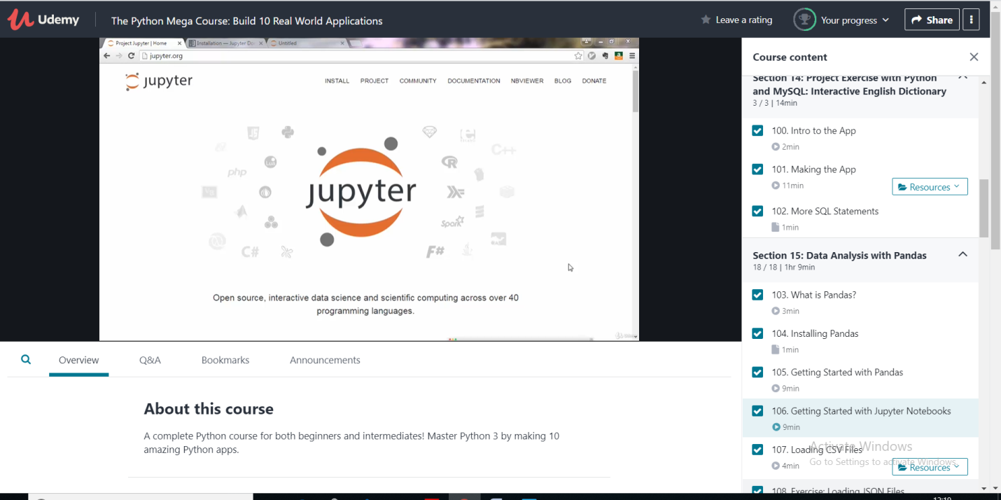

**REPORT**

* **Project exercise with python & MySQL: Interactive English dictionary**
* **Intro to the app**
* **Making the app**
* **More SQL statements**
* **Data analysis with pandas**
* **What is pandas?**
* **Installation of pandas**
* **Getting started with juypter notebooks**
* **Loading CSV, JSON, TXT & Excel files**
* **Geocoding addresses with pandas and geopy**
* **pandas  probably is the most popular library for data analysis in Python programming language. This library is a high-level abstraction over low-level NumPy which is written in pure C.**
* **Series is an object which is similar to Python built-in list data structure but differs from it because it has associated label with each element or so-called index. This distinctive feature makes it look like associated array or dictionary (hashmap representation).**
* **Example code:**

**>>> import pandas as pd  
>>> my_series = pd.Series([5, 6, 7, 8, 9, 10])  
>>> my_series  
0 5  
1 6  
2 7  
3 8  
4 9  
5 10  
dtype: int64  
>>**