**DAILY ASSESSMENT FORMAT**

|  |  |  |  |
| --- | --- | --- | --- |
| **Date:** | **22/05/2020** | **Name:** | **Kirti B S** |
| **Course:** | **TCS iON** | **USN:** | **4AL18EC026** |
| **Topic:** | |  |  | | --- | --- | | **1.Understand Artificial Intelligence (AI) - Part 1** |  | | **2.Understand Artificial Intelligence (AI) - Part 2** | | | **3.Assessment** | | | **Semester & Section:** | **3rd Sem**  **‘A’ Section** |
| **Github Repository:** | **Kirti BS** |  |  |

**FORENOON SESSION**

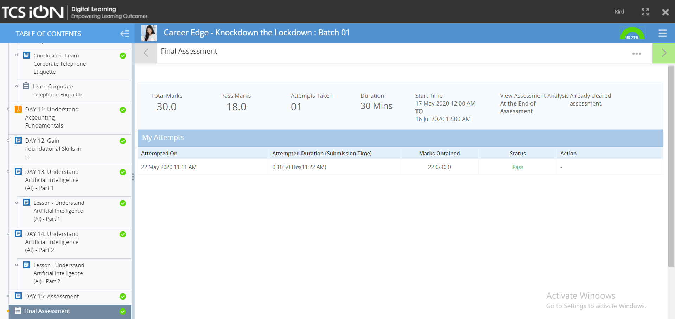

**REPORT**

* **Understand Artificial Intelligence (AI)**
* **Artificial Intelligence o build and understand intelligent entities or agents**
* **2 main approaches: “engineering” versus “cognitive modeling”**
* **Artificial Intelligence (AI) is a broad branch of computer science, aiming to create systems that can function intelligently and independently just like humans.**
* **AI is an imitation of human intelligence processes by machines. The intelligence processes include learning, reasoning, and self-correction. Specific AI applications include machine vision, speech recognition, and expert systems.**
* **Topics covered during the session were different components of intelligence behavior & types of problems that can be solved by AI**
* **What’s involved in Intelligence?**

**• Ability to interact with the real world**

**• Reasoning and Planning**

**• Learning and Adaptation**

* **History & foundation of Artificial Intelligence was also covered.**

**CERTIFICATE OF TCSiON COURSE COMPLETION**

|  |
| --- |
| **AFTERNOON SESSION** |

REPORT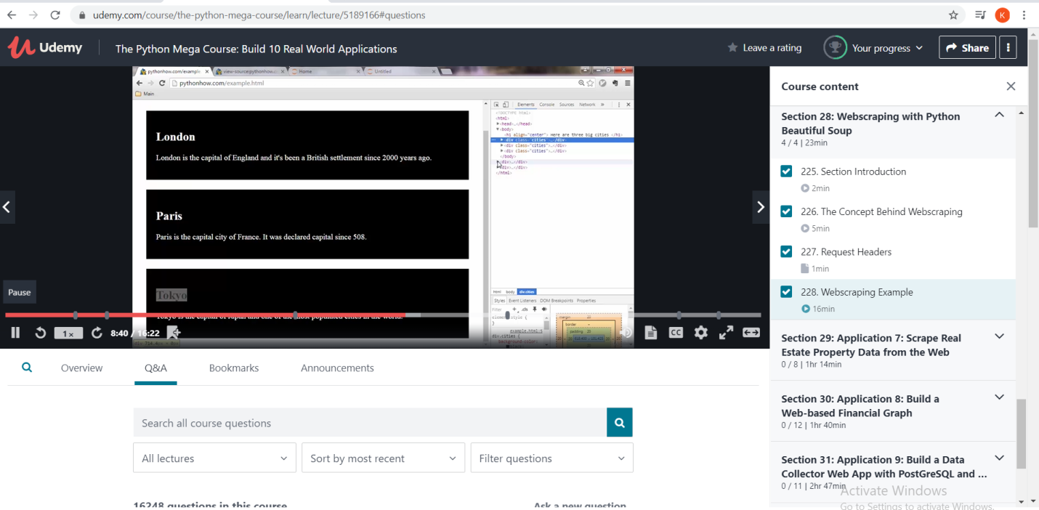

**REPORT**

* Webscraping with python Beautiful soup
* Web scraping is used to collect large information from websites.
* applications of web scraping:

**Price Comparison:** Services such as Parse Hub use web scraping to collect data from online shopping websites and use it to compare the prices of products.

**Email address gathering:** Many companies that use email as a medium for marketing, use web scraping to collect email ID and then send bulk emails.

**Social Media Scraping:** Web scraping is used to collect data from Social Media websites such as Twitter to find out what’s trending.

**Research and Development:** Web scraping is used to collect a large set of data (Statistics, General Information, Temperature, etc.) from websites, which are analyzed and used to carry out Surveys or for R&D.

**Job listings:** Details regarding job openings, interviews are collected from different websites and then listed in one place so that it is easily accessible to the user

.

* **BeautifulSoup**: Beautiful Soup is a Python package for parsing HTML and XML documents. It creates parse trees that is helpful to extract the data easily.

