**DAILY ASSESSMENT FORMAT**

|  |  |  |  |
| --- | --- | --- | --- |
| **Date:** | **20/05/2020** | **Name:** | **Kirti B S** |
| **Course:** | **Python** | **USN:** | **4AL18EC026** |
| **Topic:** | **1.create webmaps with python and folium**  **2.Fixing programming errors** | **Semester & Section:** | **3rd Sem**  **‘A’ Section** |
| **Github Repository:** | **Kirti BS** |  |  |

Image of the session

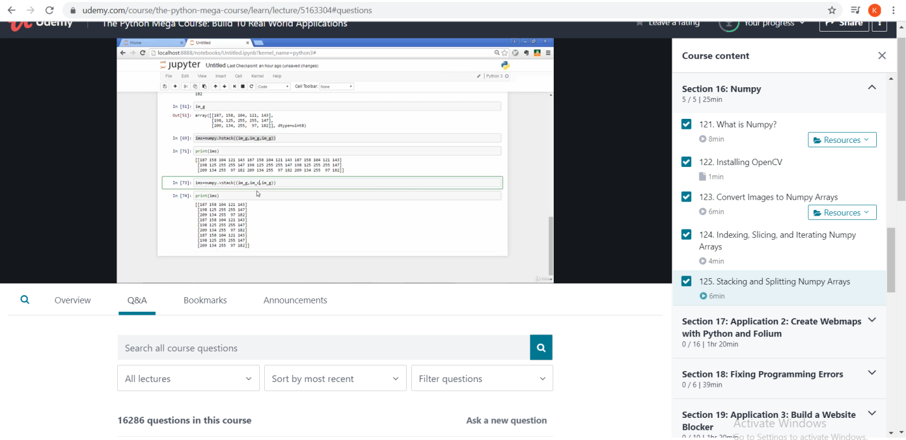

**REPORT**

* Application 2: Create webmaps with python and Folium
* The Basemap: Basemap is a great tool for creating maps using python in a simple way. It’s a [matplotlib](http://matplotlib.org/) extension, so it has got all its features to create data visualizations, and adds the geographical projections and some datasets to be able to plot coast lines, countries, and so on directly from the library.
* Adding points, adding multiple points, HTML on popups, GeoJson data, Choropleth Map
* Basemap object fields
* [Folium](https://python-visualization.github.io/folium/) is a Python package built to bridge the data wrangling muscle of Python with [Leaflet’s](http://leafletjs.com/reference-1.2.0.html) easy-to-use JavaScript library for creating attractive, interactive web maps. The open source Leaflet is a highly popular web mapping tool due to its flexibility, with a healthy number of community-developed plug-ins further expanding its native capabilities.
* Fixing Programming Errors
* Syntax errors: eg

function testFunction()  
{  
echo "Just testing.";  
}}

* Runtime errors:A [runtime](https://techterms.com/definition/runtime) error is a [program](https://techterms.com/definition/program) error that occurs while the program is running.
* How to fix difficult errors
  + - Start with reading the error from the beginning. The line tells you the location of the error
    - Next look at the error type, In case the error type is a SyntaxError
    - Look at the details of the error ,Use your logic

* Error handling

AFTERNOON SESSION

Image of the session

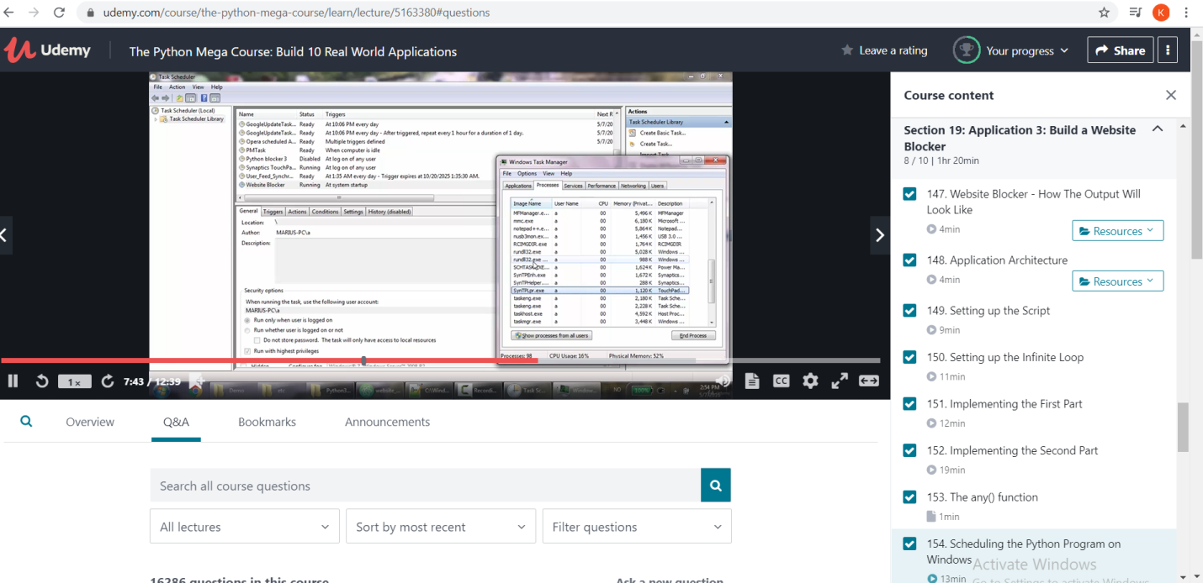

* Application 3:Build a website blocker
* Application Architecture

Every operating system has a hosts file. Location of the host file may be different for the different operating system. This host file is map hostname to IP address of the machine. In this host file, we going to list websites which we want to block.

* Setting up script & infinite loop
* Scheduling the python program on windows, mac, linux
* Application 4:Build a personal website with python and flask
* My first website
* HTML templets
* Browsing caching
* Creating a python virtual environment
* Developing a website to a live server
* Some websites built using python
* Spotify
* Uber
* Dropbox
* Pinterest
* Instacart