**DAILY ASSESSMENT FORMAT**

|  |  |  |  |
| --- | --- | --- | --- |
| **Date:** | **20/05/2020** | **Name:** | **Kirti B S** |
| **Course:** | **Signals & system** | **USN:** | **4AL18EC026** |
| **Topic:** | **1.Introduction to Fourier Series & Fourier Transform**  **2.Inner Product in Hilbert Transform**  **3.Complex Fourier series**  **4.Fourier series using Matlab & python**  **5.Fourier series and Gibbs phenomena** | **Semester & Section:** | **3rd Sem**  **‘A’ Section** |
| **Github Repository:** | **Kirti BS** |  |  |

**FORENOON SESSION**

**Image of the session**

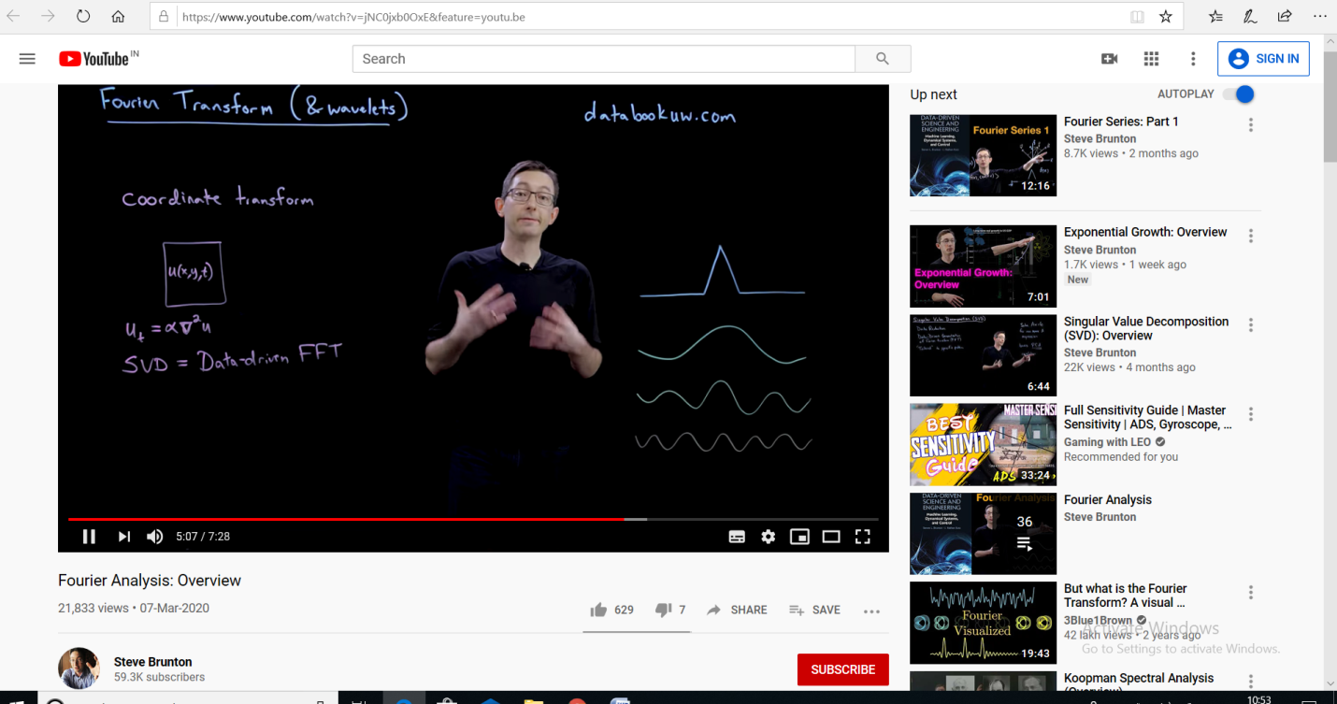

**REPORT**

* **Introduction to Fourier Series & Fourier Transform**
* **Fourier**[**series**](https://en.wikipedia.org/wiki/Series_(mathematics)) **is a**[**periodic function**](https://en.wikipedia.org/wiki/Periodic_function)**composed of harmonically related**[**sinusoids**](https://en.wikipedia.org/wiki/Sine_wave)**, combined by a weighted summation. With appropriate weights, one cycle (or *period*) of the summation can be made to approximate an arbitrary function in that interval (or the entire function if it too is periodic).**
* **The Fourier Transform is a mathematical technique that transforms a function of time, x(t), to a function of frequency, X(ω).**
* **Inner Product in Hilbert Transform**
* **The Hilbert transform is a specific**[**linear operator**](https://en.wikipedia.org/wiki/Linear_operator)**that takes a function, *u*(*t*) of a real variable and produces another function of a real variable *H*(*u*)(*t*).**
* **Complex Fourier Series**
* **Fourier series using Matlab**
* **Domain**
* **Function**
* **Compute Fourier series**
* **Fourier series using Gibbs phenomena using python**

**AFTERNOON SESSION**

**Image of session**

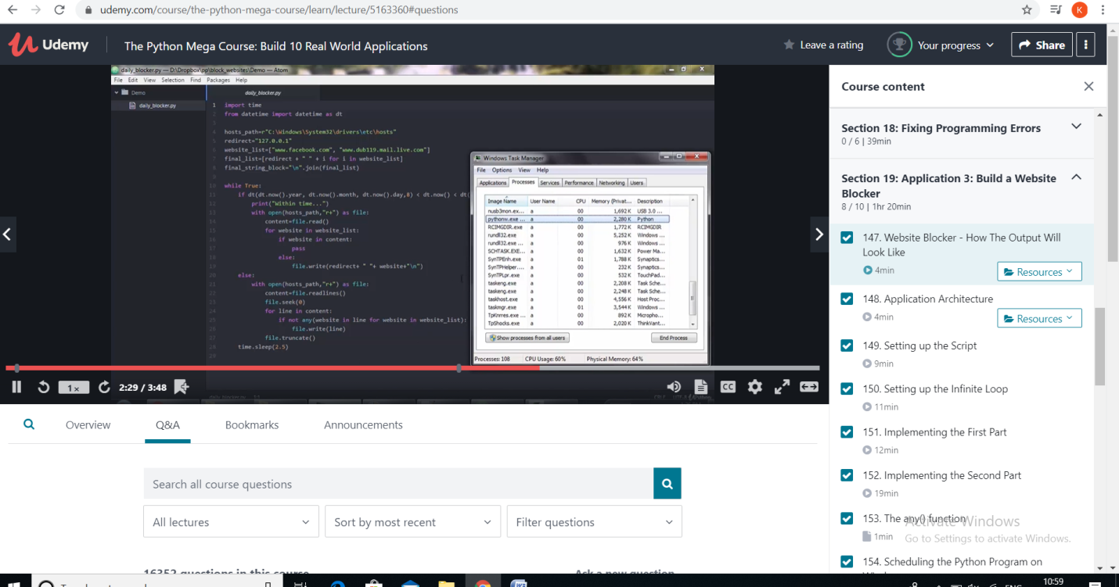

**REPORT**

* Fixing Programming Errors
* Syntax errors: eg

function testFunction()  
{  
echo "Just testing.";  
}}

* Runtime errors: A [runtime](https://techterms.com/definition/runtime) error is a [program](https://techterms.com/definition/program) error that occurs while the program is running.
* Application 3:Build a website blocker
* Application Architecture

Every operating system has a hosts file. Location of the host file may be different for the different operating system. This host file is map hostname to IP address of the machine. In this host file, we list websites which we want to block.

* Setting up script & infinite loop
* Scheduling the python program on windows, Mac, Linux
* Example Code to block a website using python:

|  |
| --- |
| Importtime |
|  | from datetime import datetime as dt |
|  |  |
|  | #hostsPath="hosts" |
|  | hostsPath=r"C:\Windows\System32\drivers\etc\hosts" |
|  | redirect="127.0.0.1" |
|  | websites=["www.facebook.com","facebook.com"] |
|  |  |
|  | while True: |
|  | if dt(dt.now().year,dt.now().month,dt.now().day,8) < dt.now() < dt(dt.now().year,dt.now().month,dt.now().day,22): |
|  | print ("Working hours...") |
|  | with open(hostsPath,'r+') as file: |
|  | content=file.read() |
|  | for site in websites: |
|  | if site in content: |
|  | pass |
|  | else: |
|  | file.write(redirect+" "+site+"\n") |
|  | else: |
|  | with open(hostsPath,'r+') as file: |
|  | content=file.readlines() |
|  | file.seek(0) |
|  | for line in content: |
|  | if not any(site in line for site in websites): |
|  | file.write(line) |
|  | file.truncate() |
|  | print ("Fun hours...") |
|  | time.sleep(5) |