**DAILY ASSESSMENT FORMAT**

|  |  |  |  |
| --- | --- | --- | --- |
| **Date:** | **26/05/2020** | **Name:** | **Kirti B S** |
| **Course:** | **Signals & Systems** | **USN:** | **4AL18EC026** |
| **Topic:** | 1. **Fourier Transform** 2. **Laplace Transform** 3. **Applications of Z-Transform** | **Semester & Section:** | **3rd Sem**  **‘A’ Section** |
| **Github Repository:** | **Kirti BS** |  |  |

**FORENOON SESSION**

**Image of session**

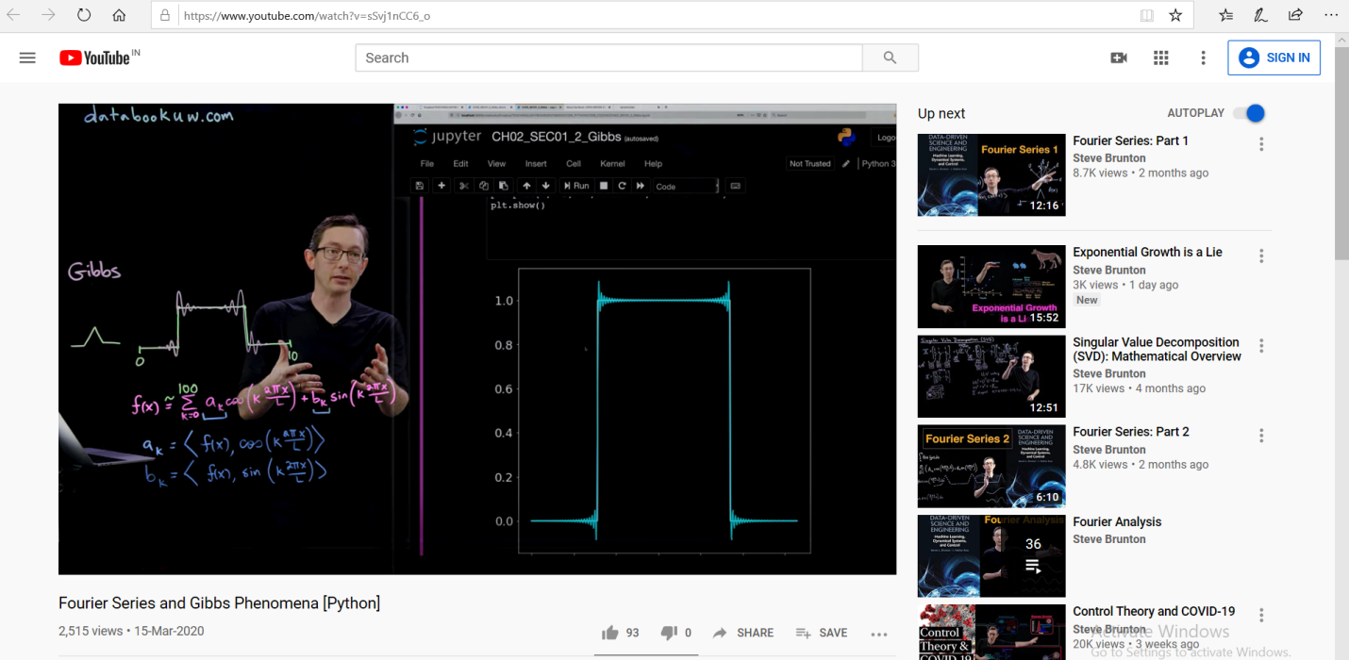

**REPORT**

* **Fourier Transform**

**● How we generalize from periodic functions to the Fourier transform which is**

**Defined on an infinite domain**

* **Fourier Transform derivatives**
* **Method of approximating a continuous function f(x)**
* **Can use that either to approximate derivatives numerically very accurately or can also use to transform from Partial Differential Equation into Ordinary Differential Equation**
* **Fourier Transform and convolution**

**● If we have two functions f and g then if we Fourier transform the convolution it just becomes the product in the Fourier transform domain**

**● Convolution becomes the product in the Fourier transform that is very useful**

* **Intuition of Fourier Transform and Laplace Transform**
* **Laplace Transform of First order**

**When we take the derivative of a function we multiply its Laplace transform by that's the rule**

**● If we have two derivatives we multiply it by square of s**

**● Changed from t time in Differential Equation to s in the Laplace transform**

* **Implementation of Laplace Transform using Matlab**
* **Applications of Z-Transform**

**Difference equation**

**● Order if Differential Equation**

**● Solution of Differential Equation**

* **Finding the Z-Transform of sequence using Matlab**

|  |
| --- |
| **AFTERNOON SESSION** |
| **Image of the session** |

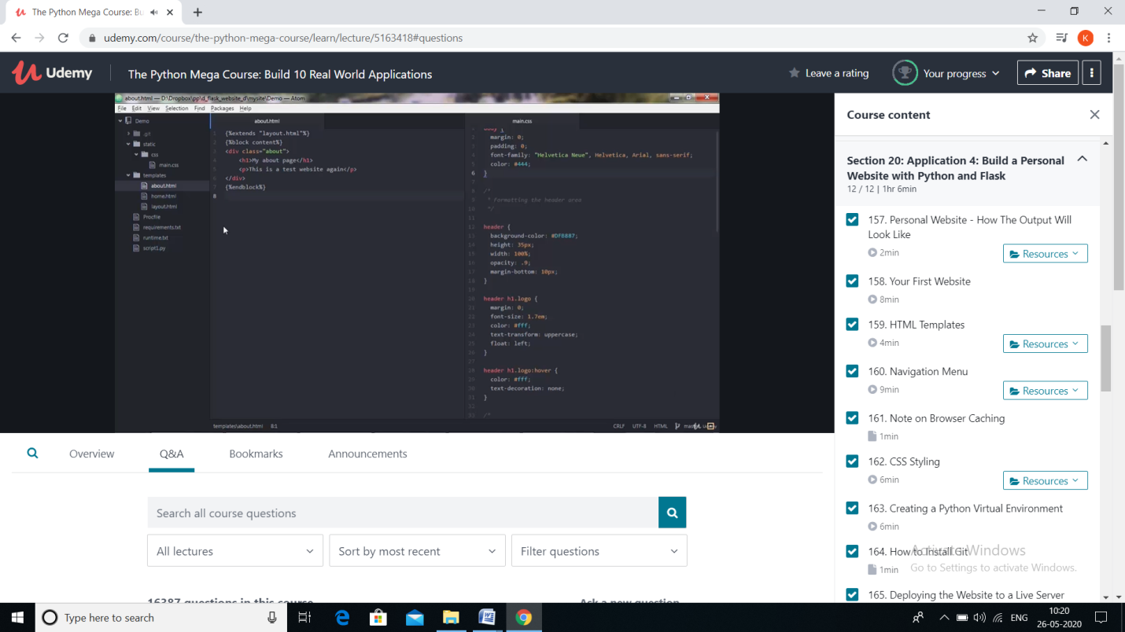

**Application 4: Build a personal website using python and flask**

* **My first website**
* **My first page**
* **Basic formatting**
* **Basic links**
* **Basic images**
* **<body>attributes**
* **Basic web design**
* **HTML tags**
* **uploading first site**
* **HTML Templates**
* **HTML business templets**
* **Design templates**
* **eCommerce website templates**
* **transport basic bootstrap HTML templates**
* **Navigation menu**
* **Navigation is the most significant element in web design.**
* **Since web-layouts don’t have any physical representation a user can stick to, consistent navigation menu is one of the few design elements which provide users with some sense of orientation and guide them through the site.**
* **Users should be able to rely on it which is why designers shouldn’t mess around with it.**
* **Browser caching**
* **Browser caching stores webpage resource files on a local computer when a user visits a webpage.**
* **"Leveraging" browser caching is when a webmaster has instructed browsers how their resources should be dealt with.**
* **What browser caching does is "remember" the resources that the browser has already loaded. When a visitor goes to another page on your website your logo, CSS files, etc. do not need to be loaded again, because the browser has them "remembered" (saved). This is the reason that the**[**first view**](https://varvy.com/pagespeed/first-view.html)**of a web page takes longer than repeat visits**.
* **CSS Styling**
* **CSS stands for Cascading Style Sheets**.
* **CSS saves a lot of work. It can control the layout of multiple web pages all at once.**

**CSS describes how HTML elements are to be displayed on screen, paper, or in other media.**

**CSS can be added to HTML elements in 3 ways:**

* **Inline - by using the style attribute in HTML elements**
* **Internal - by using a <style> element in the <head> section**
* **External - by using an external CSS file**
* **Creating python virtual environment**
* **Developing the website to a live server**