**DAILY ASSESSMENT FORMAT**

|  |  |  |  |
| --- | --- | --- | --- |
| **Date:** | **27/05/2020** | **Name:** | **Kirti B S** |
| **Course:** | **Signals & system** | **USN:** | **4AL18EC026** |
| **Topic:** | **1. Boolean equations for digital circuits. Combinational circuits: Conversion of MUX and Decoders to logic gates.**  **2. Design of 7 segment decoder with common anode display** | **Semester & Section:** | **3rd Sem**  **‘A’ Section** |
| **Github Repository:** | **Kirti BS** |  |  |

**FORENOON SESSION**

**Image of the session**

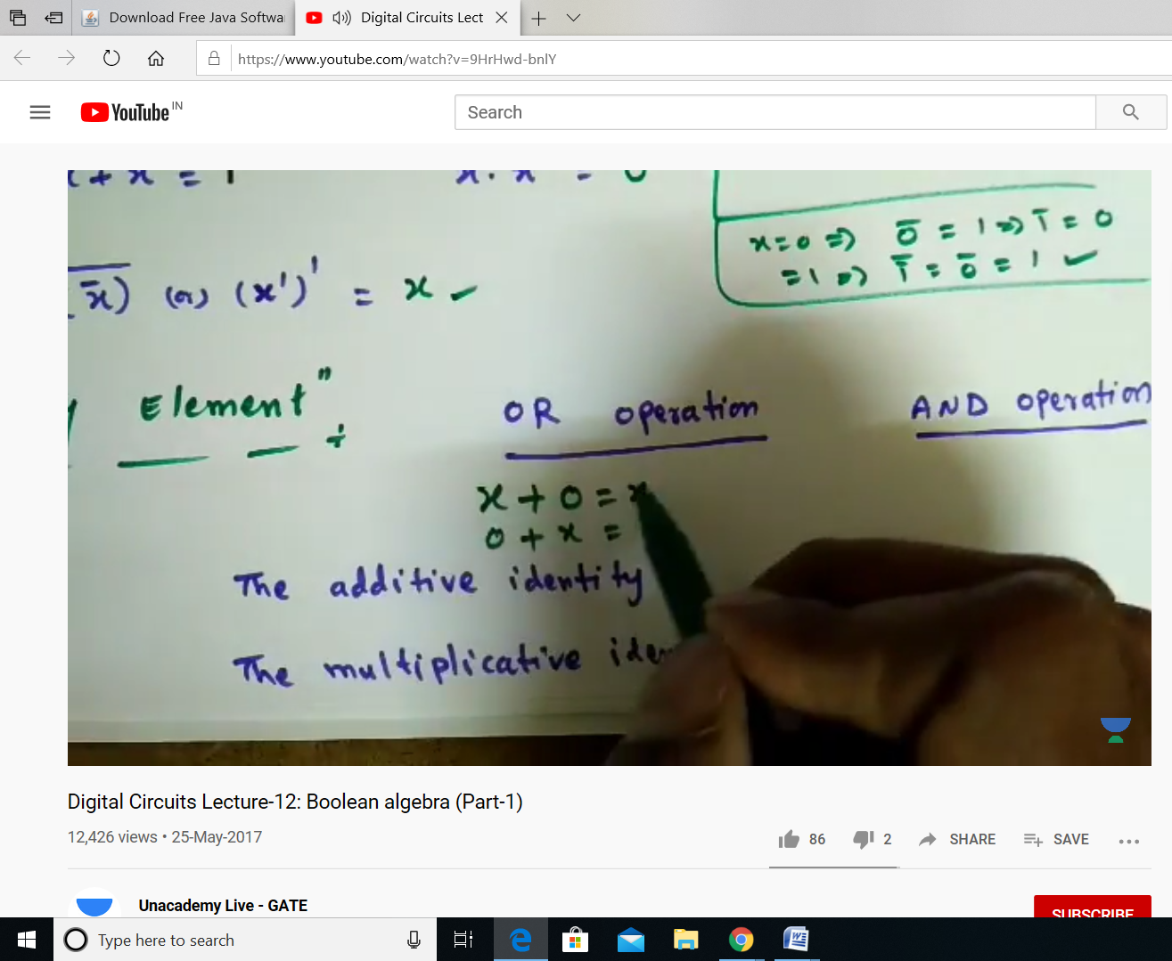

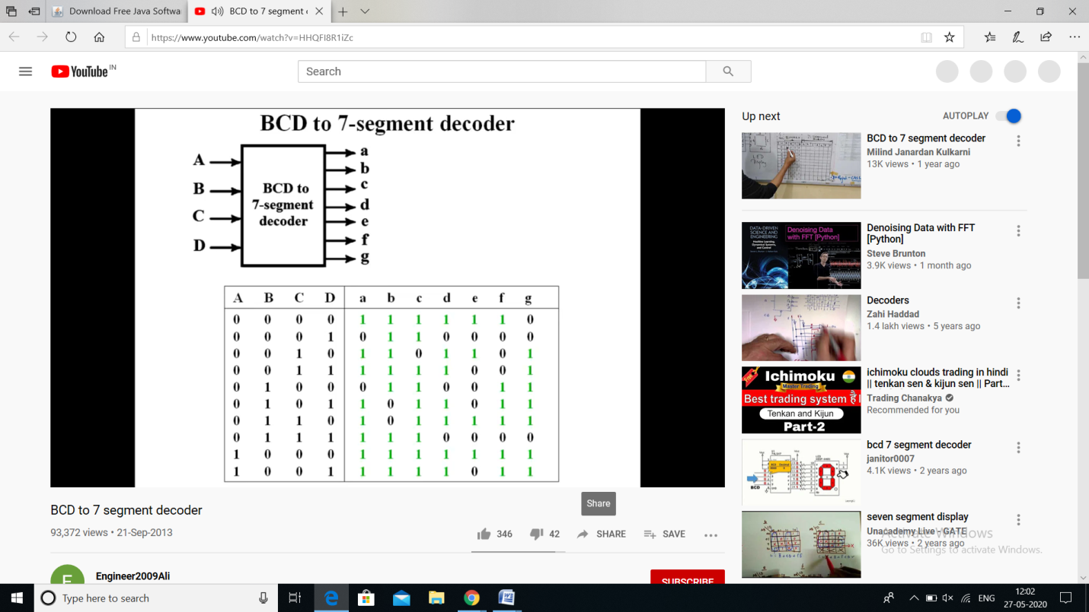

**REPORT**

* **Boolean equations for digital circuits.**
* **Boolean Algebra is the mathematical foundation of digital circuits.**
* **Boolean Algebra specifies the relationship between Boolean variables which is used to design**[**combinational logic circuits**](http://electronics-course.com/combinational-logic)**using Logic Gates.**
* **The truth table shows a logic circuit's output response to all of the input combinations.**
* **A Boolean Variable takes the value of either 0 (False) or 1 (True).**
* **Symbols are used to represent Boolean variables e.g. A, B, C, X, Y, Z**
* **There are three basic logic operations AND, OR, NOT**
* **The Boolean Operators are • + ‾**
  + - **A + B means A OR B**
    - **A • B means A AND B**
    - **A means NOT A**
    - **Nodes in a circuit are represented by Boolean Variables**
* **The most practical use of Boolean algebra is to**[**simplify Boolean expressions**](http://electronics-course.com/boolean-algebra)**which means less logic gates are used to implement the combinational logic circuit.**
* **Combinational circuits:**
* **Combinational Logic Circuits are memoryless digital logic circuits whose output at any instant in time depends only on the combination of its inputs**
* **The outputs of Combinational Logic Circuits are only determined by the logical function of their current input state, logic “0” or logic “1”, at any given instant in time.**
* **Combinational Logic Circuits are made up from basic logic NAND, NOR or NOT gates that are “combined” or connected together to produce more complicated switching circuits.**
* **These logic gates are the building blocks of combinational logic circuits.**
* **An example of a combinational circuit is a decoder, which converts the binary code data present at its input into a number of different output lines, one at a time producing an equivalent decimal code at its output.**
* **Conversion of MUX and Decoders to logic gates.**
* **A multiplexer is a device which allows one of a number of inputs to be routed to a single output.**
* **Multiplexers are useful in many situations. For example, in a CPU, data being written to memory might come from one of a number of sources - from a register, from the result of a calculation, etc - so a multiplexer would be used to select data from the appropriate source.**
* **Design of 7 segment decoder with common anode display.**

**AFTERNOON SESSION**

**Image of the session**



**REPORT**

* **Graphical user interfaces with Tkinter**
* **Introduction to Tkinter**
* **Setting up a GUI Widgets**
* **Connecting GUI widgets with callback functions**
* **Create multi-widget GUI**
* **Interacting with databases**
* **Introduction to “python with databases”**
* **Connecting and inserting data to SQLite via python**
* **Selecting, inserting, deleting and updating SQLite records**
* **Introduction to postdegreeSQL psycopg2**
* **Selecting, inserting, deleting, and updating postdegreeSQL records**
* **Querying data from a MySQL databases**