**DAILY ASSESSMENT FORMAT**

|  |  |  |  |
| --- | --- | --- | --- |
| **Date:** | **28/05/2020** | **Name:** | **Kirti B S** |
| **Course:** | **Logic design** | **USN:** | **4AL18EC026** |
| **Topic:** | **1.Analysis of clocked sequential circuits**  **2.Digital clock design** | **Semester & Section:** | **4TH Sem**  **‘A’ Section** |
| **Github Repository:** | **Kirti BS** |  |  |

|  |
| --- |
| **FORENOON SESSION** |
| **Image of the session** |

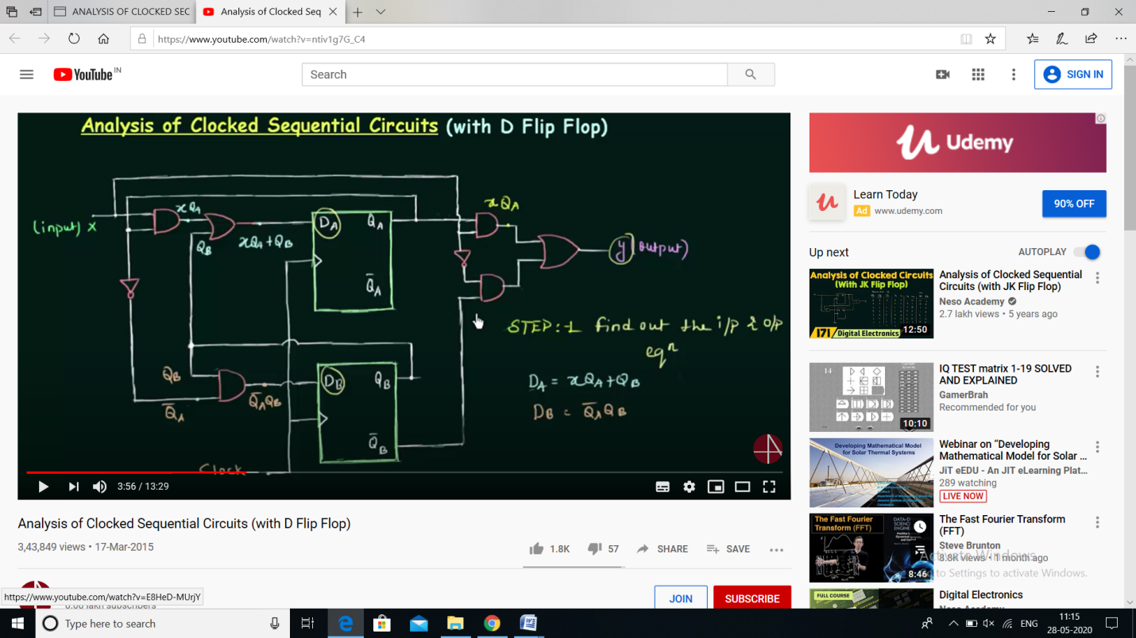

**REPORT**

* **ANALYSIS OF CLOCKED SEQUENTIAL CIRCUITS**
* **The knowledge of the type of flip-flops and a list of the Boolean expressions of the combinational circuit provide the information needed to draw the logic diagram of the se­quential circuit. The part of the combinational circuit that gene rates external outputs is de­scribed algebraically by a set of Boolean functions called output equations. The part of the circuit that generates the inputs to flip-flops is described algebraically by a set of Boolean func­tions called flip-flop input equations (or excitation equations).**
* **Positive Edge Triggered D Flip-flop**
* **Analysis with D Flip-Flops**
* **Analysis with JK Flip-Flops**
* **Analysis with T Flip-Flops**
* **STATE REDUCTION AND ASSIGNMENT**
* **The process of eliminating the equivalent or redundant states from a state table/diagram is known as state reduction.**
* **Example of State Reduction**
* **Digital clock design**

|  |
| --- |
| **AFTERNOON SESSION** |

**Image of the session**

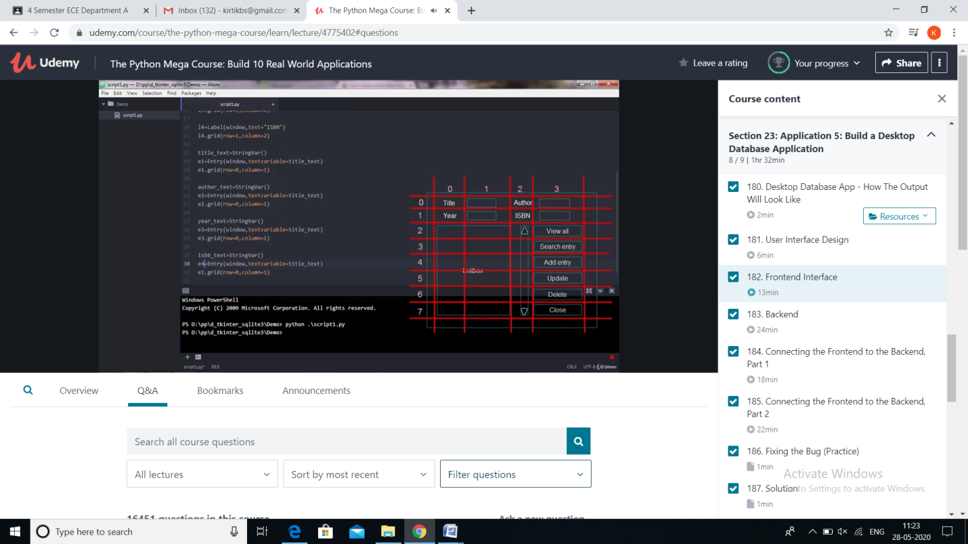

**REPORT**

**Application 5: Build a desktop database application**

* **A**[**database**](https://zapier.com/blog/common-dev-terms-explained/#database)**("DB" for short) is a structured collection of data. The key word there is "structured": searching an unstructured database would be like trying to thread a needle in a dark cave with oven mitts on.**
* **Desktop database app**
* **User interface design**
* **Fronted interface**
* **Backend**
* **Connecting frontend to the backend**
* **Fixing the bug**
* **Creating a standalone executable version of the program**
* **This session covered the basic process of starting Access and creating a database that will be used on desktop machines, not over the Web. It explains how to create a desktop database by using a template, and how to build a database from scratch by creating your own tables, forms, reports, and other database objects. It also explains some techniques that you can use to get existing data into your new database.**