**DAILY ASSESSMENT FORMAT**

|  |  |  |  |
| --- | --- | --- | --- |
| **Date:** | **29/05/2020** | **Name:** | **Kirti B S** |
| **Course:** | **Logic Design** | **USN:** | **4AL18EC026** |
| **Topic:** | |  |  | | --- | --- | | **Applications of Programmable logic controller.** |  | |  | | |  | | | **Semester & Section:** | **4th Sem**  **‘A’ Section** |
| **Github Repository:** | **Kirti BS** |  |  |

**FORENOON SESSION**

Image of session

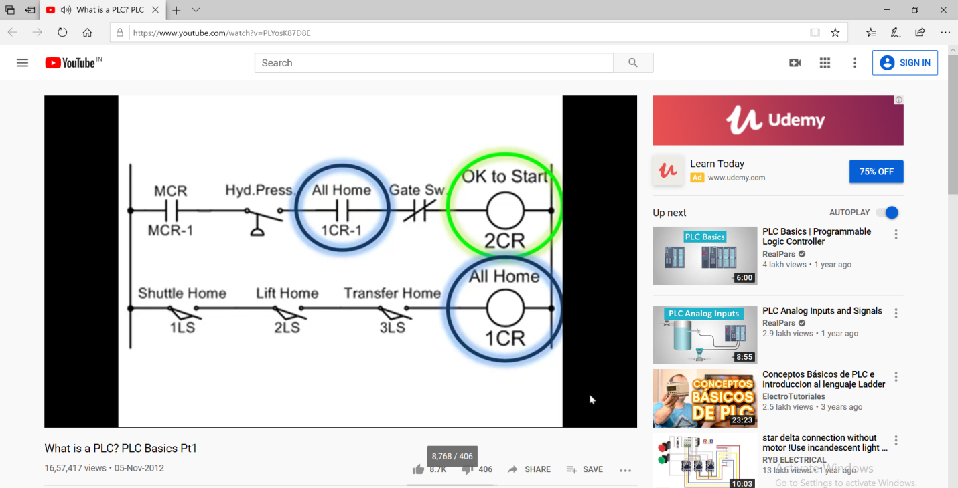

**REPORT**

* **Applications of Programmable logic controller**
* **A programmable logic controller (PLC) is an electronic device used in many industries to monitor and control construction systems and production processes. Unlike PCs and smart phones, which are designed to perform any number of roles, a PLC is designed to perform a single set of tasks, except in the case of limitations in real time and with superior reliability and performance.**
* **To meet the demands of rigorous industrial environments, PLCs are designed to be extremely robust, often capable of withstanding extreme temperatures, humidity, vibration and electrical noise. The logical controllers are commonly responsible for monitoring and controlling a large number of sensors and actuators, and therefore are different from other computer systems in their extensive input / output (I / O) arrangements**

**● Introduction -**

* **Programmable logic controllers are the major components in industrial control systems.**
* **They replaced something called electromagnetic relays**

**● Relays to bits (in memory)**

**● Illustration of an electronic circuit**

* **Relationships of power source, switches, the coil, contacts and the loads**
* **What happens when switch is closed**
* **What happens when switch is open**

**● Illustration of a Relay**

* **If the normally closed contact is closed then yes the coil is de-energized**
* **If the normally open contact is closed then yes the coil is energized**

**● Double-Break Contacts**

* **This design provides better protection against contact welding thata single break design**
* **It offers great DC load breaking capability and better isolation**
* **Double break contacts reduces the probability of welded contacts by more that 50% compared to a single-break design**

**AFTERNOON SESSION**

**Image of the session**

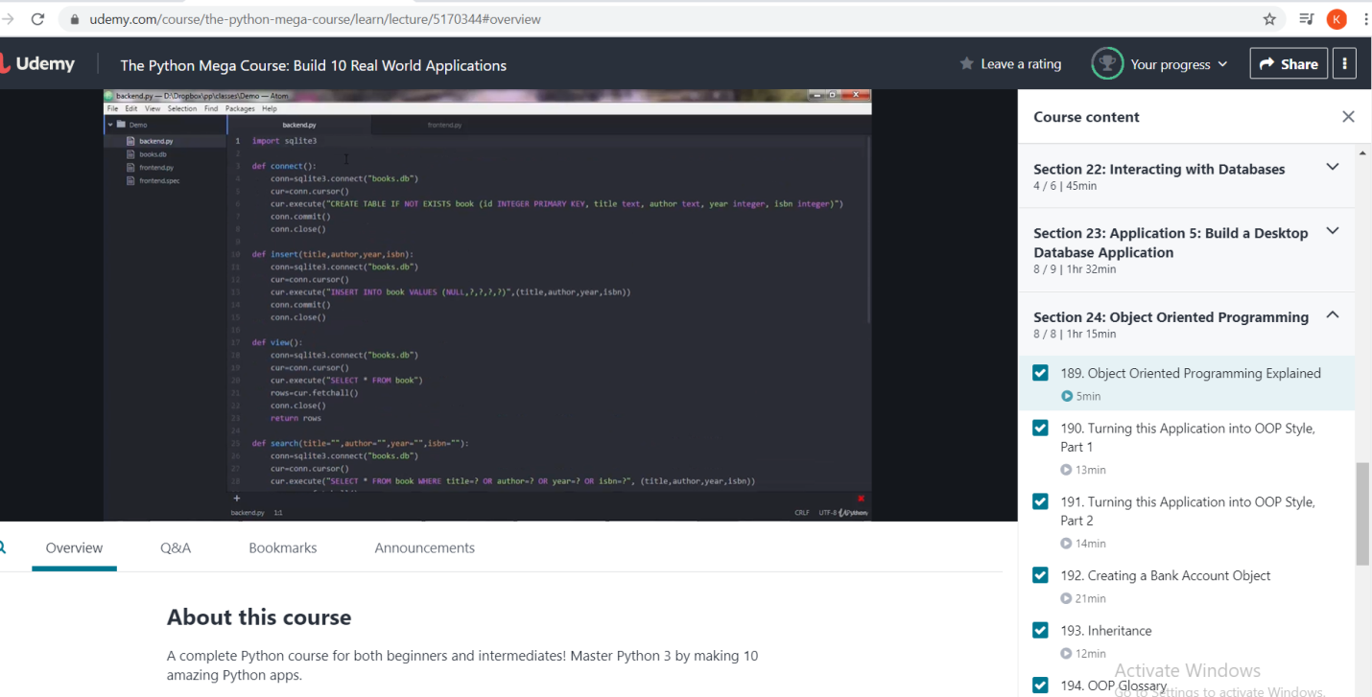

**REPORT**

* **Object oriented Programming**
* **Turning the application into OOP style**
* **Creating a bank account object**
* **Inheritance**
* **OOP Glossary**
* **GUI in OOP design**
* **Object-oriented programming (OOP) is a**[**programming paradigm**](https://en.wikipedia.org/wiki/Programming_paradigm)**based on the concept of "**[**objects**](https://en.wikipedia.org/wiki/Object_(computer_science))**", which can contain**[**data**](https://en.wikipedia.org/wiki/Data)**, in the form of**[**fields**](https://en.wikipedia.org/wiki/Field_(computer_science))**and code, in the form of procedures. A feature of objects is an object's procedures that can access and often modify the data fields of the object with which they are associated.**
* **In OOP, computer programs are designed by making them out of objects that interact with one another.**[**[1]**](https://en.wikipedia.org/wiki/Object-oriented_programming#cite_note-1)[**[2]**](https://en.wikipedia.org/wiki/Object-oriented_programming#cite_note-2)**OOP languages are diverse, but the most popular ones are**[**class-based**](https://en.wikipedia.org/wiki/Class-based_programming)**, meaning that**

**objects are**[**instances**](https://en.wikipedia.org/wiki/Instance_(computer_science))**of**[**classes**](https://en.wikipedia.org/wiki/Class_(computer_science))**, which also determine their**[**types**](https://en.wikipedia.org/wiki/Data_type)**.**

**●Briefing of Object Oriented Programming**

**★Type of computer programming (software design) in which programmers define the data type of a data structure, and also the types of operations (functions) that can be applied to the data structure**

**★Objects can inherit characteristics from other objects.**