**DAILY ASSESSMENT FORMAT**

|  |  |  |  |
| --- | --- | --- | --- |
| **Date:** | **30/05/2020** | **Name:** | **Kirti B S** |
| **Course:** | **Python** | **USN:** | **4AL18EC026** |
| **Topic:** | Python for image and video processing with openCV | **Semester & Section:** | **4th Sem**  **‘A’ Section** |
| **Github Repository:** | **Kirti BS** |  |  |

**FORENOON SESSION**

**Image of the session**

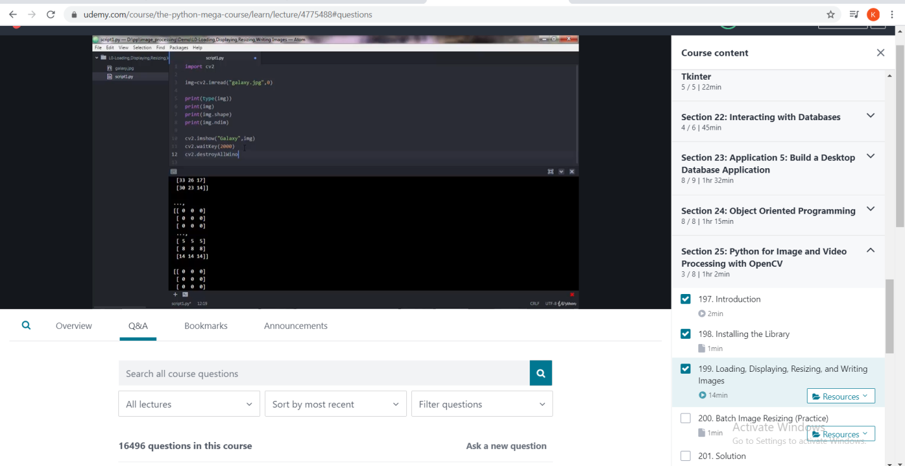

REPORT

* Python for image and video processing with openCV
* Introduction
* Installing the library
* Loading, Displaying, Resizing and writing images
* Batch image resizing
* Face detection
* Capturing video