**DAILY ONLINE ACTIVITIES SUMMARY**

|  |  |  |  |  |  |  |  |  |
| --- | --- | --- | --- | --- | --- | --- | --- | --- |
| **Date:** | **18/05/2020** | | | | | **Name:** | **M MAHAMMAD ASIF** | |
| **Sem & Sec** | **4th Sem & ‘A’ Sec** | | | | | **USN:** | **4AL18CS045** | |
| **Online Test Summary** | | | | | | | | |
| **Subject** | | Complex Analysis, Probability And Statistical Methods(18mat41) | | | | | | |
| **Max. Marks** | | **30** | | **Score** | | | **14** | |
| **Certification Course Summary** | | | | | | | | |
| **Course** | **The Complete Android App Development Masterclass:Build Apps** | | | | | | | |
| **Certificate Provider** | | | **Udemy** | | **Duration** | | | **29 Hours** |
| **Coding Challenges** | | | | | | | | |
| **Problem Statement: 1.** [**C Program to check whether the two string are Anagram or not.**](https://github.com/orgs/alvas-education-foundation/teams/2nd-year/discussions/39)  **2. Java Program to print the frequency of each character in a string.**  **3. C program to find all Triplets in an Given Array** | | | | | | | | |
| **Status: Completed** | | | | | | | | |
| **Uploaded the report in Github** | | | | | **Yes** | | | |
| **If yes Repository name** | | | | | <https://github.com/mdasif9900/Lockdown-online-coding> | | | |
| **Uploaded the report in slack** | | | | | **Yes** | | | |

Online Test Details: The Mathematics 1st Internal Assessment was conducted on 4th Module. In that I had Scored 14 marks out of 30. The reason behind the getting less marks was insufficient of time that was been provided to solve the problems.

Snapshot: Not Available

Certification Course Details: The Course that I Enrolled in Udemy is **“Complete Android App Development Masterclass: Build Apps”, which is about 29 hours of Duration. In that, I had completed introductory part, which was about 1:14 hour.**

**Snapshot:**

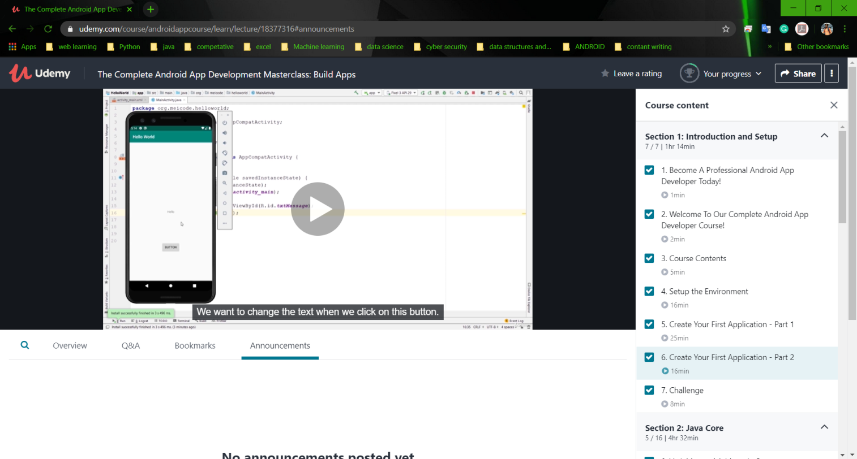

Coding Challenges Details: The Three problems I have solved By Understanding the Concepts through Online and updated the same in Github Repository. The three problem statements were

**1.** [**C Program to check whether the two string are Anagram or not.**](https://github.com/orgs/alvas-education-foundation/teams/2nd-year/discussions/39)

**2. Java Program to print the frequency of each character in a string.**

**3. C program to find all Triplets in an Given Array.**

**Snapshot:**

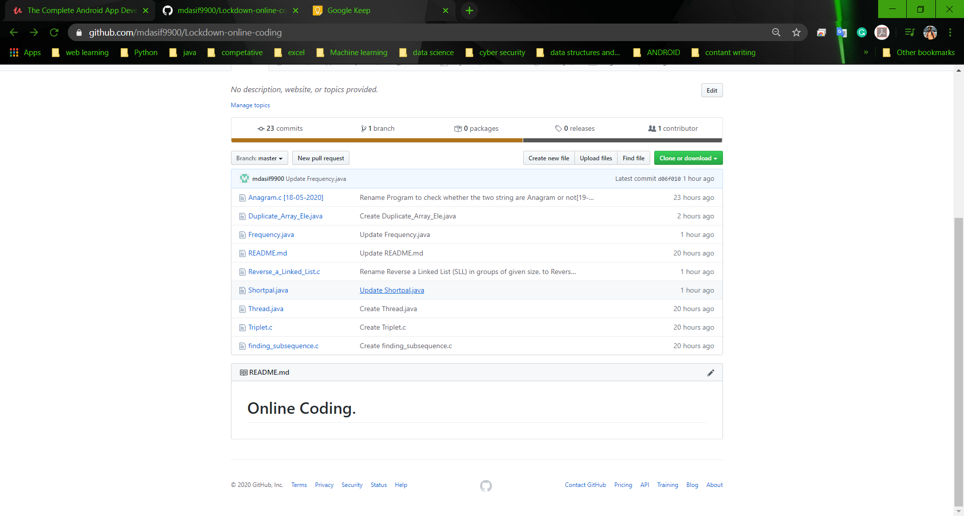

**The above is the snapshot of the Repository in which I submitted my programs.**