**DAILY ONLINE ACTIVITIES SUMMARY**

|  |  |  |  |  |  |  |  |  |
| --- | --- | --- | --- | --- | --- | --- | --- | --- |
| **Date:** | **19/05/2020** | | | | | **Name:** | **M MAHAMMAD ASIF** | |
| **Sem & Sec** | **4th Sem & ‘A’ Sec** | | | | | **USN:** | **4AL18CS045** | |
| **Online Test Summary** | | | | | | | | |
| **Subject** | | Design and analysis of algorithm(18CS42) | | | | | | |
| **Max. Marks** | | **30** | | **Score** | | | **21** | |
| **Certification Course Summary** | | | | | | | | |
| **Course** | **The Complete Android App Development Masterclass:Build Apps** | | | | | | | |
| **Certificate Provider** | | | **Udemy** | | **Duration** | | | **29 Hours** |
| **Coding Challenges** | | | | | | | | |
| **Problem Statement: 1. C program find out shortest palindrome.**  **2. [C program to check sub sequence](https://github.com/orgs/alvas-education-foundation/teams/2nd-year/discussions/65)**. | | | | | | | | |
| **Status: Completed** | | | | | | | | |
| **Uploaded the report in Github** | | | | | **Yes** | | | |
| **If yes Repository name** | | | | | <https://github.com/mdasif9900/Lockdown-online-coding> | | | |
| **Uploaded the report in slack** | | | | | **Yes** | | | |

Online Test Details: The **Design and analysis of algorithm(18CS42)** 1st Internal Assessment was conducted on 1st Module. In that I had Scored 21 marks out of 30.

Snapshot:

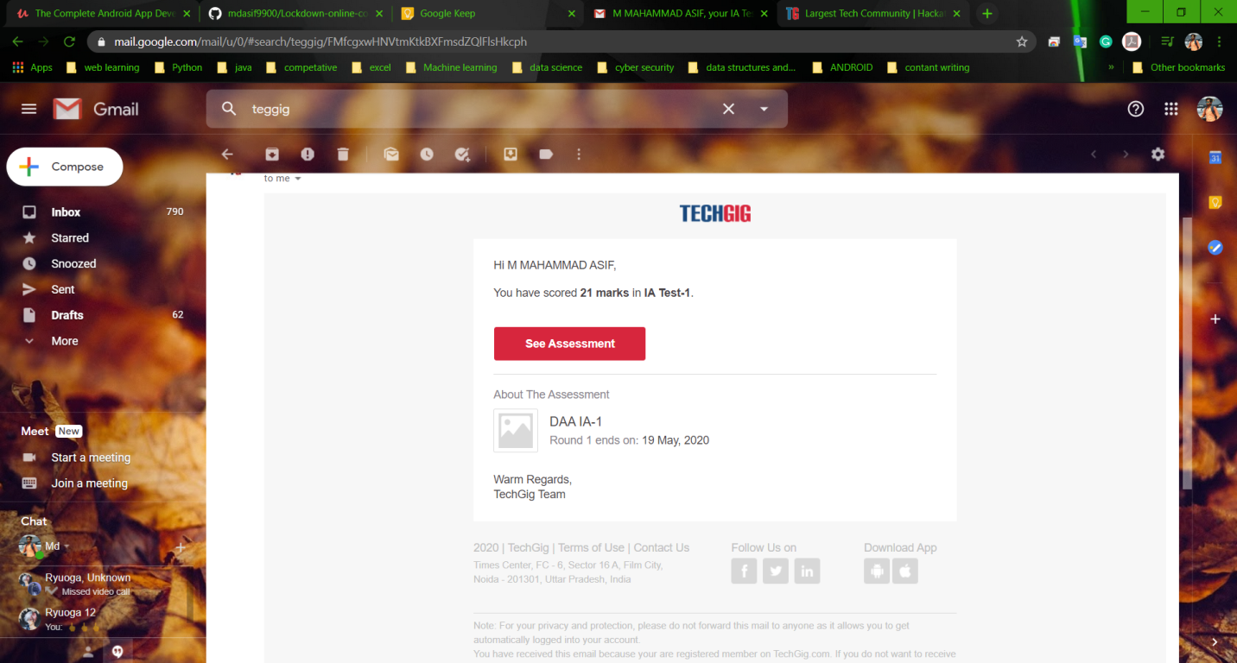

Certification Course Details: **I have continued the the course that is “Complete Android App Development Masterclass: Build Apps”, which is about 29 hours of Duration. In that, I had completed Next part of introductory, which was about 1 hour. Parallel to that whatever learn in course I’m practicing in Android Studio.**

**Snapshot:**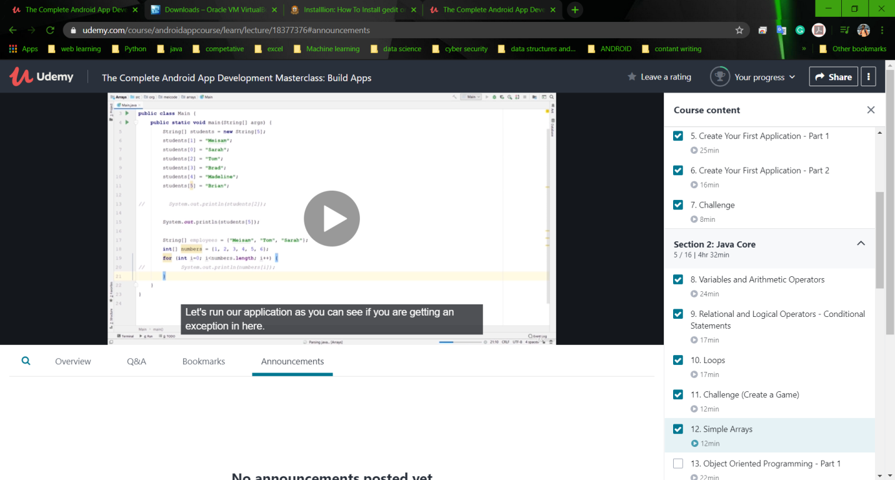

Coding Challenges Details: The Two problems I have solved By Understanding the Concepts through Online and updated the same in Github Repository. The two problem statements were:

**1. C program find out shortest palindrome.**

**Snapshot:** 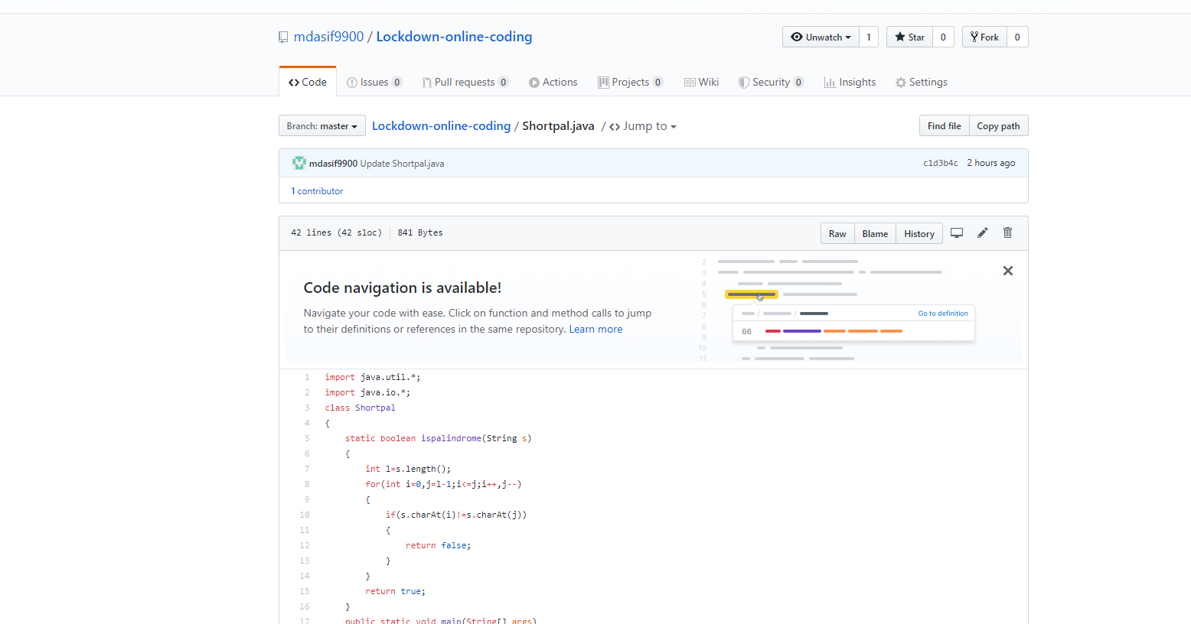

**2.** [**C program to check sub sequence**](https://github.com/orgs/alvas-education-foundation/teams/2nd-year/discussions/65)

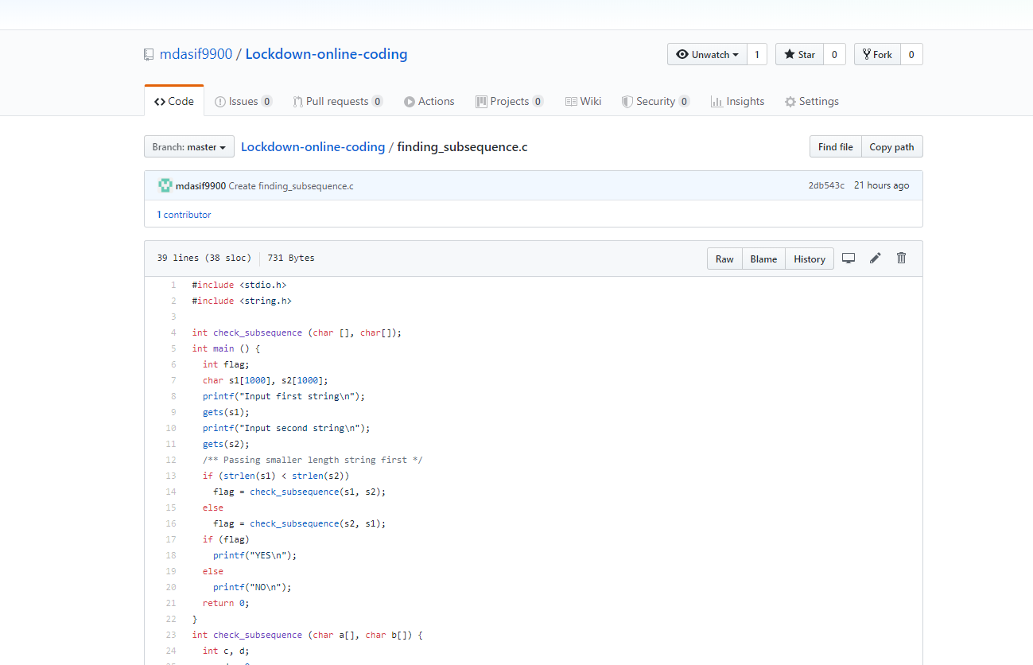

**The above is the c program for finding sub sequence.**