**DAILY ONLINE ACTIVITIES SUMMARY**

|  |  |  |  |  |  |  |  |  |
| --- | --- | --- | --- | --- | --- | --- | --- | --- |
| **Date:** | **20/05/2020** | | | | | **Name:** | **M MAHAMMAD ASIF** | |
| **Sem & Sec** | **4th Sem & ‘A’ Sec** | | | | | **USN:** | **4AL18CS045** | |
| **Online Test Summary** | | | | | | | | |
| **Subject** | | Object oriented concepts(18CS45) | | | | | | |
| **Max. Marks** | | **30** | | **Score** | | | **20** | |
| **Certification Course Summary** | | | | | | | | |
| **Course** | **The Complete Android App Development Masterclass:Build Apps** | | | | | | | |
| **Certificate Provider** | | | **Udemy** | | **Duration** | | | **29 Hours** |
| **Coding Challenges** | | | | | | | | |
| **Problem Statement: 1. JAVA Program to Print Duplicate Array Elements.**  **2. C Program to Reverse a Linked List (SLL) in groups of given size.** | | | | | | | | |
| **Status: Completed** | | | | | | | | |
| **Uploaded the report in Github** | | | | | **Yes** | | | |
| **If yes Repository name** | | | | | <https://github.com/mdasif9900/Lockdown-online-coding> | | | |
| **Uploaded the report in slack** | | | | | **Yes** | | | |

Online Test Details: **The Object oriented concepts (18CS45) 1st Internal Assessment was conducted on 1st Module. In that I had Scored 20 marks out of 30.**

Snapshot: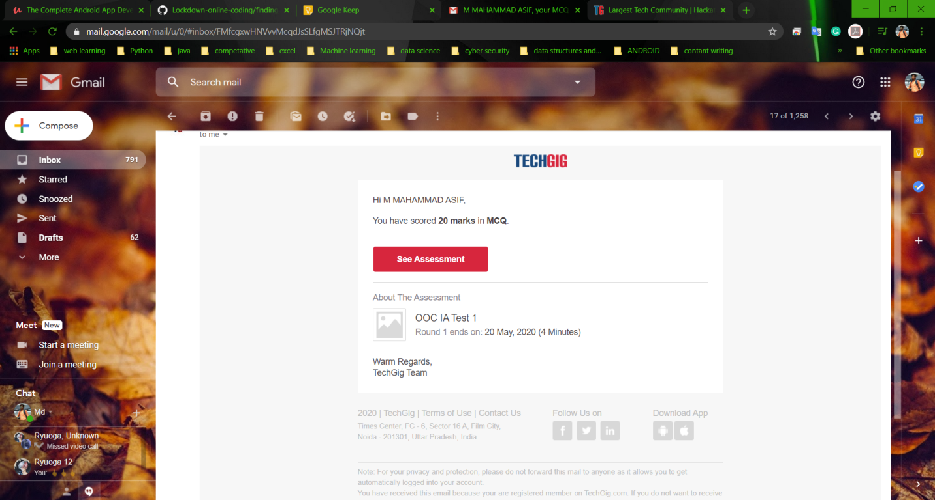

Certification Course Details: **I have continued the the course that is “Complete Android App Development Masterclass: Build Apps”, which is about 29 hours of Duration. In that, I had completed Next part of yesterdays topic, which was about 1 hour. Parallel to that whatever learn in course I’m practicing in Android Studio.**

**Snapshot:**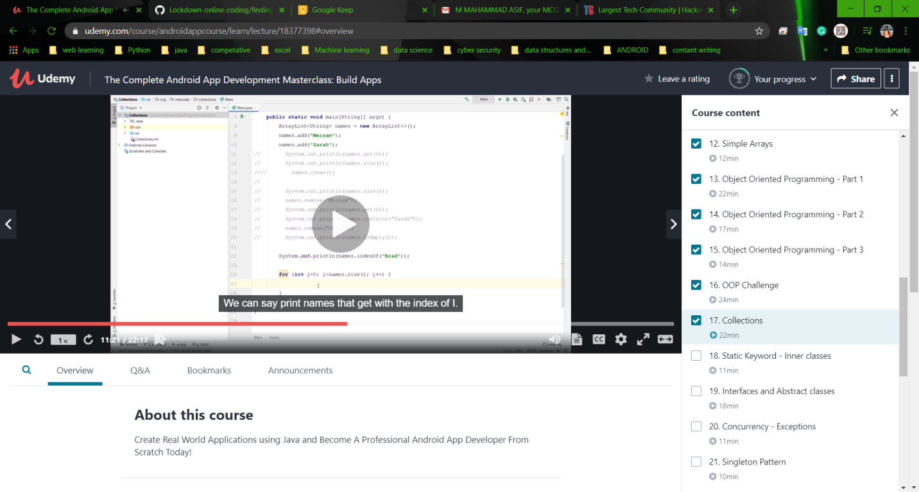

Coding Challenges Details: The Two problems I have solved By Understanding the Concepts through Online and updated the same in Github Repository. The two problem statements were:

**1. JAVA Program to Print Duplicate Array Elements.**

**Snapshot:** 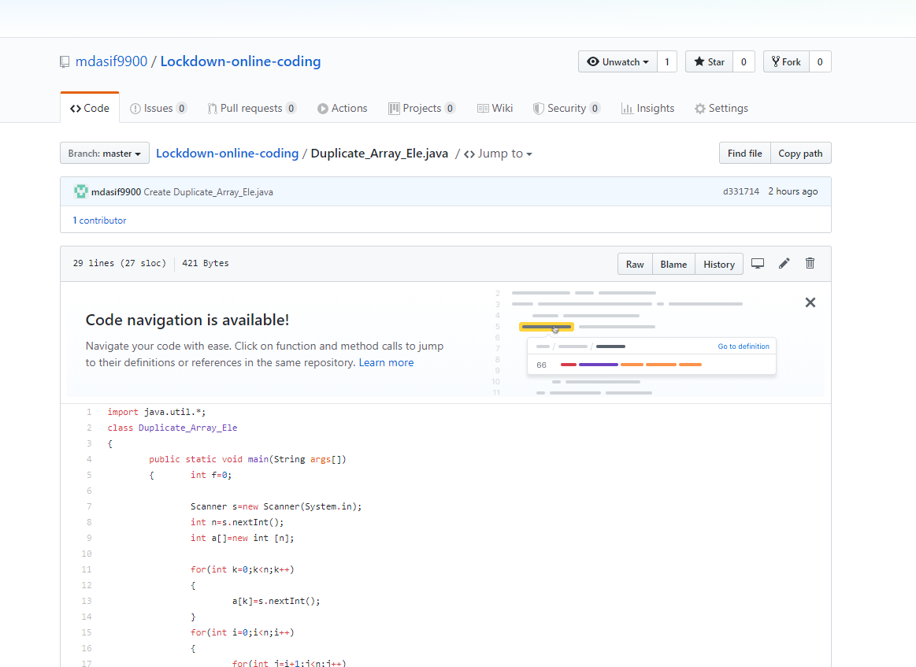

**2. C Program to Reverse a Linked List (SLL) in groups of given size.**

**Snapsot:**

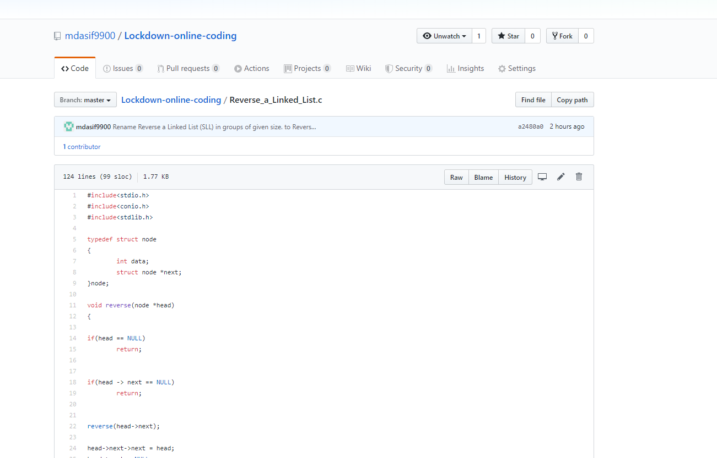

**The above is the c program to Reverse a Linked List (SLL) in groups of given size.**