**DAILY ONLINE ACTIVITIES SUMMARY**

|  |  |  |  |  |  |  |  |  |
| --- | --- | --- | --- | --- | --- | --- | --- | --- |
| **Date:** | **25/06/2020** | | | | | **Name:** | **Nagashree D** | |
| **Sem & Sec** | **8th A** | | | | | **USN:** | **4AL16CS055** | |
| **Online Test Summary** | | | | | | | | |
| **Subject** | | **-** | | | | | | |
| **Max. Marks** | |  | | **Score** | | |  | |
| **Certification Course Summary** | | | | | | | | |
| **Course** | **1) Robotic Process Automation (RPA)**  **2) Introduction to ethical hacking**  **3) Introduction to cyber security**  **4) Introduction to Hadoop** | | | | | | | |
| **Certificate Provider** | | | **1) GUVI**  **2) Great learning Academy** | | **Duration** | | | **RPA – 4 Hrs**  **Ethical hacking - 6 Hrs Cyber Security - Hrs Hadoop – 4 Hrs** |
| **Coding Challenges** | | | | | | | | |
| Problem Statement: C program for triangle number pattern 6 | | | | | | | | |
| **Status: Solved** | | | | | | | | |
| **Uploaded the report in Github** | | | | | **Yes** | | | |
| **If yes Repository name** | | | | | **Nagashreed** | | | |
| **Uploaded the report in slack** | | | | | **Yes** | | | |

Online Test Details:

Certification Course Details





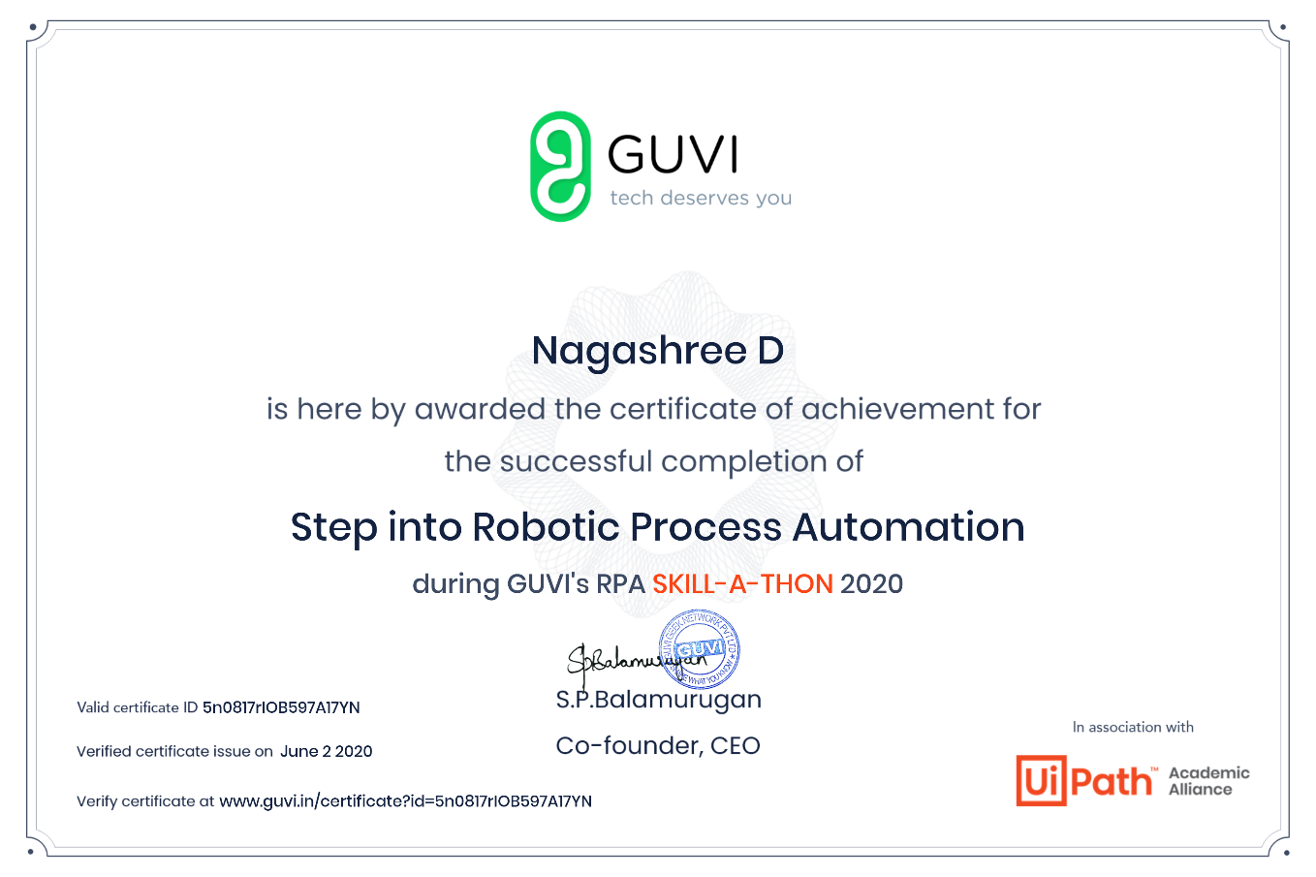



Coding Challenges Details:

#include<stdio.h>

void main()

{

    int i,j,n;

    printf("Enter the no of lines\n");

    scanf("%d",&n);

    for(i=1;i<=n;i++)

    {

        for(j=1;j<=n-i+1;j++)

        {

            printf("%d", j);

        }

        printf("\n");

    }

}